Virology in the biomedical field: biotechnological tool for the treatment of cystic fibrosis
Name: Antonio Alberto Rodríguez Sousa
Complutense University of Madrid School of Biological Sciences, Spain

Abstract
Statement of the Problem: Cystic fibrosis is the autosomal recessive genetic disorder with the highest incidence in the Caucasian population, being caused by mutations of the Cystic Fibrosis Transmembrane Conductance Regulator (CFTR) gene. Although the current treatments focus on increasing the quality of life of the patient, a gene therapy of viral origin that could involve the regeneration of damaged alveolar parenchyma is located in the experimental phase. The purpose of the present work is to establish a theoretical framework of the disease from which clinical work can be carried out aimed at the development of new therapeutic techniques. Methodology & Theoretical Orientation: A dynamic simulation model was developed on patients' hope and quality of life, taking the number of pulmonary alveoli as an estimator of respiratory function. The model was calibrated in face of different clinical situations: 1) healthy individual; 2) untreated sick individual; 3) sick individual with conventional treatments; and 4) sick individual treated with gene therapy. Findings: The study showed that the life expectancy of sick individuals was significantly reduced when compared with healthy individuals. On the other hand, while the application of conventional treatments reflected an improvement in the quality of life of the simulated patients, the administration of a viral-type gene therapy was consolidated as an option in which in the treated individual their hope of life was not affected due to the disease. Conclusion & Significance: By using viruses as a biotechnological tool, being transmission vectors of functional copies of the CFTR gene that would be inserted into the host's DNA, it would be possible to correctly resume the cellular processes altered by the disease. Therefore, the research in virology and its application in gene therapies is essential to develop curative treatments that suppose a new clinical horizon.
Image
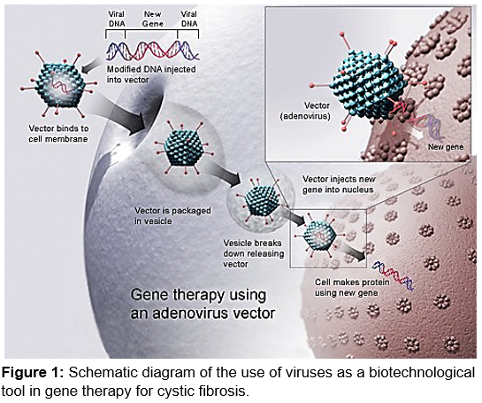
Recent Publications
- Davies JC, Geddes DM, Alton EW (2001) Gene therapy for cystic fibrosis. The journal of gene medicine 3(5): 409-417.
- Ferrari S, Geddes DM, Alton EW (2002) Barriers to and new approaches for gene therapy and gene delivery in cystic fibrosis. Advanced drug delivery reviews 54(11): 1373-1393.
- Lane S, Rippon HJ, Bishop AE (2007) Stem cells in lung repair and regeneration. Regenerative Medidine 2(4): 407-415.
- Martínez-García MA, Soler-Cataluna JJ, Perpiná-Tordera M, Román-Sánchez P, Soriano J (2007) Factors associated with lung function decline in adult patients with stable non-cystic fibrosis bronchiectasis. CHEST Journal 132(5): 1565-1572.
5. Zabner J, Couture LA, Gregory RJ, Graham SM, Smith AE, Welsh MJ (1993) Adenovirus-mediated gene transfer transiently corrects the chloride transport defect in nasal epithelia of patients with cystic fibrosis. Cell 75(2): 207-216.



Biography
Antonio Alberto Rodríguez Sousa has an extensive experience in systems dynamics and modeling. With biological training, he develops part of his personal work at Complutense University of Madrid on the simulation of the effects presented by different treatments on alveolar development in people with cystic fibrosis, a disease in which he has a high degree of specialization on the lung involvement in adults. In this sense, he has evaluated how the application of different drugs contributes to improve the hope and quality of life of patients. Specifically, and under the appropriate assumptions, it tries to make the scientific and medical sector aware that the application of a gene therapy using a virus as a transmission vector would contribute to a reversion of cystic fibrosis when the affected cellular processes are resumed. Finally, research in this area is essential to be able to propose curative treatments for diseases of genetic transmission.
Email: antonr05@ucm.es

