Title: Whole-Genome Sequencing Analysis of SFTSV Detected in South Korea.
Name: Hyun Kim, Jae Woong Lee, Ah-Ra Lee, Ju-Eun Kim, Sang-Il Kim, Youn-Jeong Kim, Yoon-Hee Jeon, Jae-Ik Han, Soon-Young Paik
College of Medicine, The Catholic University of Korea

Abstract
Severe fever with thrombocytopenia syndrome (SFTS) is a newly emerging infectious disease and caused by SFTS virus (SFTSV), a tick-borne phlebovirus in family Bunyaviridae. SFTSV was reported in China in 2011, more recently in Japan and South Korea.
In this study, samples were collected from patients with sfts in Jeju, South Korea in 2017, and its identity was confirmed as SFTSV by RT-PCR, and nucleotide sequencing and alignment analysis.
The whole-genome of the SFTSV strains sequence analysis revealed three segments comprising the whole genome: L segment (6,368 bp), M segment (3,378 bp), and S segment (1,744 bp). The SFTS strain showed amino acid identities with Korea reference strains of 98.30-99.83 %, 98.51-99.44 %, and 99.38-99.57 % in the S segment, M segment, and L segment, respectively. Additional, it showed 98.94-99.49 %, 98.42-98.70 %, and 99.09-99.42 % similarity with Japan reference strains. And, Similarities with reference strains in China were 98.39-99.28 %, 97.49-98.23 %, and 99.14-99.47 %.
Of the total amino acids, 28 mutations were identified, among 11 of which was special substitution mutations found only in our strains.
This research will be used as a full-length SFTSV sequence standard for future comparison studies. Also, it may also prove useful to the field of public health field by facilitating the diagnosis and the prediction of new emerging variants.
.

Image
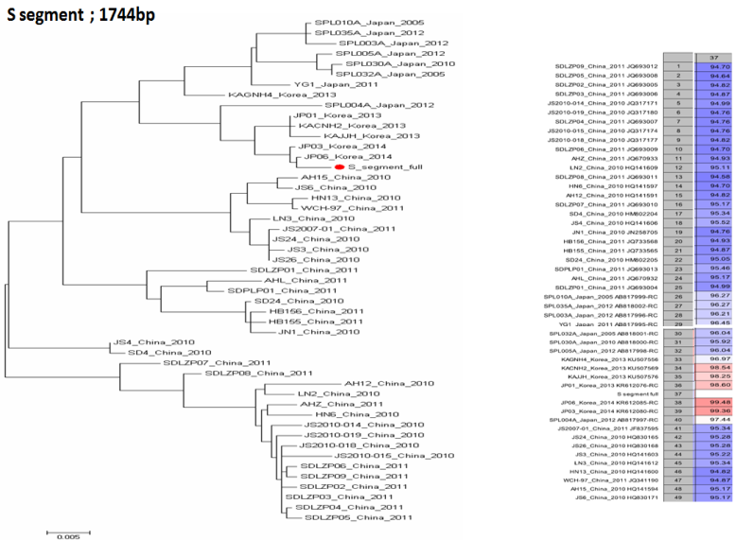
Recent Publications

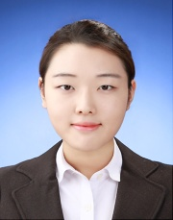

Biography
Hyun Kim has a master's course from Catholic University School of Medicine. Mainly her study is waterborne viruses.
Email: smile9667@naver.com

Notes/Comments:

