Transmission of LOM vaccine strain for Classical Swine Fever in Jeju island in South Korea
Wooseog Jeong PhD, Sungdae Park DVM, Yong-Myung Kang DVM PhD, Jihye Kim DVM, APQA, Ref. Korea. Gimcheon

Abstract
Classical swine fever (CSF) is an economically important, highly contagious disease of swine worldwide. CSF is caused by classical swine fever virus (CSFV), and domestic pigs and wild boars are its only natural hosts. In South Korea, a live attenuated vaccine (LOM strain) had been used to control CSF from 1974 and declared to CSF-free and stopped vaccination in 2001. But due to CSF outbreak again in 2003, nationwide CSF vaccination campaign has been performed since then. But Jeju island located in southern Korea was excluded from the CSF vaccination
campaign.
In 2004, LOM vaccine strain was detected in Jeju Island due to blood
meals, and it was detected in 47 farms until 2007.
It was recently detected in 20 farms through the vaccination of contaminated vaccine against LOM vaccine in 2014, 25 farms (cumulative) in 2015, 34 farms (cumulative) in 2016, and 22 farms
(cumulative) in 2017.
The farmers claim to be fever, diarrhea and mortality as the main
clinical symptoms of pigs infected with the LOM vaccine.
Epidemiological studies through network analysis have shown that the affected farms were infected with chronic wasting diseases such as PED and that they had the characteristics of sharing manure disposal plants
and vehicles in the nearby areas.
It is known that LOM vaccine infection through oral administration is feasible. In the case of individuals whose immunity is weakened by PED or the like, it can be infected if it is exposed to contaminated source through a manure vehicle and so on. There is only one slaughterhouse in Jeju island, it is possible to spread to Jeju Island through slaughterhouses. However, the detection of LOM vaccine in some areas only suggests that
it is possible to spread only in special circumstances in the region.

Image

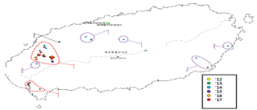
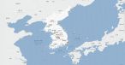
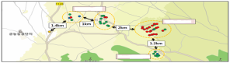
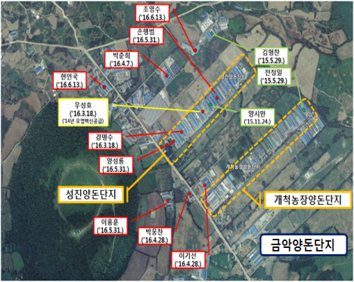
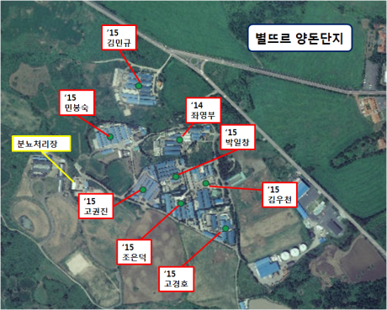
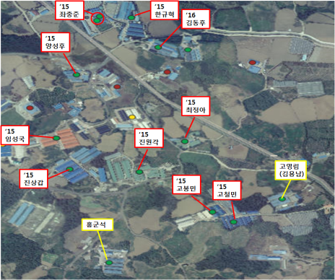
China
South Korea
Japan
Hallim
Hangyeong
Daejeong
Slaughterhouse
Aewol
Jeju
Pyoseon
Seongsan
Pig farms
Geumag
Beyulddeur

Fig. Location of farms of LOM Vaccine strain detected in Jeju island
Swine farms in Hanlim area are concentrated without fence, roads and sewage treatment facilities are shared, and human and material movements are frequent within the complex.
In addition to public vehicle sterilizers, disinfection facilities for interception and prevention of each farm are very inadequate. Among the Hanlim area complexes, feed, animal medicine, pregnancy diagnosis, and manure handling are shared with each other. Chronic diseases such as PRRS and PED are spreading. Among the 58 farms detected in the LOM, 42 farms were suspected to have PED, of which 28 farms (48.3%) conducted PED self-vaccination using intestine of PED positive pigs.

Recent Publications
- Moennig, V., 2000. Introduction to classical swine fever virus, disease and control policy. Vet. Microbiol. 73: 93-102.
- KimB, SongJY, TarkDG, LimSI, ChoiEJ, et al., (2008) Feed contaminated with classical swine fever vaccine virus (LOM strain) can induce antibodies to the virus in pigs. Veterinary Record 162:12-17.
- LimSI, SongJY, KimJ, HyunBH et al., (2016) Safety of classical swine fever virus strain LOM in pregnant sows and their offspring. Vaccine 34: 2021-2026.

Image: 
Biography
Wooseog Jeong had been studying parasitic diseases of livestock for 15 years at Korea’s Animal & Plant Quarantine Agency. In recent 6 years, he carried out research work in veterinary epidemiology division. In carrying out an epidemiological survey of various Korean livestock diseases, he learned that there were specific types of disease outbreaks and events known in the past. He is trying to solve the problem through scientific reasoning about such facts.
Email: wjeong@korea.kr

Notes/Comments:

