Pre-Clinical Development Of a Novel Survivin Therapeutic Cancer Vaccine
Dr Ahmed Bouzidi, Vaxeal Group, Switzerland

Abstract

Present cancer therapy clearly indicates that better treatment options that selectively target cancer dependent pathways with little or no toxicity to normal tissues are urgently needed. Novel and cheaper alternatives to current cancer therapeutics, including therapeutic vaccine candidates that can train the human immune system to fight deadly forms of cancer, offer great hope for patients in winning the war against cancer. This requires an adapted selection of the tumor antigen targets in order to boost both CD4+ and CD8+ T cell responses induction while limiting the Treg induction and tumor escape mechanisms. Vaxeal has designed an novel generation of therapeutic cancer vaccine enabling to overcome limitations to current vaccine-based approaches. The immunotherapy consists in long synthetic peptides (LSPs) containing multiple promiscuous CD4+ and CD8+ T epitopes derived from survivin, an ubiquitous protein over-expressed and playing vital functions in large number of human tumors and metastatic tissues. The studies have investigated the effects of various formulations to boost their immunogenicity and anti-tumoral activity. Spontaneous immune responses have also been assessed in cancer patients. Finally, the benefit of the synergistic combinations with immunomodulatory drugs has been evaluated for certain specific cancer indications.

Image
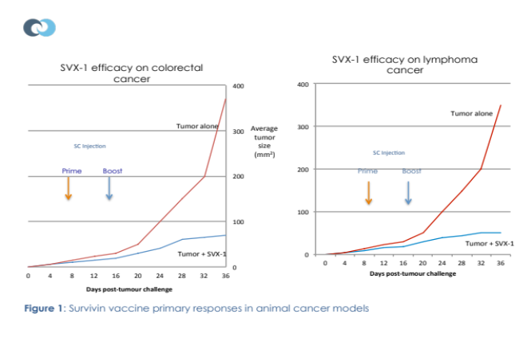
Recent Publications
- Druilhe P, Spertini F, Soesoe D, Corradin G, Mejia P, Singh S, Audran R, Bouzidi A, Oeuvray C, Roussilhon C. A malaria vaccine that elicits in humans antibodies able to kill Plasmodium falciparum. PLoS Med. 2005 Nov; 2(11): e344. Epub 2005 Nov 8.
- Pancré V, Georges B, Angyalosi G, Castelli F, Delanoye A, Delacre M, Hachulla E, Maillere B, Bouzidi A, Auriault C. Novel promiscuous HLA-DQ HIV Nef peptide that induces IFN-gamma-producing memory CD4+ T-cells. Clin Exp Immunol. 2002 Sep; 129(3): 429-37.
- Hober D, Chehadeh W, Bouzidi A, Wattré P. Antibody-dependent enhancement of coxsackievirus B4 infectivity of human peripheral blood mononuclear cells results in increased interferon-alpha synthesis. J Infect Dis. 2001 Nov 1; 184(9): 1098-108. Epub 2001 Oct 12
- Chehadeh W, Bouzidi A, Alm G, Wattré P, Hober D. Human antibodies isolated from plasma by affinity chromatography increase the coxsackievirus B4-induced synthesis of interferon-alpha by human peripheral blood mononuclear cells in vitro. J Gen Virol. 2001 Aug; 82(Pt 8):1899-907.
- Badell E, Oeuvray C, Moreno A, Soe S, van Rooijen N, Bouzidi A, Druilhe P. Human malaria in immunocompromised mice: an in vivo model to study defense mechanisms against Plasmodium falciparum. J Exp Med. 2000 Dec 4; 192(11): 1653-60.

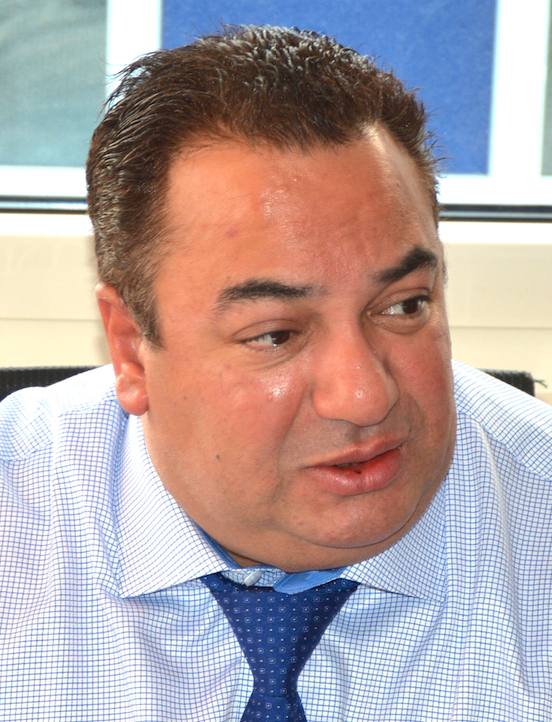
Biography
Ahmed Bouzidi is the founder and Chief Executive Officer of Vaxeal. He previously founded and managed SEDAC-Therapeutics inc., a leading biotech pioneer in peptide-based therapeutic vaccines (exit by Leveraged Buy Out), and Biophysiomics inc. (acquired by Chengdu Kuachang Science & Technology, China). Ahmed is a board member of Vaccines Europe and of the European Biopharmaceutical Enterprises (EBE-biopharma), and is a Senior Associate of the Royal Society of Medicine. He held previously senior advisory positions with Chinese pharmaceutical companies and public institutions, and worked 10 years as senior researcher at the LFB. He holds a Master degree in Animal Biology (University of Lille, France), a PhD in Cellular Biology, and a MBA in Finance (University of New Hampshire, USA).
Email: abouzidi@vaxeal.net

Notes/Comments:

