Development and Preclinical Evaluation of 15 Pneumococcal Polysaccharide CRM197 Conjugate Candidate Vaccines in Mouse Model
Huyen T Pham, MS, Konkuk University, Seoul, Republic of Korea
Chanwoo Park, Konkuk University, Seoul, Republic of Korea
Doh-Hoon Kim, Konkuk University, Seoul, Republic of Korea
Ju-Hwan Kim, Dongguk University, Seoul, Republic of Korea
Hyo-Jin Kang, Dongguk University, Seoul, Republic of Korea
Rock-Ki Kim, EuBiologics Co. Ltd, Gangwon-do, Republic of Korea
Sung-Kyun Lee, EuBiologics Co. Ltd, Gangwon-do, Republic of Korea
Yoon-Hee Whang, EuBiologics Co. Ltd, Gangwon-do, Republic of Korea
Chan-Kyu Lee, EuBiologics Co. Ltd, Gangwon-do, Republic of Korea
Suenie Park, PhD, EuBiologics Co. Ltd, Gangwon-do, Republic of Korea
Do-Young Yoon, PhD, Konkuk University, Seoul, Republic of Korea

Abstract
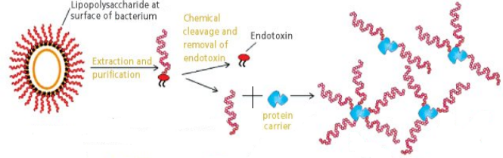
Statement of the Problem: Pneumococcal capsular polysaccharides (PnPS) are the most important virulence factor of the human pathogen Streptococcus pneumoniae, which shield pneumococci from host phagocytes. Conjugation of the PnPS to a protein carrier enhances immunologic responses to the vaccine, leading to protection against infection. Current vaccines based on the use of a limited number of PnPS and conjugated PnPS have been licensed including PPSV23 (Pneumovax) and PCV13 (Prevnar13). To compensate the defect, new vaccines against more serotypes are being developed. Methodology & Theoretical Orientation: In our study, we engineered antigens from polysaccharides or CRM197-conjugated polysaccharides which are potential to become vaccines. The treatment groups (6-week-old BALB/c mice) were vaccinated by intraperitoneally (IP) with 1 dose (100 μg of polysaccharide antigen/ mouse), or (2.5 μg of CRM197-conjugated polysaccharide antigen/ mouse) three times at 4-week intervals. After vaccination, specific antibodies against PnPS of each serotype (1, 3, 4, 5, 6A, 6B, 7F, 9V, 11A, 14, 18C, 19A, 19F, 22F, and 23F) were measured by enzyme-linked immunosorbent assay (ELISA) and functional IgG was detected by opsonophagocytic killing assay (OPA). Findings: There were good antibody responses of mice to both antigens, as compared to the baseline. In ELISA, most of the end-point titers from conjugated antigens were higher than unconjugated ones. Besides, the antisera from vaccinated mice contained functional opsonic antibodies demonstrated by OPA. Conclusion & Significance: The 15 developed-pneumococcal-conjugate vaccines manufactured by a Korean company have the effectiveness of serological immunogenicity in mouse model. These results implicate to develop a newly 15-valent pneumococcal conjugate vaccine (PCV15) and would provide the further possibility of the clinical application.

Image
Figure 1. Production of conjugate vaccines
Recent Publications
- Pham, T. H., Kim, M. S., Le, M. Q., Song, Y. S., Bak, Y., Ryu, H. W., ... & Yoon, D. Y. (2017). Fargesin exerts anti-inflammatory effects in THP-1 monocytes by suppressing PKC-dependent AP-1 and NF-ĸB signaling. Phytomedicine, 24, 96-103.

 Biography
Huyen T Pham is a PhD candidate in immunology research at Department of Bioscience and Biotechnology, Konkuk University, Seoul, South Korea. She currently works for Professor Do-Young Yoon at Konkuk University, where she manages projects focused on inflammation, interleukin 32, and pneumoniae vaccine research. Before pursuing her PhD, she obtained her master degree in proteomics in Department of Molecular Biotechnology, Konkuk University.
Email: huyenpham@konkuk.ac.kr

