
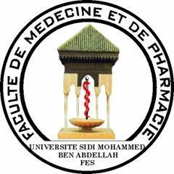

ASSESSEMENT OF CHEMICAL RISK FACTORS AMONG ARTISANAL TANNERY WORKERS IN MOROCCO

ARHOUNE.I^{1,2}, HOUMMANI.H¹, KHATTABI.A³, FAQIR.S⁴, ACHOUR.S^{1,2}
¹pharmaco-toxicology service of CHU Hassan II Fez.
² Laboratory of Biomedical and Translational Research, Faculty of Medicine, USMBA Fez, Morocco.
³ National school of public health, Rabat, Morocco.
⁴Laboraoty of Epidemiology Clinical Research and community health, USMBA. Fez, Morocco.

Abstract
Epidemiological studies among tannery workers have shown different risks and toxic effects on the health of tanners(1),(2). However, health problems of traditional tannery workers has never been studies in Morocco with medical monitoring. Aims: To assess the health hazards faced by the workers in traditional tanneries in Morocco. Materials and methods: In this cross-sectional study, a total of 440 study population that 220 are the workers from three artisanal tanneries located in the old medina of Fez city, besides 220 subjects served as a control. The study was approved by the University Hospital committee of Ethics at fez. The questionnaire included socio-demographic, clinic-pathological, biological and toxicological informations. The results were analyzed by statistical tests included Chi Square and student’s t-test. Total blood chromium was estimated by ICP-MS. Results: All the research population was men. The most recruted age section was between 40 and 60 years. The clinical manifestation was significantly higher (86%) in comparison to the control group (32%). Musculoskeletal diseases (77.5%), Dermatological (19%) genito-urinary disorders (36%) were found more frequently for tanners in comparison to the controls (9%), (4.5%) and (1.8%) concurrently. The frequency of anemia (3%) and urinary infections (34%) was higher for the tannery workers in comparison to the control (0%). Also, there is no statistical difference in liver enzyme activities and renal functions between the two studies groups. Blood chromium level showed no significant difference in workers as compared with control. Conclusion: Health risks among artisanal tannery workers are very high and they are extremely associated with some chemicals and insupportable working conditions.

Key words: tannery workers, artisan, health risks, blood chromium.

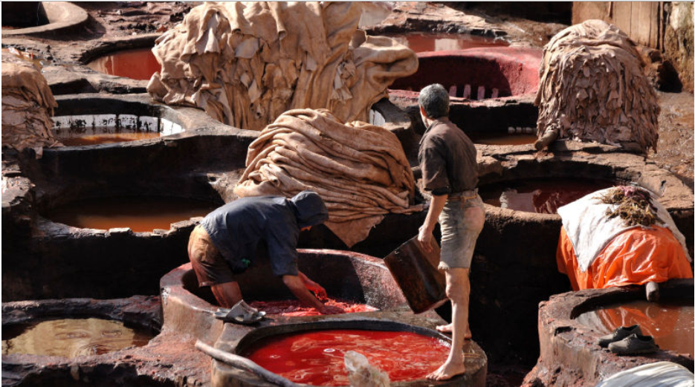
Recent Publications (minimum 5)
- Islam Rabiul (2017) Occupational health hazards and safety practices among the workers of tannery industry in Bangladesh. J. Biol. Sci. 6(1): 13-22, 2017 (June).
- Faridah H. (2014) Chromium Exposure and Related Health Eﬀects
among Tannery Workers in Kenya Journal of Health & Pollution Vol. 4, No. 7: 25-35
- Faizan Haider Khan (2012) Assessment of health risks with reference to oxidative stress and DNA damage in chromium exposed populationScience of the Total Environment 430 (2012) 68–74.
- Kursat Ozdilli (2007) Biological Hazards in Tannery Workers. Indoor Built Environ 2007;16;4:349–357
- MUHAMMAD MASHHOOD AHSAN (2006) Biochemical and Haematological Abnormalities in Factory Workers Exposed to Hexavalent Chromium in Tanneries of Kasur District. Pakistan J. Zool., vol. 38(3), pp. 239-253.

Biography
1. Özdilli K, Işsever H, Özyildirim BA, Hapçioglu B, Ince N, Ince H, et al. Biological hazards in tannery workers. Indoor Built Environ. 2007;16(4):349–57.
2. Ahsan MM. Biochemical and Haematological Abnormalities in Human Population Exposed To Hexavalent Chromium in Effluents of Tanneries Industrial Area of District Kasur. 2003;38(3):239–53.

Presenting author details
Full name (As per the passport): Ilham Arhoune
University/Industry/Organization name: University Sidi Mohamed Ben Abd Llah, Faculty of Medecine and Farmacy Fez.Morocco
Designation (Director/Prof/Assistant or Associate prof/Researcher/Student): PhD Student
Country: Morocco
Mobile number (country code – number): +212 689 631 631
Email: arhoune.ilham@gmail.com
Track number: https://europe.toxicologyconferences.com/
(For track number follow this link)
Category (Oral presentation/ Poster presentation/Young researcher forum/E-poster): Oral presentation
Research interest: to evaluate the health hazards faced by the workers in traditional tanneries in Morocco

