


Mercury Distribution from Blood to Hair in Humans and Dogs

Gianpaolo Guzzi¹, Anna Ronchi², Barbara De Marco³, Paolo D. Pigatto⁴, Manuela Passoni¹
1. Italian Association for Metals and Biocompatibility Research – A.I.R.M.E.B., Milan, Italy.
2. Pavia Poison Control Center and National Toxicology Information Centre, Toxicology Unit, IRCCS Maugeri Found. and University of Pavia, Italy.
3. Private Veterinary Practice, Milan, Italy.
4. Department of Biomedical, Surgical and Dental Sciences, Unit of Dermatology, IRCCS Galeazzi Hospital, University of Milan, Milan, Italy.

Abstract
Mercury accumulates in hair. Head hair, along with blood, is a matrix for the biological monitoring of organic mercury exposure. We compared the levels of hair mercury in humans and in a dog to examine the relationship. Patient 1. A 50-year-old man with hyperglycemia and elevated levels of CD69 (25%) had mercury whole-blood 32.7 Hg µg/L and scalp hair mercury 8.4 Hg µg/g: the blood-to-hair ratio was 1:257. Intake of fish was 7 portion per week. Patient 2. A 44-year-old female with anemia, weight loss, high serum beta-2-glycoprotein 1, hyperamylasemia, and tremors had mercury whole-blood 13.4 Hg µg/L and scalp hair mercury 3.1 Hg µg/g: the blood-to-hair ratio was 1:231. Fish intake was 3 portion per week. Patient 3. A 57-year-old female with memory impairment and electric shock sensation from head to extremities had mercury whole-blood 24.3 Hg µg/L and scalp hair mercury 6 Hg µg/g: the blood-to-hair ratio was 1:276. Fish intake per week was 7. Patient 4. A 54-year-old female with paresthesia, dermatitis, and mycosis had mercury whole-blood 26.5 Hg µg/L and scalp hair mercury 3.2 Hg µg/g: the blood-to-hair ratio was 1:121. Intake of fish was 3 per week. Patient 5. A 28-year-old man with abdominal pain, mesenteric lymphadenitis (mercury-related enlarged mesenteric lymph-nodes), and an elevated antistreptolysin-O titers in serum had mercury whole-blood 43.4 Hg µg/L and scalp hair mercury 12 Hg µg/g: the blood-to-hair ratio was 1:257. Fish intake was 5 portion per week. In humans, mercury levels in scalp hair are proportional to simultaneous concentrations in blood, but are about 250 times higher. In a dog, the estimates of the blood-to-hair ratio was found to be greater than in humans.

Recent Publications

- Lieske CL, SK Moses, JM Castellini, J Klejka, K Hueffer and TM O'Hara (2011) Toxicokinetics of mercury in blood compartments and hair of fish-fed sled dogs. Acta Vet. Scand. 53:66.
- Guzzi G, C Marsili and PD Pigatto (2010) Mercury in pediatric poisoning. Eur J Pediatr 169:907.
- Minoia C, A Ronchi, PD Pigatto and G Guzzi (2008) Measuring mercury exposure in children. Pediatr Int 50:839-840.
- Nyland JF, M Fillion, F Barbosa, Jr., DL Shirley, C Chine, M Lemire, D Mergler and EK Silbergeld (2011) Biomarkers of methylmercury exposure immunotoxicity among fish consumers in Amazonian Brazil. Environ Health Perspect 119:1733-1738.
- Magos L and TW Clarkson (2008) The assessment of the contribution of hair to methyl mercury excretion. Toxicol. Lett. 182:48-49.

Key words: animal, blood-to-hair ratio, comparative toxicology, dog, fish consumption, hair-to-blood, head scalp hair, humans, indicator, mercury analyses, mercury hair levels, mercury poisoning, mercury testing, toxicokinetic parameters.

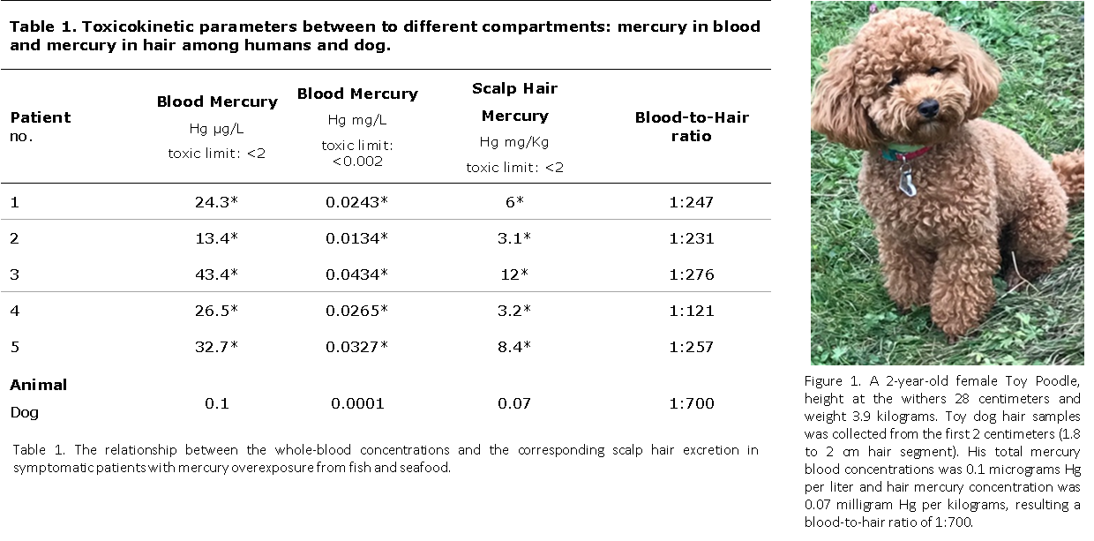

Biography
Gianpaolo Guzzi is the president - founder and clinical research coordinator – of the Italian Association for Metals and Biocompatibility Research – A.I.R.M.E.B., a Milan-based not-for-profit organization. His field of expertise is toxicology of mercury.

Presenting author details
Full name (As per the passport): Gianpaolo Guzzi
University/Industry/Organization name: Italian Association for Metals and Biocompatibility Research – A.I.R.M.E.B., Milan, Italy.
Designation: President - founder and clinical research coordinator.
Country: Italy
Email: gianpaolo_guzzi@fastwebnet.it
Category: Poster presentation
Research interest: Mercury toxicology

Year of birth: 1964

