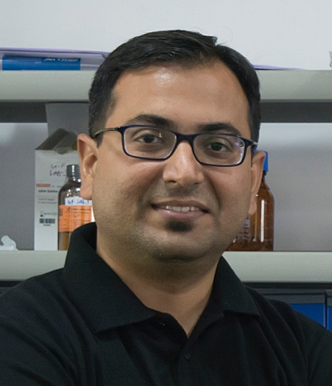



Interactions of natural organic matters with nanoparticles and their combined effects in aquatic organisms

Ashutosh Kumar, PhD, Division of Biological & Life Sciences, Ahmedabad University, Gujarat, INDIA

Abstract
In the last decade, population growth and increased industrial activity has led to both intentional and inadvertent release of nanoparticles (NPs) into the environment. Therefore, large number of NPs exist in the environment for which toxicity data are not sufficient due to limited understanding of their behaviour in the aquatic ecosystem and bioavailability to the aquatic organisms. The present study has attempted to investigate the behaviour of titanium dioxide nanoparticles (TiO₂ NPs), one of the most commonly used NPs in different experimental buffers in the presence of humic acid (HA). Also, the effect of TiO₂ NPs were assessed in different aquatic organisms with and without the presence of HA. The results demonstrate that the HA increases the dispersion of TiO₂ NPs in the experimental buffers by adsorption on the surface of NPs. The adsorption of HA on TiO₂ NPs was mainly driven by electrostatic interactions as observed by deference in the values of zeta potential in the presence and absence of HA.The maximum aggregation was observed in the E3 medium even in the presence of HA. The intensity of TiO₂ NPs sedimentation was observed in the order: E3 media > Dryl’s buffer >MilliQ water. Interestingly, the ecotoxicity results on the Tetrahymena pyriformis and Danio rerio showed that presence of HA reduces the toxicity of TiO₂ NPs.
Environmental significance: the study provides significant insights on the effects of humic acid in the experimental buffers extensively used in the ecotoxicological assays. The finding suggests that the use of HA in the ecotoxicological assays will facilitate the long term risk assessment of NPs by increasing the stability.

Keywords- Tetrahymena, Zebrafish, Fate, Ecotoxicity, Natural organic matter

Image
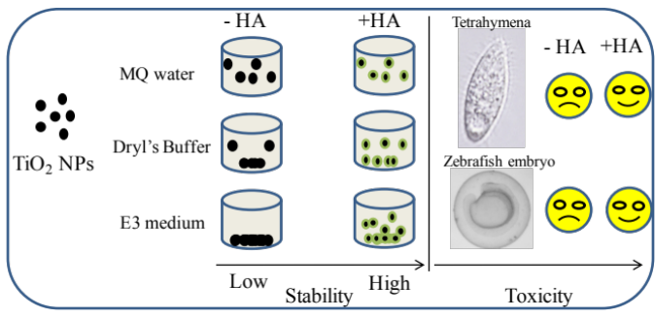
Recent Publications

- Violet Aileen Senapati, Krupa Kansara, Rishi Shanker, Alok Dhawan and Ashutosh Kumar. Monitoring characteristics and genotoxic effects of engineered nanoparticle-protein corona. Mutagenesis. 32(5):479-490 (2017)
- Govind Saran Gupta, Ashutosh Kumar, Violet A Senapati, Alok K Pandey, Rishi Shanker, Alok Dhawan. Laboratory scale microbial food chain to study bioaccumulation, biomagnification, and ecotoxicity of cadmium telluride quantum dots. Environmental Science and Technology. 51(3):1695-1706 (2017)
- Govind Saran Gupta, Ashutosh Kumar, Rishi Shanker, Alok Dhawan. Assessment of agglomeration, co-sedimentation and trophic transfer of titanium dioxide nanoparticles in laboratory scale predator-prey model system. Scientific Report 6:31422 (2016)
- Margit Heinlaan, Marge Muna, Melanie Knobel, david Kistler, Niksa Odzak, Dana Kuhnel, Josefine Muller, Govind Saran Gupta, Ashutosh Kumar, Rishi Shanker, Laura Sigg. Natural water as the test medium for Ag and CuO nanoparticle hazard evaluation: An interlaboratory case study. Environmental Pollution. 216:689-699 (2016)
- Violet Aileen Senapati, Govind Sharan Gupta, Alok Kumar Pandey, Rishi Shanker, Alok Dhawan and Ashutosh Kumar. Zinc oxide nanoparticle induced age dependent immunotoxicity in BALB/c mice. Toxicology Research, 6, 342-352 (2017)

Biography
Ashutosh Kumar works as an Assistant Professor at Ahmedabad University, Gujarat, India. He obtained his Master’s degree in Applied Microbiology from Vellore Institute of Technology, Vellore in 2008 and worked at CSIR-Indian Institute of Toxicology Research, Lucknow for his Doctorate degree and was involved in understanding the fate of nanomaterials in biological systems. His current research areas of interest includes, nanomedicines for cancer and arthritis therapy, DNA Biochip for pathogen detection, nanobased drug and gene delivery, nanoemulsions for food industries, environmental nanotechnology and nanotoxicology. His studies shall have far reaching applications in predicting the adverse health effects of nanoparticles and safe use of ENMs to protect human and environmental health. He has published more than 50 research papers and 12 book chapters in internationally reputed peer reviewed journals.

Presenting author details
Full name (As per the passport): Ashutosh Kumar
University/Industry/Organization name: Ahmedabad University
Designation (Director/Prof/Assistant or Associate prof/Researcher/Student): Assistant Professor
Country: INDIA
Mobile number (country code – number): 91-8238019923
Email: ashutosh.kumar@ahduni.edu.in
Track number: http://toxicology.global-summit.com/europe/
(For track number follow this link)
Category (Oral presentation/ Poster presentation/Young researcher forum/E-poster): Oral Presentation
Research interest: Nanoecotoxicology, Food nanotechnology, Nano drug delivery
Your profile page URL in your department: https://ahduni.edu.in/dbls/people/faculty/ashutosh-kumar
Year of birth: 1984
Linked In/Facebook/twitter account:

Note: Please fill up the Red mark fields so that it would be easier for us to cite your details in the conference particulars. (Please do not forget to fix your photo and Logo above the title)

