Does Phytohemagglutinin-L may be useful for studying glycocalyx role of PBMC cells in patients with atopic dermatitis?

Anna M Bogdali PhD, JUMC, Poland
Grazyna Antoszczyk PhD, JUMC, Poland
Wojciech Dyga PhD, JUMC, Poland
Krystyna Obtułowicz Prof PhD, JUMC, Poland

Abstract (300 word limit)
Atopic dermatitis is a chronic inflammatory allergic skin disease. Nowadays its frequency increases in the world especially in low-income countries.
Mechanisms of interaction between molecules such as metals ions f.e. nickel, proteins and receptors expressed on the cell membrane is still not well understood. Oligomerization of receptor units is often a triggering signal for activation of intracellular signaling transduction. Understanding the mechanism of regulation of the oligomerization of receptor units still requires detailed studies. Receptors are usually glycoproteins being a part of glycocalyx. Glycocalyx is composed of a negatively charged network of proteoglycans, glycoproteins, glycolipids of cell membrane and it surrounds a cell. It is known that nickel ions can interact with negatively charged sugar residues and create complexes in vitro. Interestingly, the potential role of the glycocalyx of T cells as a trap for metal ions, being a pre-step in interaction between a ligand and a receptor, has not been studied yet. The purpose of the study was to propose a discussion on the utility of the model of potential interaction between glycocalyx of T cells and molecules such as nickel sulfate, Derp1 of Dermatophagoides pteronyssinus (House Dust Mite) or staphylococcal enterotoxin A or B in patients with atopic dermatitis. This type of study can enable to understand if glycocalyx may act as a trap for ligands f.e. nickel in a pre-step before activation of receptor and consequently regulate oligomerization of receptor units by neutralization of the negative charge of glycocalyx.
Methodology: This model was created by comprison of cytokine profiles (IFN-γ, IL-2, IL-13) secreted by PBMC (peripheral blood mononuclear) cells from patients with atopic dermatitis and healthy volunteers in vitro. PBMC cells were stimulated with L- phytohemagluttynin able to bind to glycocalyx or other molecules unknown to interact with glycocalyx such as nickel sulfate, staphylococcal enterotoxin A or B or Derp1 in vitro. We considered each found correlation in cytokines profile secreted under L-PHA stimulation and the other molecule to understand if such molecule may interact with glycocalyx too.
Findings: We found similarities in secretion of cytokines by PBMC stimulated with L-PHA and other stimulants such as nickel sulphate in vitro.
Conclusion and Significance: Similarities in secretion of cytokines by PBMC being a result of glycocalyx activation by L-PHA and other stimulants f.e. nickel ions suggest that glycocalyx may be a pre-step before binding a ligand to the receptor. Understanding a mechanism of interaction between a ligand and a receptor with details can facilitate to develop better medicines for atopic patients with nickel allergy and other allergies too.

This study was founded by the Ministry of Science and Higher Education in Poland (No. 4266/B/PO1/2010/39).

Image

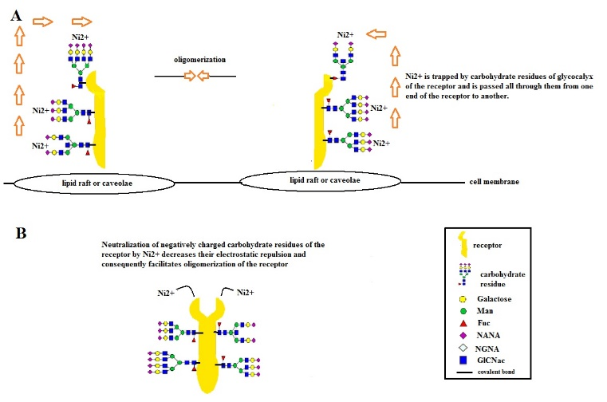
Figure 1: Theoretical model of interaction between glycocalyx, nickel ions and TCRs

Recent Publications (minimum 5)
- Sakuma K, Furuhashi T, Kondo S, Yabe U, Ohmori K, Ito H, et al (2012). Sialic acid cyclization of human Th homing receptor glycan associated with recurrent exacerbations of atopic dermatitis. J Dermatol Sci: 68(3): 187-193.
- Saito M, Arakaki R, Yamada A, Tsunematsu T, Kudo Y, Ishimaru N (2016). Molecular Mechanisms of Nickel Allergy. Int J Mol Sci. 17: 1-8.
- Shigenobu Y (1998). Intelligent metal complexes containing N-glycosides formed from Tris(2-aminoethyl)amine and aldoses, having molecular recognition ability. Chinese Journal of Polymer Science 16(3):193-206
- Reddad Z, Gerente C, Andres Y, Ralet M-C, Thibault J-F, Le Cloirec P (2002). Ni(II) and Cu(II) binding properties of native and modified sugar beet pulp. Carbohydrate Polymers 49(1): 23-318.
- Raghavan B, Martin SF, Esser PR, Goebeler M, Schmidt M (2012). Metal allergens nickel and cobalt facilitate TLR4 homodimerization independently of MD2. EMBO Rep. 13(12): 1109-1523.
- Wang JH, Reinherz EL (2013). Revisiting the putative TCR Cα dimerization model through structural analysis. Front Immunol 4(16): 1-6
- Devuyst O (2014). Glycocalyx: the fuzzy coat now regulates cell signaling. Perit Dial Int;34(6): 574-575.


Anna Magdalena Bogdali graduated with her Master’s degree at the Department of Biochemistry, Biophysics and Biotechnology of Jagiellonian University in Krakow. She completed her PhD on Atopic Dermatitis from Jagiellonian University Medical College in Medical Biology. She participated in the Socrates/Erasmus and 6th and 7th Framework European Programs. She stayed in the Angioedema Hungarian Center at the Semmelweis University in Budapest and she is involved in projects on hereditary angioedema concerning genetic background and immune mechanisms at the Jagiellonian University Medical College in Krakow. Her interests are immune and genetics mechanisms mostly related to T cells in the skin and circulatory system.
.
Email: anna.bogdali@gmail.com

Notes/Comments:

