Molecular mechanisms and neuronal pathways implicated in rapid-acting antidepressive ketamine properties

Vesna Pešić, MSc Pharm, PhD

Abstract
Statement of the Problem: The emergence of rapid-acting antidepressants such as ketamine has motivated studies aiming to reveal the molecular mechanism of the ketamine antidepressant effect and to enable the clinical
application of rapid-acting antidepressants. Furthermore, potential role of of integrin beta-3 (ITGB3) and close homologue of L1 (CHL1), in the mode of action of antidepressants was postulated. There is substantial number of ongoing studies addressing the antidepressant effects of ketamine in depressed patients and animal models of depression. Reduction of depressive symptoms in humans could be compared with the reduction in immobility time in the forced swim test in rodents after acute ketamine treatment.
Methodology & Theoretical Orientation:
Using corticosterone-induced chronic stress and depression model we have previously demonstrated reduction of expression of ITGB3 in prefrontal cortex (PFC) of stressed/depressed animals, and protective role of 14-day long oxytocin treatment on DNA oxidative damage and expression of ITGB3 in this model. In the ongoing study we are exploring effects of acute ketamine treatment on behavioral and molecular markers of depression and oxidative stress. Also, IHC analysis is applied in order to examine potential biochemical pathways involved in the rapid antidepressant response to ketamine, and weather the activation of the ventral hippocampus—medial prefrontal cortex—dorsal raphae nuclei (vHC-mPFC–DRN) neuronal pathway may mediate the antidepressant effect of ketamine.
Conclusion & Significance: Hopefully, our current results will contribute to the progress in ketamine research and to more precisely identify molecular markers and neuronal pathways involved in ketamine’s mode of action. Further longitudinal clinical trials are necessary to identify patients that would be good candidates and responders to the ketamine treatment or successful application of novel rapid-acting antidepressants in the future.
Image
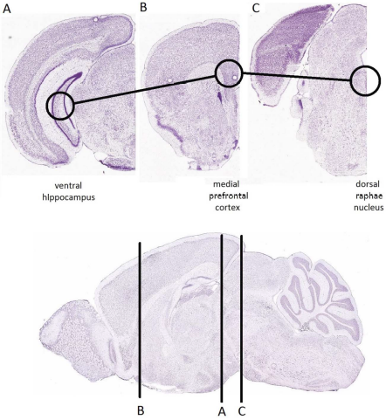

Fig. 1. Activation of ventral hippocampus—medial prefrontal cortex—DRN pathway as a candidate mechanism for an antidepressant effect of ketamine. Coronal sections of the mouse brain are taken displayed for (A) ventral hippocampus, (B) medial prefrontal cortex, and (C) DRN. (vHC-mPFC-DRN) neuronal pathway is marked by the line connecting these sections. The location of the coronal sections on rostrocaudal axis is marked below on the medial sagittal section. All cresyl violet-stained pictures are taken from the reference adult (P56) mouse brain atlas (http://atlas.brain-map.org/). [Color figure can be viewed at wileyonlinelibrary.com]
Recent Publications
- Pešić V, Petrović J, Jukić MM (2016) Molecular mechanism and clinical relevance of ketamine as rapid-acting antidepressant. Drug Development Research 77:414-422.
- Pešić V, Jukić MM (2016) Are adult neurogenesis and glucocorticoid signaling missing links between stress and depression? Arh Farm 66:207-216.
- Stanić D, Plećaš-Solarović B, Mirković D, Jovanović P, Dronjak S, Marković B, Đorđević T, Ignjatović S, Pešić V (2017) Oxytocin in corticosterone-induced chronic stress model: focus on adrenal gland function. Psychoneuroendocrinology in press.
- Petrović J, Stanić D, Dmitrašinović G, Plećaš-Solarović B, Ignjatović S, Batinić B, Popović D, Pešić V (2016) Magnesium supplementation diminishes peripheral blood lymphocyte DNA oxidative damage in athletes and sedentary young man Oxidative Medicine and Cellular Longevity http://dx.doi.org/10.1155/2016/2019643.
5. Stanić D, Plećaš-Solarović B, Petrović J, Bogavac-Stanojević N, Sopić M, Kotur-Stevuljević J, Ignjatović S, Pešić V (2016) Hydrogen peroxide-induced oxidative damage in peripheral blood lymphocytes from rats chronically treated with corticosterone: The protective effect of oxytocin treatment. Chemico-Biological Interactions 256:134-141.

 Biography
Vesna Pešić is currently working on experimental models of depression, chronic stress and dysregulation of the hypothalamic-pituitary-adrenocortical (HPA) axis activity and functionality. Her research team is exploring potential novel and adjacent therapy that could, along with classical antidepressants, help in restoring normal hormonal and behavioral activity. Her expertise covers behavioral testing, neuroendocrinology, immunohistochemistry, neurogenesis, and antioxidative properties of hormones in animal and human studies. She teaches and works at the Department of Physiology, University of Belgrade, Faculty of Pharmacy, Belgrade.

E-mail: vepesic@pharmacy.bg.ac.rs

Notes/Comments:

