Influence of ¹³⁷Cs on the wildlife in the Kopački Rit Nature Park, Croatia
Branko Petrinec, Dinko Babić, Marko Šoštarić, Tomislav Meštrović, Zdenko Franić and Gordana Marović, Institute for Medical Research and Occupational Health, Radiation Protection Unit, Ksaverska cesta 2,10000 Zagreb, Croatia
Marina Poje Sovilj, Denis Stanić, Vanja Radolić, Igor Miklavčić, Branko Vuković and Irena Lukanović, Department of Physics, University of Osijek, Trg Ljudevita Gaja 6, 31000 Osijek

Abstract
We collected samples in accordance with the standard procedures recommended by the International Atomic Energy Association, within an internal project of the Institute for Medical Research and Occupational Health and in collaboration with the Physics Department of the University of Osijek. The activity concentration of ¹³⁷Cs was determined using a high-purity germanium gamma-ray spectrometry system (FWHM of 2.24 keV and relative efficiency of 74.2%, all at 1.33 MeV ⁶⁰Co). The measured activity concentrations in soil from 11 locations range from 1.81±0.16 Bq/kg (Kozjak) to 10.65 ± 0.26 Bq/kg (Hulovski Channel), averaging to of 7.20 ± 0.28 Bq/kg which is comparable to other parts of Croatia.

Image 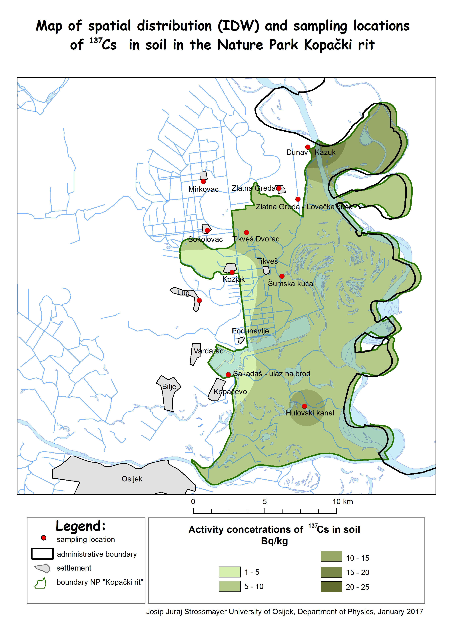
Data sets consisting of measured activity concentrations of ¹³⁷Cs in soil and water samples within the boundaries of the Nature Park Kopacki rit were used for the risk assessment for the wildlife and dose rates for freshwater and terrestrial organisms were estimated.
For the freshwater ecosystem in Kopački rit, the highest risk quotient (RQ) values were obtained for “pelagic fish” 0.038 and “amphibian” 0.037, respectively. Appropriate dose rates were below the screening level of 10 μGy h⁻¹: amphibian 0.37 μGy h⁻¹, bird 0.27 μGy h⁻¹, insect larvae 0.12 μGy h⁻¹, mammal 0.29 μGy h⁻¹, pelagic fish 0.38 μGy h⁻¹ and vascular plant 0.022 μGy h⁻¹.
Also, for terrestrial ecosystems, all RQs are far below 1 (the highest values are 0.0013 for “Lichen”, 0.0019 for “small mammal”, 0.0027 for “large mammal”) and the dose rates to species studied were clearly below the screening level of 10 μGy h⁻¹ (one-thousandth of this value: 0.0128 μGy h⁻¹ for the lichen, 0.0196 μGy h⁻¹ and 0.0277 μGy h⁻¹ for small and large mammals, respectively) indicating no significant impact of the ¹³⁷Cs fallout on all of the investigated species.

Recent Publications
- Pavičić-Hamer D, Barišić D, Šimunac B, Petrinec B, Štrok M (2016) ¹³⁷Cs distribution in the northern Adriatic Sea. Journal of Radioanalytical and Nuclear Chemistry. 309:989-998
- Franić Z, Šega K, Petrinec B, Marović G (2009) Long-term investigations of post-Chernobyl radiocaesium in fallout and air in North Croatia. Environmental Monitoring and Assessment. 148, 1-4; 315-323
- Petrinec B, Štrok M, Franić Z, Smodiš B, Pavičić-Hamer D (2013) Radionuclides in Adriatic Sea and related dose rate assessment for marine biota. Radiation protection dosimetry. 154, 3; 320-330
- Šoštarić M, Petrinec B, Babić D (2013) ¹³⁷Cs in Soil and Fallout around Zagreb (Croatia) at the Time of the Fukushima Accident. Arhiv za higijenu rada i toksikologiju. 64, 4; 561-565
- Franić Z, Petrinec B, Marović G, Franić Z (2007) Radiocaesium Activity Concentrations in Potatoes in Croatia after the Chernobyl Accident and Dose Assessment. Journal of Environmental Science and Health - Part B: Pesticides, Food Contaminants, and Agricultural Wastes. 42, 2; 211-217

Biography
Branko Petrinec obtained his PhD degree from the Physics Department of the University of Zagreb. He is a Research Associate at the Institute for Medical
Research and Occupational Health in Zagreb, and an Assistant Professor at the Department of Physics of the Josip Juraj Strossmayer University in Osijek. He has
published more than 20 papers in reputed journals. He was the President of the Scientific Committee of the Tenth Symposium of the Croatian Radiation Protection
Association. In 2011, he was the Laureate of the CRPA Young Scientists Award.
Email: petrinec@imi.hr

Notes/Comments:

