


Name: Jose Luis Covarrubias Rosas.
Affiliation: Clinica Hospital del Sol.

ABSTRACT
COVAS-LIFT

This article describes a new technique for facial contouring and support system of the third midface, which uses an innovative technique. This procedure is a minimally invasive facial enhancement that has been increasing in the last years.

Aging of the face involves alterations in the appearance, the tone of the outer layers of the skin, ptosis of the malar and cheek pads, and the most important is the atrophy of the fat pads of the cheek this leads to the loss of contour in the malar area, nasolabial folds and the marionette lines, this also increase the lower cheeks.

“Repositioning of the tissue is the key to the rejuvenation”

This procedure is ideal for Patients with heavy faces and early aging process, when there is a main issue like ptosis involves, a sub-periostal mid facelift doing it through an intraoral incision (CADWELL LOOK), its done, a suture is placed in the temporal area to lift the malar tissue, whit a innovative 18-cm long curved double-beveled needle (COVAS NEEDLE) bearing a tiny sliding carriage to which 2/0 Non Absorbable suture may be anchored, this create suspension loops, that are anchored to the deep galea in the temporal region and this provide more tissue support, - fat grafts are used to increase volume, Vivification Peel and Botulism Toxin is the COVAS-LIFT procedure and can be combine with other modalities, blepharoplasty, rhinoplasty, liposuction of the double chin, otoplasty, and much more procedures, this is to have a more natural look ,and the satisfaction of both the doctor and patient.

In 6 years 575 patients, we only had 4 complications, 3 tenderness in the temporal area and one infection of a suture because hair.

This procedure can be done at any age ...

Biography

26 years of experience as a plastic surgeon. Creator of the Covas-Lift procedure.

Contact Jose L. Covarrubias
E-mail: voncovas@mac.com
Telephone: (520) 595 6892 U.S.A.

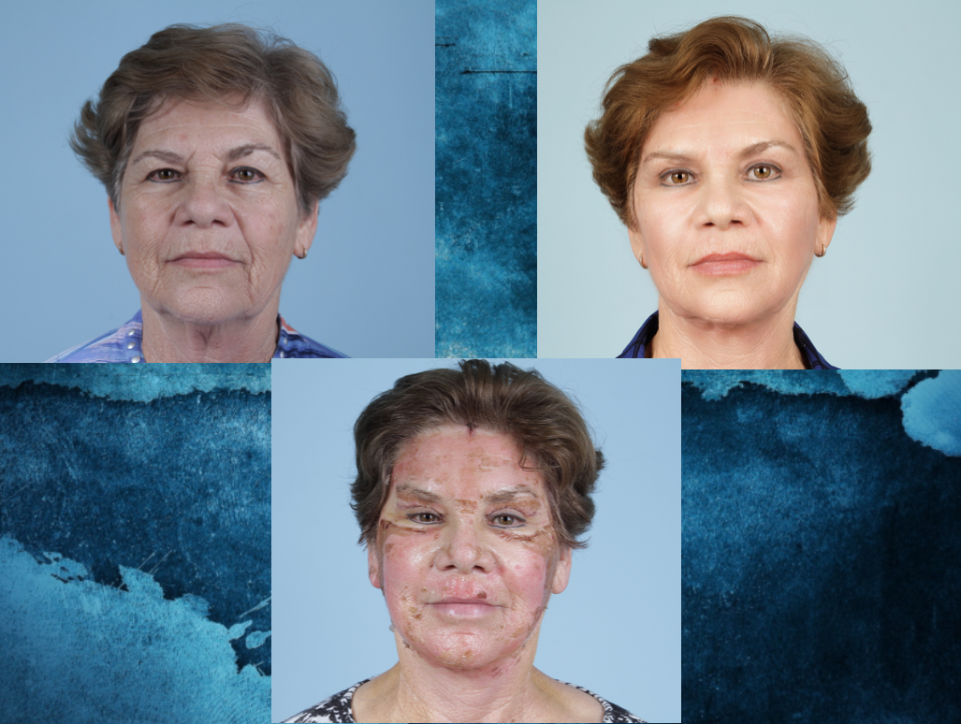
Patient with a 9 day of post Surgery and then 90 days

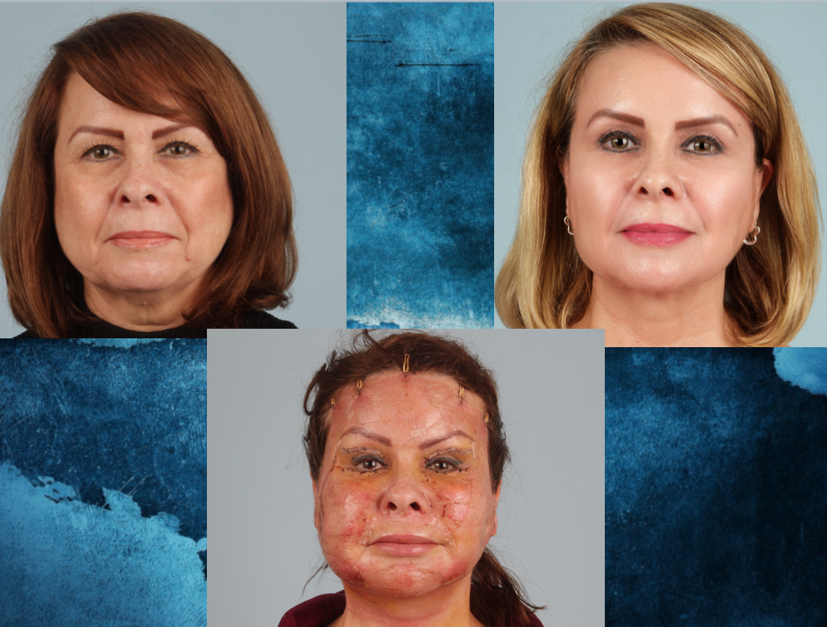
Patient with one week , then 120 days

