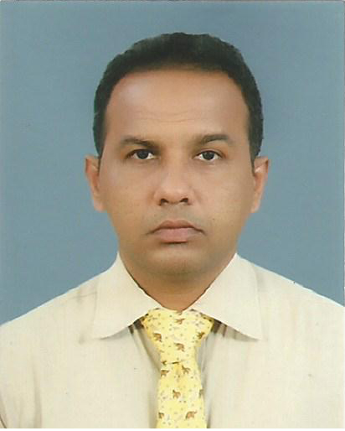
FACIAL COSMETIC SURGERY - FROM KNIFE TO NEEDLE
Dr. Ashraf Mohamed
Teaching Hospital, Eastren University of Sri Lanka, Batticloa, Sri Lanka.

Facial cosmetic surgery had a major drift from conventional surgery to minimal invasive procedure in the last decad. The term surgery by it’s wickypedia and perception evoke agitation and resistance in the client’s mind. With the extensive down time after surgery, it was felt very strongly that injectables could be a tangible option to help the soft clients.
Three injectables at least took up the facial aesthetic in exchange of knife based surgery. 1. Fillers Injection 2. Botulinum toxin injection 3. Injection of growth factors and growth factor based products. In addition to injetables liposuction, threads, Radio Frequency (RF), micro needling are getting popularized. Fillers were replacing the need for surgical procedure that were performed to fill up the defitcits or to alternate the conventional surgical augmentation. Botulinum toxins (BT) were enormously used to correct the folds and creases of the neck and face otherwise the option is to cut or plicate. BT was amicable to correct facial imbalance from mild to moderate. The out come of BT injections for hemi facial paralysis and congenital facial imbalances were promising. Further, complex multiple procedures for facial rejuvanisation mostly failed in meeting the expectation of the customers and were well put back with injections of pletelet rich plasma, platelet rich fibrin and other growth factors.

Hence; in my opinion’ we surgeons are now compelled to say bay to our knives and employ our selves with needles. Certainly, its going to be more than the fillers, botulinum toxins and growth factors in the new era.

Biography

Dr. Ashraf Mohamed has obtained his Doctor of Medicine in Maxillofacial Surgery from Faculty of Medicine at University of Colombo and he is having the experience of more than 7 year in cosmetic facial procedure in a well known practices. He is a visiting lecture at Eastren University of Sri Lanka. He is an Editor Sri Lanka Association of Oral and Maxiloofacial Surgeons. He is a fellow of many international societies and forums.

Presenting author details
Full name: Mohamed Ashraf
Contact number: +94717808993
Twitter account:
Linked In account:ridhaash@gmail.com
Session name/ number:
Category: Presentation

