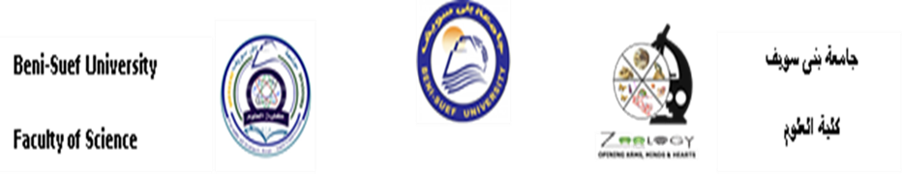
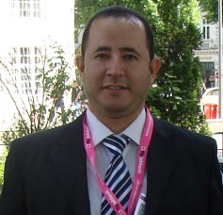

Title: Microstructure of scales in selected lizard species

Name: Ahmed A Allam

Bnei-Suef University, Egypt

ABSTRACT (250-300 words)

In the present study, it was hypothesized that micromorphology of the surface of many lizard scales appears to mimic the topography of the habitat in which they live. Many authors have suggested that the microstructure of the superficial surface of scales have undergone important adaptations and have functional value in lizards. In this study, we investigated the variation and adaptation of the micromorphology and microstructure of the superficial surface of the dorsal and ventral scales from the mid-body region of Stellagama stellio (Agamidae), Stenodactylus petrii (Gekkonidae), Acanthodactylus boskianus (Lacertidae), Eumeces schneideri (Scincidae), Trachylepis quinquetaeniata (Scincidae), Scincus scincus (Scincidae), Varanus griseus (Varanidae), Chameleo chameleon (Chamaeleonidae). Skin specimens were prepared and analyzed using scanning electron microscopy. The dorsal and ventral scale surfaces had microstructure in the studied species and they exhibited unique patterns that somewhat resembled the topography of the microhabitats in which they lived. Similarity was detected in the three most related species, those having a common family, Scincidae. Ecomorphological relationships were detected between the dorsal and ventral scale microstructures and microhabitats. We conclude that environmental factors have observable influences on the microstructure of lizard scales.

BIOGRAPHY (100-150 words)
Ahmed Allam has his expertise in the field of neurogenesis and neurobehaviors especially in the newborns. Many of his publications and works focus on the damage which produced in the brain regions due to perinatally toxins exposure during development and how to repair this damage and reduce its hazards and how mothers could be avoided from these teratogenic factors even tough toxins or manners. Also, Dr Allam has some expertise in the following area Biochemistry, Genetics and Molecular Biology, Biological Sciences, Neuroscience, Medicine, Chemistry, Environmental Science, Pharmacology, Toxicology and Pharmaceutics Immunology.

Presenting author details
Full name: Ahmed Aly Allam
Contact number: +201288222647
Session name: Track 1-3Biological system
Category: Oral presentation
Email: ahmed.aliahmed@science.bsu.edu.eg
allam1081981@yahoo.com aallam@ksu.edu.sa ahmedalyallam@gmail.com

