
Title: Evolving Wi-Fi to Cope with Low-Latency Requirements in Contemporary Systems: Smart Grids as a Use Case
Author (s) Name: Nahla Ali, University of Brescia, Italy.

The requirement for fast interactions among electricity producers and consumers in Smart Grids is pushing the research on low-latency wireless networks. While past research mostly focused on the applicability of standard 802.11 technologies over Smart Grids, we investigate a new technique for rapid forwarding in wireless multihop networks, based on Concurrent Transmission (C.XMSN). Although C.XMSN has gained momentum in the last few years, researchers focused on slow modulations like 802.15.4: to fill the gap we extend the analysis to 802.11 modulations and we report our insights on the main issues that affect the deployment of C.XMSN using usergradeWi-Fi hardware that we reprogrammed to implement rapid forwarding. We justify our findings analytically and we provide directions for enhancing C.XMSN in Wi-Fi.

Figures if any (BW/Color):
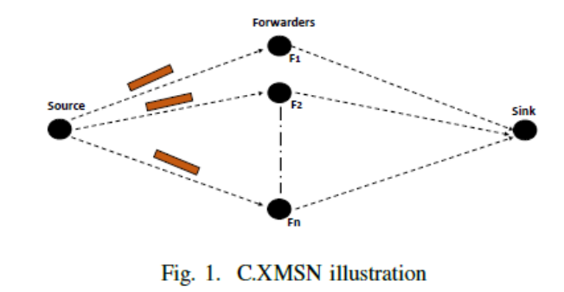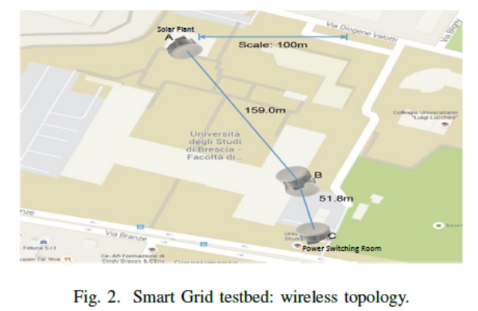

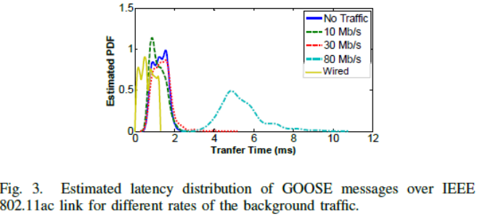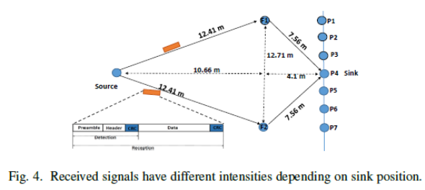

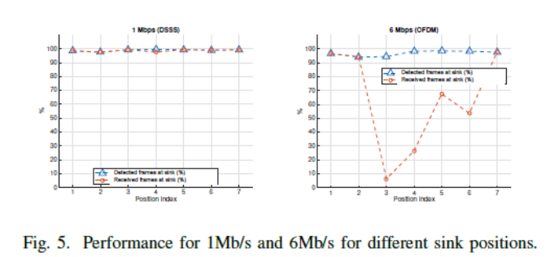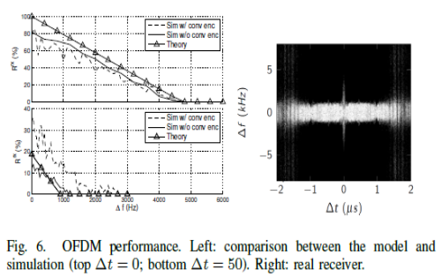

Biography

Nahla Ali has recently completed her PhD in Information Engineering from the University of Brescia, Italy. I successfully defended my thesis on 21 June 2018. I also have an MA and a BSc in Electrical Engineering from the University of Khartoum, Sudan. My PhD thesis research, titled "Design and Experimental Investigation of Advanced Smart Grid Infrastructure Using Concurrent Transmission on Multi-Hop Wireless Networks" combined conceptual/theoretical and applied approaches. She has published 5 papers in reputed journals and she is a member in a number of recognized organizations.
Presenting author details
Full name: Nahla Mustafa Mohamed Ali
Contact number: +32467835450
Email id:nahlammali@gmail.com
Category: Oral presentation
Session name: Evolution of Wireless Communication
Website: https://nahlammali.wixsite.com/nahlaali
Research interest: Wi-Fi, Networks, Embedded Systems

