Barriers to adoption of healthy lifestyle behaviours for noncommunicable diseases in India
Ashwati Nair, MSc, London School of Economics and Political Science, UK
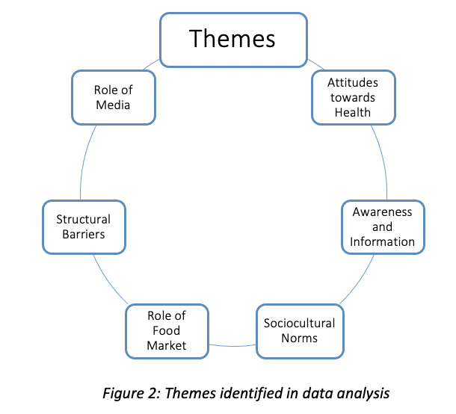

Abstract (300-word limit)

Statement of Problem: The incidence of noncommunicable diseases (NCDs) is rising worldwide. These conditions are typically chronic and include cardiovascular disease, chronic respiratory diseases, cancer, and diabetes among others. This rise is disproportionately higher in LMICs, significantly contributing to morbidity and mortality. In particular, India has seen a drastic rise in NCD-related premature death and ill health. The impoverishing nature of these conditions through catastrophic healthcare spending and income loss results in significant socioeconomic costs. It is thus increasingly important to explore the challenges to tackling this area of health and developing viable solutions. Lifestyle interventions, such as encouraging healthier dietary habits and promoting physical activity, represent a significant opportunity for improvement. However, despite increased efforts to promote such interventions, NCD burden remains high and little research has been conducted to understand why. The purpose of this study is to explore the barriers that prevent adoption of healthy lifestyle behaviours for NCDs in India. Methodology and Theoretical Orientation: This study adopts a qualitative approach through thematic analysis of key informant interviews; key informants included various health professionals in India. The analysis is focused using the five levels of influence in McLeroy et al’s ecological model for health promotion and Jacobs et al’s four key dimensions of access barriers. Findings: The study highlights the various levels at which behaviours are influenced in India and identifies key barriers including poor health attitudes, inadequate awareness and information, sociocultural norms, food market, media, and structural barriers. Conclusion and Significance: It is evident that there are numerous factors that shape people’s attitudes towards lifestyle changes and their willingness and ability to adopt them. This study hopes to enable future policies and public health programmes to successfully promote healthy lifestyle behaviours for NCDs in India. Recommendations have been included to improve the adoption of these changes.
Image

Recent Publications (minimum 5)
- Adjaye-Gbewonyo, K., & Vaughan, M. (2019). Reframing NCDs? An analysis of current debates. Global Health Action. https://doi.org/10.1080/16549716.2019.1641043
- Bachani, D. (2017). Need for strategic revamping to prevent and control non-communicable diseases in India. In Indian Journal of Community Medicine. https://doi.org/10.4103/0970-0218.199803
- Eggleston, K., & Jain, R. (2020). Cost-effective interventions to prevent noncommunicable diseases: increasing the evidence base in India and other low- and middle-income settings. In BMC Medicine. https://doi.org/10.1186/s12916-020-01850-0
- Kataria, I., Siddiqui, M., Gillespie, T., Goodman, M., Dhillon, P. K., Bann, C., & Squiers, L. (2020). A research agenda for non-communicable disease prevention and control in India. Health Research Policy and Systems. https://doi.org/10.1186/s12961-020-00639-0
- Mohanty, S., Venkatarao, E., & Yasobant, S. (2020). Non-communicable disease care and physical activity promotion in India: Analysis of recent policies, guidelines and workplans. In Family Medicine and Community Health. https://doi.org/10.1136/fmch-2019-000206
- Nethan, S., Sinha, D., & Mehrotra, R. (2017). Non communicable disease risk factors and their trends in India. Asian Pacific Journal of Cancer Prevention. https://doi.org/10.22034/APJCP.2017.18.7.2005
- Sriram, U., Morgan, E. H., Graham, M. L., Folta, S. C., & Seguin, R. A. (2018). Support and Sabotage: A Qualitative Study of Social Influences on Health Behaviors Among Rural Adults. Journal of Rural Health. https://doi.org/10.1111/jrh.12232


 Biography (150 word limit)
Ashwati Nair is a fourth-year medical student at King’s College London with a special interest in global health. She recently completed her MSc in Health and International Development from the London School of Economics and Political Science in 2021. This study was conducted as part of her final dissertation for the MSc. Her recent endeavours in this field include completing a Postgraduate Consultancy Project with the MICS division of UNICEF analysing global household data on menstrual hygiene management and participating in the Healthcare Leadership Academy’s Global Exchange weekend. She hopes to work in the field of global health to improve healthcare provision in developing countries alongside practising medicine in the UK in the future.
Email: ashwatirnair@gmail.com

Notes/Comments:

Presenting author details
Full name: Ashwati Ravi Nair
Contact number: +447504604386
Twitter account: @ashwati_nair03
Linked In account: Ashwati Nair
Session name/ number: Track 20 Health Systems and Economics
Category: (Oral presentation/ Poster presentation)

