HARDI NAJMALDDIN
GASTROINTESTINAL DISEASES
Abstract

The goal of this short review is to summarize recent data on gastrointestinal changes with aging, focusing on gastrointestinal motility disorders, and mucosal variations. First of all, this review focused on gastrointestinal motility disorders with aging, even though an increased prevalence of several gastrointestinal motor disorders (i.e., dysphagia, dyspepsia, anorexia, and constipation) occurs in older people, aging per se appears to have a minor direct effect on most gastrointestinal functions. Secondly, this review focused on histological changes with aging, i.e., regulation of gastrointestinal mucosal growth, gastrointestinal carcinogenesis, and gastric mucosal changes, especially changes in gastric acid secretion, bacterial overgrowth and its consequences on elderly patients.

BIOGRAPHY :
My Name Is Hardi , I Born On 14:01:1989, I Know 6 Language : English, Russian ,Turkish, Arabic Persian And Kurdish, I Graduated At Saratov State Medical University In Russia, Now I Am A Doctor , I Passed All My Previous Exams With The Best Result , I Am Interested to make Poster Presentation About Digestive Diseases , I Wanna Create New Pathway For Improving Healthcare, I Had Many Practice And Experience About Medical Emergency

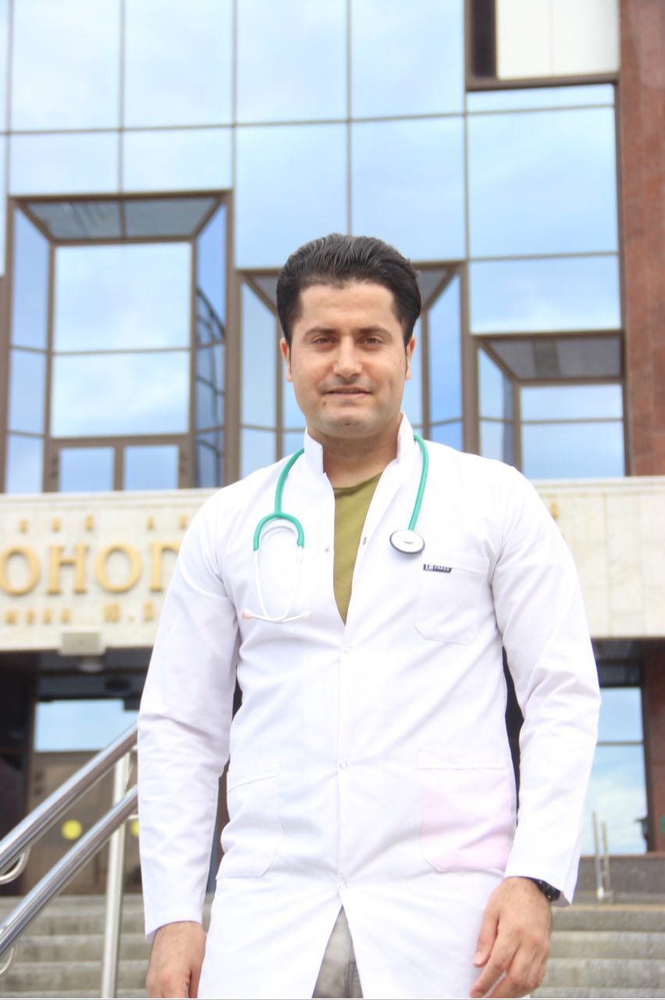

BIOGRAPHY :
MY NAME IS HARDI , I BORN ON 14:01:1989, I KNOW 6 LANGUAGE :ENGLISH,RUSSIAN ,TURKISH,ARABIC PERSIAN AND KURDISH, I GRADUATED AT SARATOV STATE MEDICAL UNIVERSITY IN RUSSIA,NOW I AM A DOCTOR , I PASSED ALL MY PREVIOUS EXAMS WITH THE BEST RESULT , I AM INTERSTING TO COME TO NETHERLAND AND MAKE POSTER PRESENTATION ABOUT DIGESTIVE DISEASES , I WANNA CREAT NEW PATHWAY FOR IMPROVING HEALTHCARE, I HAD MANY PRACTICE AND EXPERIENCE ABOUT MEDICAL EMERGENCY

