Post Release Psychiatric Care in Calgary
Liya Xie MD, PhD, University of Calgary, Canada

Abstract (300 word limit)
- Objective: Globally, incarcerated populations have a higher prevalence of both acute and chronic health conditions than the general population. In 2010, Alberta brought Correctional Health under the Ministry of Health to provide accredited health services and intervention programs for the most high risk and vulnerable inmates. Continuity of care after release is a key component of ensuring effective care. In June 2015, Calgary Corrections Transition Team (CTT) was fully implemented to assist and support inmates with mental health and addiction issues to develop release plans for successful reintegration to the community. The purpose of this study is to analyze the usage of psychiatric services through CTT post release. Methods: Administrative and clinical CTT data between 2016 and 2019 were used to identify the barriers to successful transition of clients from correctional health care to community mental health care. Results: Among the CTT referrals, 2621 cases (85%) were accepted, 85% of them were male. As part of their release plans, 333 (14.4%) were referred to forensic psychiatric outpatient services but only 250 clients (75%) used this service. The most significant diagnoses are: mood and anxiety disorder, substance use disorder, adjustment disorder, and ADHD. Many of them have dual diagnoses. Conclusion: CTT has made great contributions to bridging the gaps between correctional mental health care and community mental health care. Unsuccessful transition is related to systemic and individual barriers, such as financial and housing difficulties, clients’ relapse on substances, mental instability, lack of motivation, violent history, and so on. We should advocate for change in policy and practice that will remove barriers to access and improve continuity of care.

Image 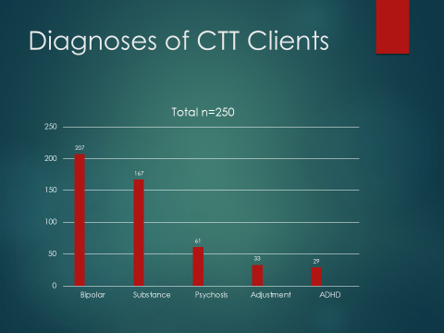
Fig. 1. Diagnoses of CTT Clients
Recent Publications (minimum 5)
- Goldbloom DS (2010) Unacceptable status quo in access to mental health care. CMAJ.182: 112.
- Williams N. (2007) Prison health and the health of the public: ties that bind. J Correctional Health Care 13:80–92.
- Shakespeare C (2008) Prison health care BMJ 337:0810345
- Vogel L. (2010) Pan-Canadian strategy being developed to tackle mental health in prisons. CMAJ 18:182
- McLeod K., Martin R (2018) Health in correctional facilities is health in our communities CMAJ 10:190
- Abbott P, Magin P, Davison J, et al (2017) Medical homelessness and candidacy: women transiting between prison and community health care. Int J Equity Health 16:130

Biography (150 word limit)
Dr. Liya Xie is a forensic psychiatrist of Southern Alberta Forensic Psychiatry Services, in Canada. She has her expertise in evaluation and treatment of mentally disordered patients who are involved in legal system. In addition to her forensic psychiatry outpatient services, she is the assigned psychiatrist dedicated to CTT Calgary. She works with CTT to support the most vulnerable and high risk individuals with addiction and mental health issues to reduce their recidivism.
Email: liya.xie@ahs.ca

Notes/Comments:

