Allocentric vs. Egocentric Neglect in Stroke Patients: Assessment through Eye-Tracking and Impacts on Functional Outcome
Maya Libben, PhD, R.Psych, University of British Columbia, Canada
Jennifer Upshaw, MA, University of British Columbia, Canada

Abstract (300 word limit)
Statement of the Problem: Hemispatial neglect is defined as a failure to report, respond, or orient to stimuli on the contralesional side of space (Wong et al., 2017). Despite affecting up to two-thirds of right-hemisphere stroke patients (Parton et al., 2004), neglect is a relatively poorly understood phenomenon. Of particular importance to rehabilitation and clinical outcome studies is the differentiation between viewer-centered or egocentric neglect, and stimulus-centered or allocentric neglect (Bickerton et al., 2011; Marsh & Hillis, 2008, Ota et al., 2001). The current study aimed to a) develop a novel method of assessing neglect subtypes using eye-tracking technology; b) investigate specific patterns of attention associated with each subtype; and c) determine the relationship between neglect subtype and functional outcome. Methodology: Twenty acute stroke patients and twenty matched controls were administered comprehensive neuropsychological assessment batteries, a traditional pencil-and-paper assessment of neglect subtype (Bickerton et al., 2011), a novel eye-tracking measure of neglect subtype and a functional outcome measure. Findings: The eye-tracking measure was more sensitive in identifying neglect subtype in patients than the traditional pencil-and-paper test. The eye-tracking measure also demonstrated adequate specificity, with control participants scoring as normal (Figure 1). Classification of neglect subtype based on eye-tracking performance was a significant predictor of functional outcome above and beyond neuropsychological test performance and traditional tests of neglect. Analysis of early (automatic) vs. late (controlled) eye movement data suggest that early mechanisms of attention remain intact among neglect patients, and that deficits lie in later controlled stages of attention. Conclusion & Significance: The current results have significant implications for methods of assessing hemispatial neglect to better predict long-term prognosis. Results indicating deficits in controlled mechanisms of attention will be fundamental in directing rehabilitative treatment for individuals suffering from both ego- and allocentric neglect.

Image
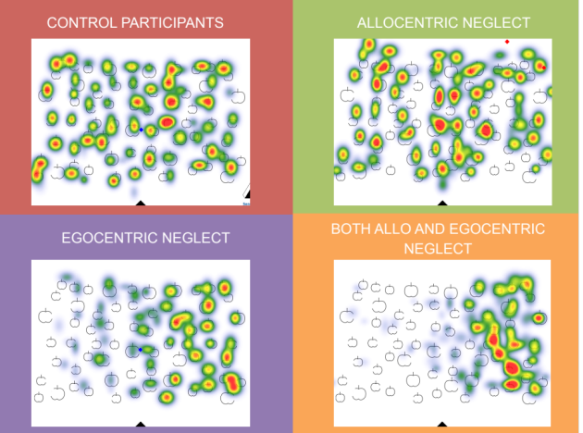
Figure 1: Eye movement dwell times for stroke patients diagnosed with allocentric neglect, egocentric neglect, simultaneous allo- and egocentric neglect, as well as matched control participants.
Recent Publications (minimum 5)
- Bickerton, W. L., Samson, D., Williamson, J., & Humphreys, G. W. (2011). Separating forms of neglect using the Apples Test: validation and functional prediction in chronic and acute stroke. Neuropsychology, 25(5), 567
- Marsh, E. B., & Hillis, A. E. (2008). Dissociation between egocentric and allocentric visuospatial and tactile neglect in acute stroke. Cortex, 44(9), 1215-1220.
- Ota, H., Fujii, T., Suzuki, K., Fukatsu, R., & Yamadori, A. (2001). Dissociation of body-centered and stimulus-centered representations in unilateral neglect. Neurology, 57(11), 2064-2069.
- Parton, A., Malhotra, P., & Husain, M. (2004). Hemispatial neglect. Journal of Neurology, Neurosurgery & Psychiatry, 75(1), 13-21.
5. Wong, C., Branco, L., Cotrena, C., Joanette, Y. & Fonseca, R. (2017) Attentional impairments following right hemisphere damage with and without hemispatial neglect: A comparative study. Applied Neuropsychology: Adult, 42, 1-9.

 Biography (150 word limit)
Dr. Maya Libben is an Assistant Professor of Psychology and director of the Psychopathology Lifespan and Neuropsychology (PLAN) Laboratory at the University of British Columbia Okanagan. Her research focuses on the use of cutting-edge methodological platforms to advance neuropsychological treatment and rehabilitation protocols. Most recently, Dr. Libben has focused on the use of eye-tracking techniques to advance our understanding of the attentional deficits underlining hemispatial neglect and develop new rehabilitation protocols. Dr. Libben’s research has been supported by grants from the Natural Sciences and Engineering Research Council of Canada, the Canadian Foundation for Innovation and the Brain and Behaviour Research Foundation. In addition to her research, Dr. Libben is a practicing clinical psychologist, providing psychotherapeutic and neuropsychological assessment services to members of the community.

Email: maya.libben@ubc.ca

Notes/Comments:

