Title: Comparative studies of chemical composition, antioxidant and antimicrobial potentials of essential oils and oleoresins obtained from seeds and leaves of Anethum graveolans L.
Name: Dr. Sunita Singh
Affiliation: Department of Chemistry, Navyug Kanya Mahavidyalaya, University of Lucknow-226004 INDIA

Abstract (upto 300 words)
The chemical composition, antioxidant and antimicrobial potentials of essential oils and oleoresins obtained from dill (Anethum graveolens L.) seeds and leaves have been studied. The isolated essential oils and oleoresins were analyzed by gas chromatography coupled with mass spectrometry. The antioxidant activity of essential oils and oleoresins in comparison with synthetic antioxidants were evaluated using different antioxidant assays namely peroxide, thiobarbituric acid values. The antioxidant potentials were further confirmed using other methods such as ferric thiocyanate method in linoleic acid system, scavenging effect (%) on DPPH radical and metal chelating activity. Total phenolic content was also calculated using Folin-Ciocalteau method. Their antimicrobial activity was investigated using various methods on an array of microorganisms. Carvone (47.2%) was the major component in seed essential oil whereas dillapiole (90.2%) was the main component of leave essential oil. The oleoresins were mainly having a major fraction of carvone, dillapiole and oleic acid. Both essential oils have shown excellent antioxidant activity. The seed essential oil showed excellent antimicrobial activity against Aspergillus flavus and Fusarium graminearum in food poisoned method. Significant antibacterial activity was recorded for essential oils against Staphylococcus aureus and Bacillus subtilis while nominal inhibitory effects were observed against Escherichia coli and Pseudomonas aeruginosa.
Biography (upto 150 words)
Dr. Sunita Singh is an Assistant professor of Chemistry in the Navyug Kanya Mahavidyalaya, University of Lucknow. She pursued her Ph.D. in the year 2015 on the topic, “Chemistry, antioxidant and antimicrobial activities of essential oils and oleoresins of spices” from DDU Gorakhpur University, Gorakhpur. She has awarded with Junior Research and senior research fellowships from University Grant Commission. She also worked as Research Assistant (2010-2011) on the project title, “Chemistry, Antioxidant and Antimicrobial activities of Oleoresins extracted from Cardamom, Black pepper and Caraway”. Her work was mainly focused on quantitative and qualitative analyses of essential oils and oleoresins of spices namely Piper nigrum, Nigella sativa, Mentha longifolia, Anethum graveolans, Brassica juncea and Sinapis alba were done. Chemistry, Antioxidant and antimicrobial efficacies of essential oil and oleoresins were investigated using different techniques. She has published 9 papers in journals of National and International repute.

Email ID: oceans.singh@gmail.com

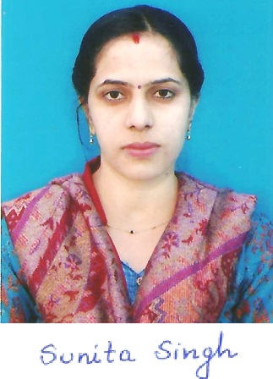

Presenter Name: Dr.Sunita Singh
Type of Presentation: E-poster
Contact Number: +91-522-2421825

