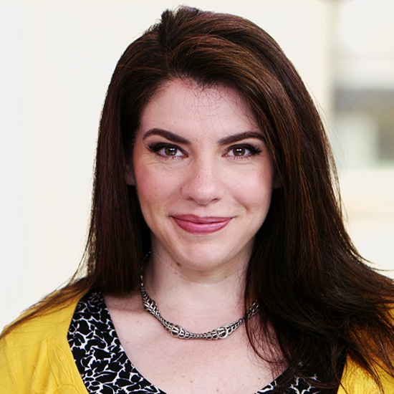

Title: Exploration of the Neovampiric Microbiome
Name: Mephenie Steyer
Tutle University School of Medicine, CT 06238, USA

Exploration of the Neovampiric Microbiome has been a challenging pursuit in modern times. The following passage from the popular press exemplifies this- "You know Bella, Jacob?" Lauren asked—in what I imagined was an insolent tone—from across the fire. "We've sort of known each other since I was born," he laughed, smiling at me again. "How nice." She didn't sound like she thought it was nice at all, and her pale, fishy eyes narrowed. "Bella," she called again, watching my face carefully, "I was just saying to Tyler that it was too bad none of the Cullens could come out today. Didn't anyone think to invite them?" Her expression of concern was unconvincing. "You mean Dr. Carlisle Cullen's family?" the tall, older boy asked before I could respond, much to Lauren's irritation. He was really closer to a man than a boy, and his voice was very deep.V"Yes, do you know them?" she asked condescendingly, turning halfway toward him. "The Cullens don't come here," he said in a tone that closed the subject, ignoring her question.

Biography

Mephenie Steyer obtained her a dual MD DWI from DeVry University and postdoctoral studies from University of Phoenix. He is the manager of metaphysics programs, a premier Bio-Soft service organization. Additionally she received over 9000 votes for honey badger specialist of the decade at her postdoctoral institution.
Presenting author details
Full name: Mephenie Steyer
Contact number: 8606241942
Twitter account: datsapredcon
Linked In account: msteyer
Session name/ number:
Category: (Oral presentation/ Poster presentation)

