 | 

STUDY OF INFLUENCE OF THE ELECTROHYDRAULIC EFFECT ON HIGH-VISCOSITY OIL
N.B.Mansurov¹, D.U. Bodykov²

¹Kazakh-British Technical University, 050000 Tole bi str. 59, Almaty, Kazakhstan
² The Institute of Combustion Problems, 050012 Bogenbay str. 172, Almaty, Kazakhstan

Introduction
The electrohydraulic effect is based on the method of processing and utilization of oil sludge, high-viscosity and highcooling petroleum in order to find ways to increase the yield of light and medium oil fractions by means of deeper processing of heavy fractions using high-voltage electroimpulse discharges in an aqueous medium without the use of organic solvents1- 3. The fractional composition of the oil of the Zhangurshi deposit was studied using NMR 1H, 13C methods. The fragmental compositions of the studied raw materials were presented by the method of calculating the integrated intensities of the 1Н, 13С NMR signals of the oil of the Zhangurshi deposit.

Results
After cleaning the oil sludge from the mechanical impurity, a sample was taken to determine the substances containing in the oil sludge. Samples were also taken after the electrohydraulic action. 92 samples were identified in the sample without treatment, and 119 substances in the sample after electrohydraulic treatment. After electrohydraulic treatment, the content of cyclic hydrocarbons is higher.
The composition of the liquid fractions were paraffins, isoparaffins, aromatic hydrocarbons, naphthenes and ether compounds. According to the data of the light fractions analysis spectra treated with electrohydraulic impacts were very different from the analyzes of the obtained light fractions treated without electrohydraulic impacts, both in quantity and composition.

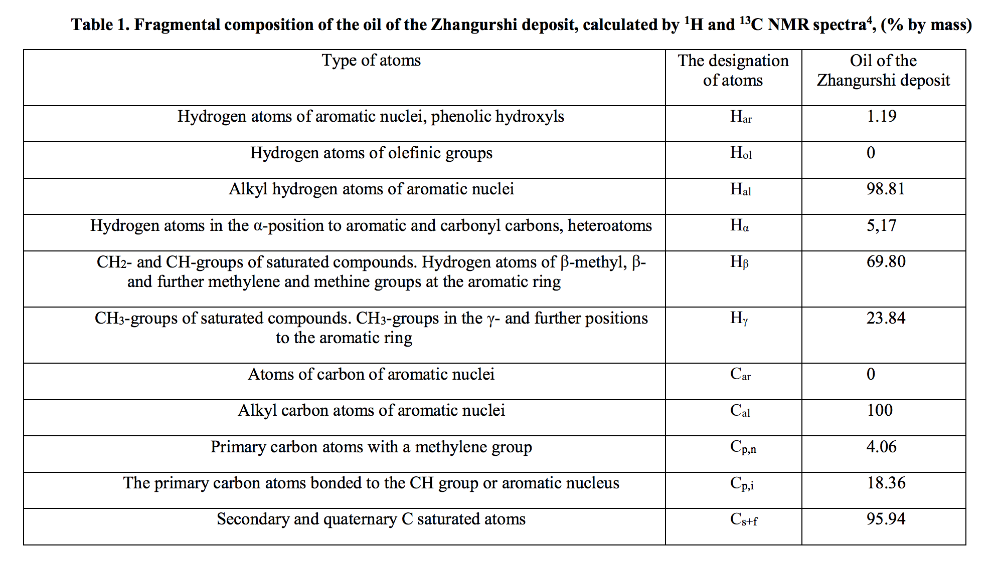

The obtained results show that in the composition of the oil practically no protons of olefinic nature. Also, the content of aromatic carbon atoms was absent in the tested oil sample. Proton spectra confirm the obtained results – the content of aromatic protons is 1.19%. The low content of Hα protons also indicates a low content of aromatic and carbonyl carbons, as well as heteroatoms in the sample.

Conclusions
Thus, the possibility of processing high-viscosity oils with the use of electro-hydraulic effect was shown.

Recent publications

1. Bodykov DU, Abdikarimov MS, Mansurov Z.A. "Processing of oil sludge using the electro-hydraulic effect of Yutkin" / / Journal "Combustion and Plasmochemistry" 2015, volume 13, №4, p.303-311.
2. Patent number 9400. 2016g Bodykov DU, Abdikarimov MS, Mirtalipov RT, Aliev ET, Salakhov R.Kh., Mansurov Z.A. "Method of processing oil sludge."
3. Duisen.U. Bodykov, Meiram. S. Abdikarimov, Zulkhair A. Mansurov, Meruyert Nazhipkyzy. Sludge processing using electrohydraulic effect // Carbon, USA 2016.
4. Bodykov DU, Abdikarimov MS, Nazhypkyzy M., Mansurov ZA Processing of oil sludge using the electrohydraulic effect of Yutkin // Abstracts. IX - International Symposium "Combustion and Plasma Chemistry". - Almaty, 2016, part 4, p.25-28.
5. Abdikarimov MS, Elemesova Zh.K., Mirtalipov RT, Bodykov DU, Salakhov R.Kh., Aliev ET, Mansurov ZA Electrohydraulic unit for processing complex molecules // Theses of the dossier of the VIII International Symposium "Combustion and Plasma Chemistry". - Almaty, 2015. - 235-238s.
6. BT Lesbaev, ZA Mansurov, Zh.A. Kulekeev, GK Nurtayeva, DU Bodykov, MS Abdikarimov, M. Atamanov, S. Tursynbek, G.T. Smagulov. Features of combustion of hydrogen sulphide-containing oil on the surface of water. / / Journal of Combustion and Plasma Chemistry 2015, Volume 13, №4, p.284-293.
7. DU.Bodykov., MSAbdikarimov, MASeytzhanova, Zh.K.Elemesova. Processing of oil sludge using electrohydraulic effect. Combustion and plasmochemistry. Almaty. 2017. №1. Volume 15.
8. D.U. Bodykov, M.S. Abdikarimov, M.A. Seitzhanova, M. Nazhipkyzy, Z.A. Mansurov, Kabdoldina A.O., Ualiyev Zh.R. Processing of oil sludge with the use of the electrohydraulic effect // Journal of Engineering Physics and Thermophysics, 2017, No. 5, V. 90.
9. Bodykov DU, Abdikarimov MS, Salakhov R.KH., Nazhypkyzy M., Mansurov Z.A. Processing of oil sludge by electrohydraulic method. // Thesis dokl. IX - International Symposium "Combustion and Plasma Chemistry" - Almaty, -2017. Part 6, - 6-9s.

Biography

Nurkadyr Mansurov is Bachelor student of Kazakh-British Technical University, Faculty of Oil and Gas Industry. He has completed Republic specialized physical and mathematical school in Almaty. He is the silver winner of the International Competition of Scientific Projects on Physics, Baykonyr, Kazakhstan, 2015. He has published 4 papers in Proceedings of International Scientific Conferences. He is interested in Petroleum Geology, Safety of environment in Oil and Gas Industry.
E-mail: mansurov.nurkadyr@mail.ru

