

Managing Isolated Posterior Cruciate Ligament Avulsion Fracture
With Limited Resource, A Case Report

Name: Noorhuda A.M.
Affiliation: Orthopaedic Department, Melaka General Hospital, Malaysia

Co authors:
Dineshkumar C.,Ismyth A.R, Norzatulsyima N.
Orthopaedic Department, Miri General Hospital, Malaysia

Abstract:

INTRODUCTION
Isolated PCL avulsion fracture is an uncommon injury in children. We report a case that was only 7 years old and was managed based on clinical judgement associated with subtle Xray findings.

CASE REPORT:
A 7-year-old boy from rural area was a pillion rider when his father’s motorbike was hit by a van from behind. He sustained pain over the left knee. There was bruising over the left shin, with diffuse tenderness and swelling over left knee. Xray showed a sliver of bone over the posterior knee.

Patient was put up for examination under GA KIV screw fixation. Assessment under general anesthesia, there was posterior sagging and posterior drawer test was positive.

Fixation done with cannulated cancellous screw 4.0mm (image intensifier guidance). The knee was immobilized at 20 degrees with a cylinder slab then changed to cylinder cast once swelling reduced.

Cast was kept for 6 weeks followed by range of motion physiotherapy and progressive weight bearing. Full weight bearing, and range of motion achieved by 3 months post trauma without laxity or instability.

DISCUSSION
PCL avulsion is often missed in paediatric patients due to subtle or lack of Xray finding. In this case, mechanism of injury (knee in flexion falling forward with significant impact from behind) and the physical examination is typical of PCL injury lead to accurate decision for surgical intervention without waiting for the limited MRI availability. Furthermore, the placement of screw should be considered to avoid any damage to the plate.

CONCLUSION
It is possible to diagnose PCL avulsion fracture from careful clinical and radiographical evaluation. Attending physician/surgeon must have high index of suspicion to identify this injury especially in young children.

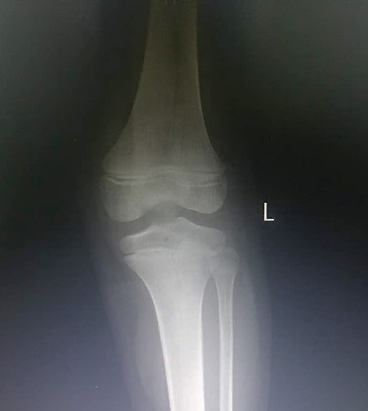
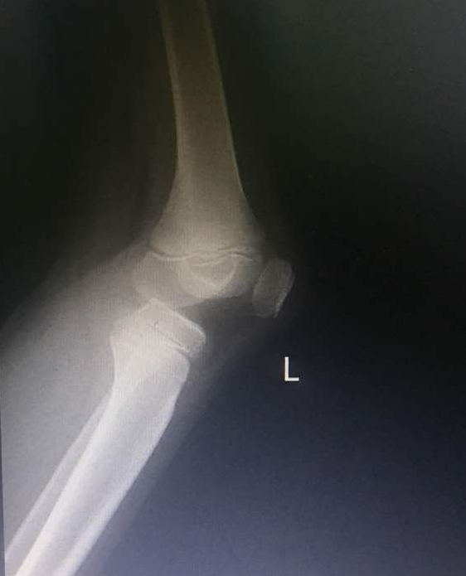
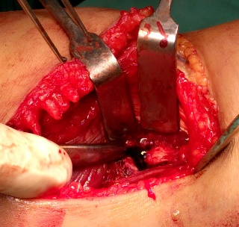
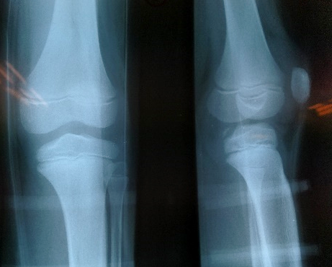
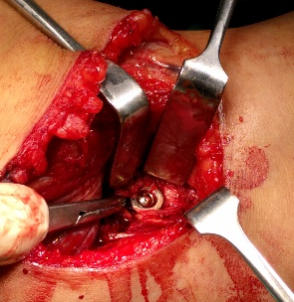
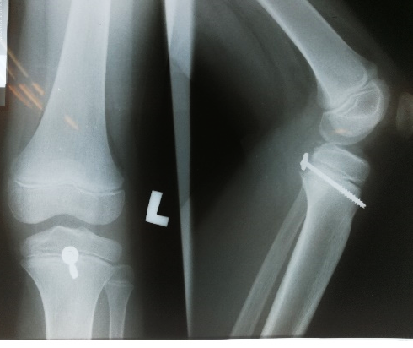
Presenting author details
Full name: Noorhuda Abdul Mutalif
Contact number: 60192378213
Category: Poster presentation
Figure 2 & 3: Arrow show PCL avulsion fracture large enough for 4.0 mm cannulated cancellous screw osteosynthesis. I/I was used to avoid growth plate
Figure 4: Check Xray post op
Figure 5: Post removal of screw (post trauma 6 month) – growth plate intact
Figure 5
Figure 4
Figure 3
Figure 2
Figure 1
Figure 1: Arrow show small sliver of bone over posterior knee

