Morphological Features of Changes of Various Types of Grafts in Patients Who Died after Coronary Artery Bypass Graft Surgery from Isolated
Coronary Heart Disease and Associated with Hypertensive Disease

A. Prof Ruzanna Petrosyan
PhD, DM, MD, MSc.
BAU, Faculty of Medicine
Department of Basic Medical Sciences
Phone - ext: 009611300110-2641.
Email: r.petrosian@bau.edu.lb
rupetrossian@yahoo.com

Key Words
Coronary artery bypass graft. Hypertensive disease. Vascular grafts. Morphology. Coronary heart disease.

Abstract

Objectives: Vascular graft failure is one of the most common finding in patients undergoing coronary artery bypass graft (CABG) surgery and still remains the major problem after surgery. The aim of the present study was to investigate features of pathomorphological changes in different type of grafts after CABG in patients with isolated coronary artery disease and associated with hypertensive disease.
Material and Methods: Histopathological study was performed on 207 fragments of autopsy sections of autoarterial and autovenous grafts using light microscopy.
Results: It is shown that the condition of the vascular wall is depend on hemodynamics leading to degenerative changes of the graft as a result of destructive and proliferative processes in the intima and the middle layer. Active replacement of smooth muscle cells of the media by fibrous tissue and then connective tissues leads to thickness of the vascular wall, stenosis on one hand and on the other hand development of unstable atheromatous plaques.
Conclusions: Morphological changes of the venous grafts in patients how undergone CABG and had died after surgery from coronary heart disease associated with hypertonic disease were more acute with more aggressive course of atherosclerotic changes with diffuse proliferation of processes and formation of unstable plaques.

Introduction

Cardiovascular diseases as a result of an atherosclerotic damage of heart's arteries are the most urgent health problem in many countries. They are leading global cause of death, accounting for 17.3 million deaths per year, a number that is expected to grow to more than 23.6million by 2030. More than one-third of these deaths occur in middle-aged adults. 80 percent of those deaths occurred in the low- and middle-income countries. [1, 2, 3, 4, 5].
Aorto-coronary bypass graft surgery (ACBG) is one of the surgical treatments of patients with ischemic heart disease (IHD). The widespread use of coronary artery bypass surgery is the result of its high effectiveness in relieving the symptoms of angina and increasing lifetime.
Coronary artery bypass surgery is a quite traumatic procedure and requires mobilization of all compensatory capacity of the organism after the operation. However, to date the problem of complications arising after CABG surgery is quite common. In the United States for treatment of complications after CABG surgery spent annually about one billion dollars [6, 7, and 8].
The most serious complication arising after CABG surgery is the peri and postoperative myocardial infarction. About 34% of mortality from ischemic heart disease were thromboses and occlusion of coronary bypass grafts and stents.
Another very important point is the mortality frequency after CABG surgery. [9, 10, 11,12,13,14, 15].
Accordingly this retrospective autopsy study aimed to evaluate histopathological changes of various type of grafts after ACBG surgery in patients how dead from isolated coronary artery disease or associated with hypertonic disease.

Material and methods
The autopsy material of sixty nine sections of myocardium of the left ventricle and fragments of coronary artery bypass grafts (saphenous vein, radial artery and mammary artery), were obtained from patients who had undergone CABG surgery and had died at different period after surgical revascularisation for pathohistological inspection using a light microscope.
The cause of death was determined from correlation of the clinical history with autopsy findings and the following clinical features were recorded: patient age and sex- 56 men (80% of cases) and 13 women (20% of cases) with a mean age of 50± 3.2 year (min.: 40; max.:80y). Postoperative survival was up to 1 year.
In order to reveal the features of morphological changes in various types of shunts in patients with isolated coronary artery disease and combined with hypertonic disease all cases were divided into the following two groups: group 1, cases with isolated coronary artery disease (11cases of which 9 men and 2 woman) and group 2, cases with coronary heart disease (CHD) combined with the hypertonic disease (58 cases of which 48 men and 10 woman). Dominated age in the first group was 60 to 70 or older - 8 cases (72.72%) in the second group-dominated age was 40 to 60 years - 30 cases (51.72%).
Total number of investigated fragments of autovenous transplants of the great saphenous vein was 178 and 29 autoarterial grafts of which 28 cases were used internal thoracic artery in an anterior descendence position and radial artery 1 case which was used in a diagonal position.
The cardiac ventricles were examined by horizontal sectioning at I-cm intervals from the apex to near the base of the heart, parallel to the posterior atrioventricular groove, and examined grossly and histologically for the presence or absence of acute and/or healed myocardial infarction.
In the first group branches of the oblique artery(OM) - 11 cases, left anterior descending artery ( LAD) – 7cases, left posterior descending artery (PDA) – 5cases, the diagonal artery – 1case, right coronary artery (RCA) - 1 case were used for CABG surgery .
In the second group - LAD - 46 cases, OM - 36 cases, diagonal – 27cases, PDA – 25cases, RCA – 11cases were used for CABG surgery.
Samples were fixed in buffered formalin (formaldehyde, 10% wt/vol, and acetate buffer, 0.05mol/L) for 48 hours at room temperature, followed by dehydration, embedding in paraffin, and cutting into 4μm serial sections. Sections were stained with hematoxylin and eosin, Heidenhain’s Azan modification of mallory’s triple stain, van Gieson, some of the sections were also stained with Haematoxylin basic fuchsin picric acid methods. All histopathological analyses were performed with an Olympus microscope.
RESULTS
During the study period 207 fragments from 69 autopsy where evaluated. Causes of death in the first group were as follows: out of 11, six cases - acute heart failure, one case acute cerebral insufficiency (stroke), one case -thrombosis of mesenteric vessels, sepsis-tow cases, pulmonary arterial thrombo-embolism – one case. In the second group out of 58 deaths: acute heart failure- 45 cases, sepsis -8 cases, 2 cases -stroke, thrombosis of mesenteric vessels – 2 cases, gastro - intestinal bleeding – 1case.
Mortality due to insufficiency of the shunts after CABG surgery was 6 cases in the first group (54.5%) and 48 cases (84.5%) in the second group.
Patency of functioning grafts in the first group was as follows: in 2 cases from 4 - 6 weeks, in 4 cases from 6 month to 1 year.
In the second group patency of the functioning grafts was in 35 cases from 2 weeks up to 6weeks and in 20 cases from 6 months up to 1 year, and in 3 cases from one year and more.
In relation to the age in the first group patient’s age ranged mainly from 60 to 70 years and more, in the second group number of patients in middle age (from 40 to 60 years) was more.
Histological findings on the comparative evaluation of the effectiveness of venous and arterial grafts has been revealed that arterial grafts were not damaged. Only in the second group in two cases swelling and small areas of endothelial lesion was seen.
The morphological lesions in the wall of venous grafts were clearly more severe than those in the wall of arterial grafts in both groups. Lesions were seen in the grafts to the branches of blind edges of diagonal coronary artery.
In the second group except changes that given above, changes in the grafts to the posterior descending and right coronary arteries are detected as well.
In the first group out of 33 vein grafts 21 had maintained patency, in the remaining 12 fragments were found significant hemodynamic changes leading to deterioration of patency of shunt.
The main histological lesions of the venous grafts in 4 fragments (patency of grafts 2 - 4 weeks) were as follows: endothelial desquamation, presence of the fibrin on the inner surface of the endothelium, unorganized atheromatous lesions, and homogeneous inner layer. A significant degeneration of the smooth muscle cells was observed and in 3 fragments of vein grafts replacement those by connective tissue with the presence of fresh fibrin thrombi were found. In some fragments fibrinous hyperplasia with luminal narrowing leading to ischemic myocardial injury were found.
In the 8 fragments atheromatous changes with significant proliferation of smooth muscle cells, proliferation of connective tissue, vascular sclerosis, with significant narrowing of the lumen were observed, 4 fragments demonstrated rupture and detachment of a region of the plaque leading to myocardial infarction.

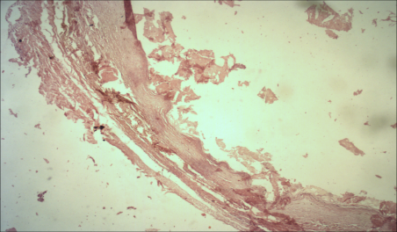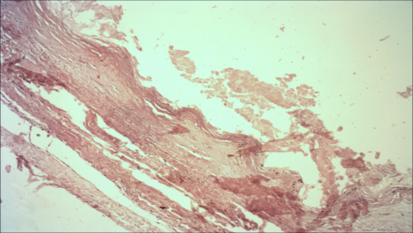
b
a

Figure 1(a, b) Photographs from light microscopy showing autovenous graft. Extensive areas of endothelial desquamation.
Graft patency 2 weeks. (H & E stain) x100

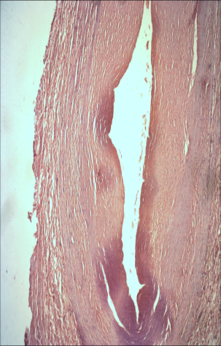
Figure 2 Photographs from light microscopy showing fibrointimal hyperplasia caused a significant degree of luminal stenosis
Graft patency 4 weeks. (H & E stain) x100

In the second group 34 investigated grafts (bypass graft fragments n=174) had maintained patency, whereas more or less hemodinamicly damaged grafts were 99.
5 cases demonstrated acute thrombosis of the shunt (life duration of the shunt was up to 2 weeks), in 30 shunts (live duration of the shunt was up to one month) degenerative changes of the conduit with the development of connective tissue, almost complete replacement of muscle tissue with scar tissue, areas of hyalinization, wall thickening (wall was composed almost entirely of connective tissue) were observed. In other cases there were atherosclerotic changes with the detachment of the plaque with a thin fibrous sheath (unstable plaque), severe calcification located superficially (close to the lumen of the conduit) and an inflammatory reaction of the shunt’s wall were also frequent.

a. 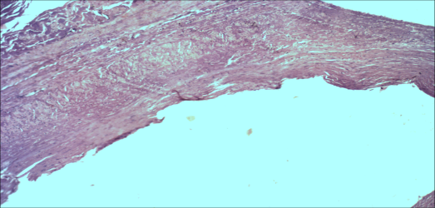 b. 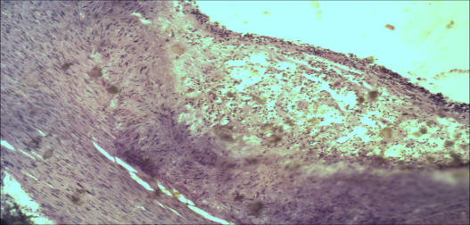
c. 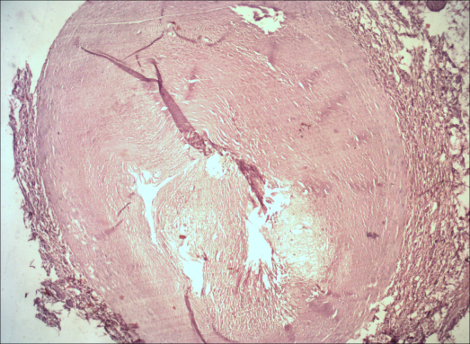 d. 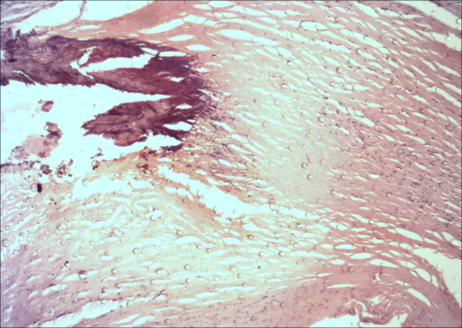

Figure 3(a, b, c, d) Photographs from light microscopy showing various stages of atherosclerosis in saphenous vein grafts. Early atherosclerotic plaque with fibrointimal hyperplasia (a); detachment of a region of the plaque (b). Severe atherosclerosis leading to luminal occlusion (c). Calcification within the atherosclerotic lesion (d). Hematoxylin and eosin stain. х 100 and х 250.

- 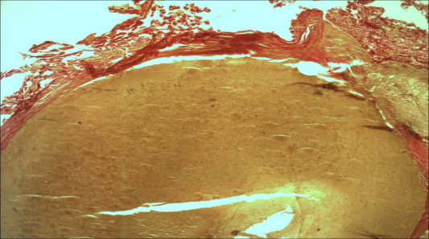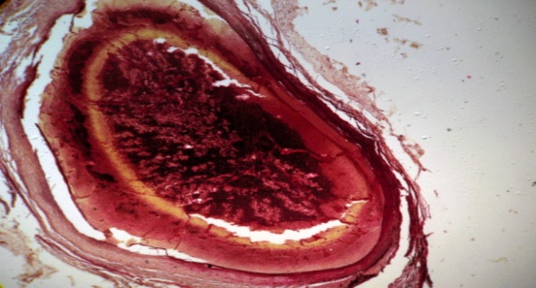 b.

Figure4 (a, b) Photographs from light microscopy, showing thrombosis of the venous grafts. Van Gieson stain x100
DISCUSSION
The results of this study using light microscopy showed that acute heart failure was dominant cause of death in the both first (54.5%) and second (77.5%) groups and this accords with previous studies (16). Herlitz J. et al mentioned that the factors most commonly contributing to death in the long term after CABG were, in order of frequency, heart failure, myocardial infarction, cancer, stroke and infection.
The hypertonic patients who had undergone CABG surgery had a significantly higher mortality rate due to insufficiency of the shunts (second group 84.5%) than patients with isolated coronary artery disease (first group 54.5%).
Patency of functioning grafts up to 1 year was more in the second group where number of patients with the middle age was dominated (51.72%).
Only 3.4 % of arterial grafts were damaged in the second group showing swelling and small areas of endothelial lesion of the wall. The findings concerning arterial grafts of the present study are also confirmed by other experimental studies reported in the international literature (17).
Venouse grafts have maintained patency more in the first group 64% then in the second group 19.5%.
In the first group mortality after CABG was dominated by reasons not related to the pathology of the shunt - 54.54 %, most of the grafts remained patent (63.6%).
Morphological changes in the different type of grafts mostly had chronic character, which are also agreed with an earlier reports (17, 18).
The main histological lesions of venous grafts in both groups where endothelial desquamation, presence of the fibrin on the inner surface of the endothelium, organized atheromatous lesions. A significant degeneration of the smooth muscle cells and replacement those by connective tissue were observed with the presence of fresh fibrin thrombi. In some fragments fibrinous hyperplasia with luminal narrowing were the predominant leading to ischemic myocardial injury.
Morphological changes of the venouse grafts in the first group had mostly chronic caracteristics wheres in the second group morphological changes were clearly more acute with more aggressive course of atherosclerotic changes with diffuse proliferation of processes and the formation of unstable plaques and mortality after coronary artery bypass surgery was mainly due to dysfunction of the shunts (56.8 %).
A clearer understanding of pathohistological changes of various types of coronary artery bypass grafts will prepare the ground for the introduction of new interventions to improve the outcomes of CABG.

References
1.Mozaffarian D, Benjamin EJ, Go AS et all, Heart disease and stroke statistics— 2015 update: a report from the American Heart Association [published online ahead of print December 17, 2014]. Circulation. doi: 10.1161/CIR.0000000000000152.
2. Xu J.Q., Kochanek K.D., Murphy S.L., Tejada-Vera B. vol. 58 no. 19. National Center for Health Statistics; Hyattsville, MD: 2010. Deaths: final data for 2007. (National vital statistics reports).
3. Scarborough P., Wickramasinghe K., Bhatnagar P., et all, British Heart Foundation; London: 2011. Trends in coronary heart disease 1961–2011.
4. Rosamond W., Flegal K., Furie K. Heart disease and stroke statistics—2008 update: a report from the American Heart Association Statistics Committee and Stroke Statistics Subcommittee. Circulation. 2008;117(4):e25–e146. [PubMed]
5. Pilote L, Dasgupta K, Guru V, et al; A comprehensive view of sex-specific issues related to cardiovascular disease. CMAJ. 2007 Mar 13;176(6):S1-44.
6.Gallagher R, McKinley S. Stressors and Anxiety in Patients Undergoing Coronary Artery Bypass Surgery. Am J Crit Care. 2007;16:248–57. [PubMed]
7.Apostolakis T. et al. Which are the exact guidelines for more rationale
intervention concerning beta-blockers administration in coronary patients preoperatively? // Eur J Cardiothorac Surg. 2009. - Vol. 35. - P. 746-747. ]
8. Nwasokwa ON: Coronary artery bypass graft disease. Ann Intern Med 1995;123:528–545.
9. Hassantash SA, Bikdeli B, Kalantarian S, et all: Pathophysiology of aortocoronary saphenous vein bypass graft disease. Asian Cardiovasc Thorac Ann 2008;16:331–336.
10. Motwani JG, Topol EJ: Aortocoronary saphenous vein graft disease: pathogenesis, predisposition and prevention. Circulation 1998;97:916–931.
11. Lie JT, Lawrie GM, Morris GC Jr: Aortocoronary bypass saphenous vein graft atherosclerosis. Anatomic study of 99 vein grafts from normal and hyperlipoproteinemic patients up to 75 months postoperatively. Am J Cardiol 1977;40:906–914.
12. Ip JH, Fuster V, Badimon FL, et all: Syndromes of accelerated atherosclerosis: role of vascular injury and smooth muscle cell proliferation. J Am Coll Cardiol 1990; 15: 1667-1687.
13. Davies MG, Hagen P-O: Pathobiology of intimal hyperplasia. Br J Sur 1994; 81: 1 254-1269.
14. Montwai JG, Topol E: Aortocoronary saphenous vein graft disease: Pathogenesis, predisposition and prevention. Circulation 1998; 97: 916-931.
15.European Coronary Surgery Study Group: Long tern results of prospective randomized study of coronary artery by-pass surgery in stable angina pectoris. Lancet 1982; 2: 1173-1179.
16. Herlitz J¹, Brandrup-Wognsen G, Caidahl K et all, Cause of death during 13 years after coronary artery bypass grafting with emphasis on cardiac death. Scand Cardiovasc J. 2004 Oct;38(5):283-6.
17. Kanellaki-Kyparissi M¹, Kouzi-Koliakou K, Marinov G et all. Histological study of arterial and venous grafts before their use in aortocoronary bypass surgery. Hellenic J Cardiol. 2005 Jan-Feb;46(1):21-30. PMID:15807391 [PubMed - indexed for MEDLINE]
18. Bikdeli B. Hassantash S. Pourabdollah M, et all. Histopathologic Insight into Saphenous Vein Bypass Graft Disease, Cardiology 2012; 123:208–215 Vol. 123, No. 4, 2012

