Pd/DNA as highly active and recyclable catalyst of Suzuki-Miyaura coupling and aminocarbonylation

M. Martª, W. Tylus^{b}, A.M. Trzeciakª

ª University of Wrocław, Faculty of Chemistry, Poland
^{b} Wroclaw University of Technology, Institute of Inorganic Technology, Poland

Palladium-catalyzed coupling reactions offer efficient and simple procedures leading to important aryl compounds, such as acids, amides, ketones, or biaryls [1-3]. Benzoic acids, amides, and ketones are common structural motifs found in many natural products, pharmaceuticals, and agrochemicals [4]. Although palladium is a metal of choice in the Suzuki–Miyaura and carbonylative coupling reactions due to its very high efficiency, searching for new palladium catalysts is still a challenge. Not only complexes but also palladium nanoparticles (Pd NPs) should be taken into account [5-6].

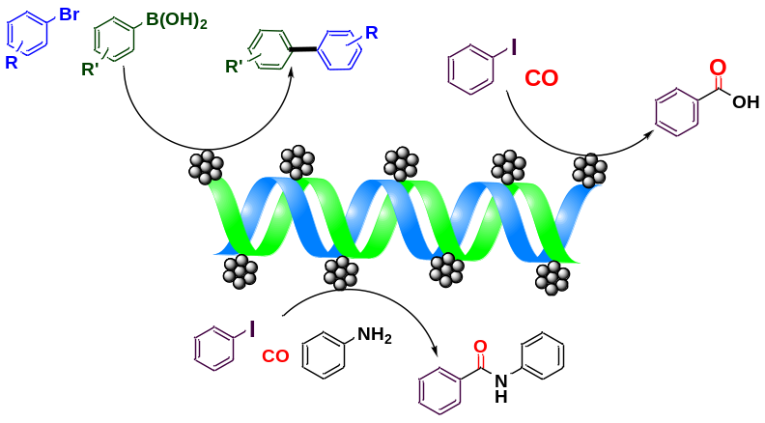
Fig. 1 Pd/DNA catalyzed Suzuki-Miyaura coupling and carbonylations reactions
In our studies, Pd/DNA catalysts were prepared in a mixed H₂O/EtOH solvent using palladium precursors, Pd(OAc)₂ and PdCl₂, in different dosages and salmon fish sperm DNA. As prepared, the Pd/DNA contained palladium nanoparticles of various sizes and morphologies, active in the Suzuki–Miyaura cross-coupling of various aryl bromides with phenylboronic acids. The catalyst was recovered by simple phase separation and then reused in seven consecutive cycles with a high activity. For the first time, Pd/DNA was applied with very good results in the carbonylative coupling of iodobenzene, leading to amides, benzoic acid, or benzophenone, depending on the kind of nucleophile used. The aminocarbonylation of iodobenzene with n-hexylamine was performed with excellent selectivity using Mo(CO)₆ as a CO source, while a mixture of products was formed with gaseous CO. The recovered Pd/DNA catalyst was used in the next four runs with high activity.
[1] A. Molnar, Palladium-Catalyzed Coupling Reactions. Practical Aspects and Future Development. Wiley-VCH, Weinheim, Germany, (2013).
[2] I.P. Beletskaya, V.P. Ananikov, Chem. Rev., (2011), 1596-1636.
[3] J. Tsuji, Palladium Reagents and Catalysts. New Perspectives for the 21 st. Century. Wiley, (2004).
[4] J.B. Peng, X. Qi, X.F. Wu, Synlett (2016), A-T.
[5] D. Astruc, Inorg. Chem. (2007), 1884-1894.
[6] D.B. Eremin, V.P. Ananikov, Coord. Chem. Rev. (2017), 2-19.

