Perstraction Study of Dyes through a Polymeric Membrane
Nosheen Iftikhar, Rupesh Bhavsar, Peter M. Budd,
School of Chemistry, University of Manchester, UK

Abstract
Perstraction is a membrane-based solvent extraction process used for the separation of a non-vaporizing solute from its solution. The solute is allowed to adsorb on one side of the membrane and is then desorbed by a stripping liquid on the other side of membrane (Figure 1). The perstraction process is advantageous as a continuous process, in comparison with a batch process of adsorption and desorption in two separate steps. The present study focused on the separation of a mixture of dyes (Oil Red O and Remazole brilliant blue R) from their ethanolic and aqueous ethanolic solutions. A polymer of intrinsic microporosity (PIM-1) was chosen as the polymeric membrane material because it not only has a higher BET surface area of 780 m² g⁻¹ and interconnected free volume of 11 %, but also has a higher affinity for neutral solutes. It was crosslinked with polyethyleneimine (PEI) to enhance its stability towards the organic solvents. PIM-1 alone is selective for the neutral solute, but after crosslinking anionic dye (Remazol) also got adsorbed on the polymeric membrane. Dye fractionation was still maintained in the present case as Remazol was not desorbed by toluene as a stripping liquid. Toluene strips away only the Oil Red O and not the Remazol. The amount of dye in both feed and stripping solution was measured by a UV/Visible spectrophotometer.
It was seen that the nature of the solvent played an important role in the adsorption of dye onto the membrane surface. Adsorption of dye was enhanced and equilibrium was attained in much quicker time when the solvent nature was changed from ethanolic to aqueous ethanolic (70 wt. % ethanol + 30 wt. % H2O). The perstraction process was also compared with an adsorption/desorption process carried out in two separate steps and it was seen that the decrease in dye concentration in the feed solution for the perstraction process was greater as compared to the batch process of adsorption.

Image

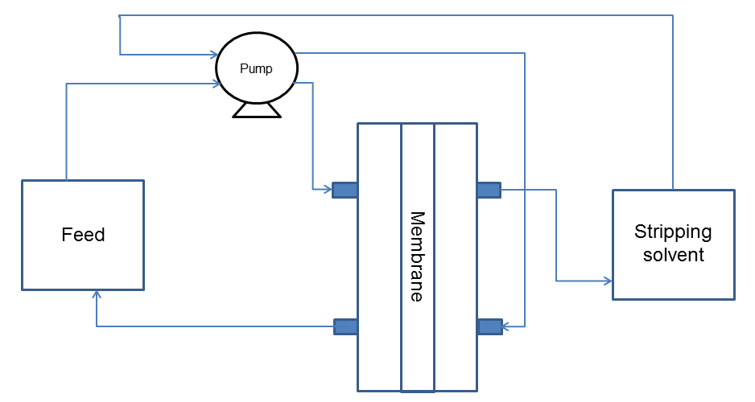

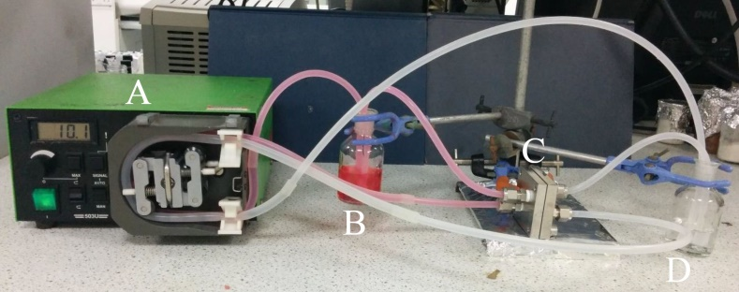

Figure 1.Schematic diagram (top) and photograph (bottom) of perstraction equipment. In the photograph, A is a peristaltic pump, B is the feed solution, C is the perstraction cell with polymeric membrane mounted inside and D is the stripping solvent.

Biography
Nosheen Iftikhar is currently doing a Ph. D. at the University of Manchester, School of Chemistry, and also work as a teaching assistant in the same institute. Her main project is based on separation of dyes through polymeric membranes.
Nosheen Iftikhar
Tel: 07443585448
Session Name/Number
Category: (Oral presentation/Poster presentation)
Email: nosheen.iftikhar@manchester.ac.uk

