Catalytic oxidation of chlorobenzene over noble metals: Further insights into reaction mechanism via in-situ FTIR and DFT studies
Xiaolong Liu, Institute of Process Engineering, Chinese Academy of Sciences, China

Abstract (300 word limit)
Volatile organic compounds (VOCs) emitted from the industrial plants are toxic and are dangerous to human health. Among the abundant VOCs pollutants, chlorinated volatile organic compounds (OVOCs), including chlorobenzene (CB), dichloromethane (DCM), 1,2-dichloroethane (DCE), and thrichloroethylene (TCE), are regarded as an important group of VOC pollutants due to its high toxicity, strong stability, and poor reactivity.
In comparison to other noble metals (Pd, Pt, Rh), Ru catalysts have been far less explored in environmental catalysis. Recently, Ru catalysts have been well demonstrated in catalytic oxidation of alkanes, alkenes, aromatics, and some halogenated volatile organic compounds.¹⁻⁵ In this work, noble metal catalysts (Pd, Pt, Ru, and Rh) were prepared and evaluated in the catalytic oxidation chlorobenzene, and Ru/TiO₂ contributed the best catalytic performance (Fig. 1). During the oxidation, polychlorinated benzenes PhCl_{x} (x ≥ 2) were observed, and Ru/TiO₂ showed apparently lower PhCl_{x} concentrations than other three samples. Besides, the dioxin-like PCBs (dl-PCBs) were collected and analyzed for Pd/TiO₂ and Ru/TiO₂. The ∑dl-PCBs produced by Pd/TiO₂ was about 1.5 times that of Ru/TiO₂. XPS analyses revealed that Ru/TiO₂-used gave the lowest Cl content among the used catalysts, and the lowest (Cl_{ad}+Cl_{or})/Cl value and the highest Cl_{br}/Cl value, which might be an important reason for its strongest chlorine removal ability and the lowest yields of polychlorinated by-products. In-situ FTIR studies were also conducted for Pd, Pt, Ru, and Rh catalysts, and various organic intermediates were observed on the catalyst surface. Besides, density functional theory (DFT) was also conducted to investigate the main reason for the difference of the catalytic performance of Ru and other three samples (Pd, Pt, and Rh). Accordingly, a reaction mechanism for the catalytic oxidation of chlorobenzene was proposed.

Image
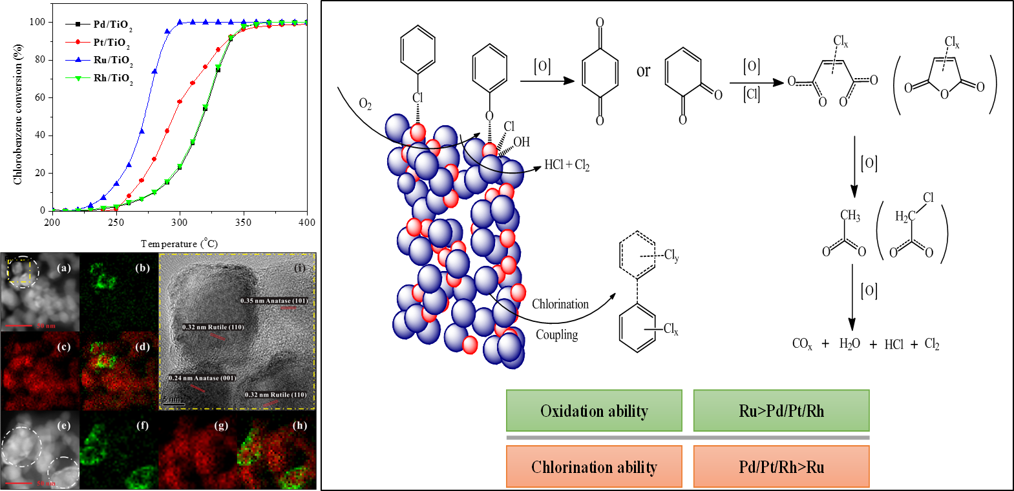

Fig. 1. Catalytic oxidation of chlorobenzene over noble metals
Recent Publications (minimum 5)
- Liu X, Zeng J, Shi W, Wang J, Zhu T, Chen Y (2017) Catalytic oxidation of benzene over ruthenium –cobalt bimetallic catalysts and study of its mechanism. Catal. Sci. Technol. 7:213-221.
- Shi W, Liu X, Zeng J, Wang J, Wei Y, Zhu T (2016) Gas‐solid catalytic reactions over ruthenium‐based catalysts. Chin. J. Catal. 37:1181-1192.
- Liu X, Chen L, Zhu T, Ning R (2019) Catalytic oxidation of chlorobenzene over noble metals (Pd, Pt, Ru, Rh) and the distributions of polychlorinated by-products. J. Hazard. Mater. 363:90-98.
- Wang J, Liu X, Zeng J, Zhu T (2016) Catalytic oxidation of trichloroethylene over TiO₂ supported ruthenium catalysts. Catal. Commun. 76:13-18.
- Ye M, Chen L, Liu X, Xu W, Zhu T, Chen G (2018) Catalytic Oxidation of Chlorobenzene over Ruthenium-Ceria Bimetallic Catalysts. Catalysts 8:116.

Biography (150 word limit)
Xiaolong Liu has completed his PhD from Zhejiang University. Now, he works in Institute of Process Engineering, Chinese Academy of Sciences as an assistant professor. He has published more than 15 papers in reputed journals. His research interests mainly focus on the catalytic oxidation of organic pollutants, such as VOCs (volatile organic compounds) & POPs (persistent organic pollutants).
Email: liuxl@ipe.ac.cn

Notes/Comments:

