Cyclic Peptides as Platforms for Supramolecular Constructions
Juan R. Granja, Prof. PhD, Centro Singular de Investigación en Química Biolóxica e Materiais Moleculares (CIQUS). Universidad de Santiago de Compostela. Santiago de Compostela, SPAIN

Abstract (300 word limit)
The ability to construct complex functional materials using small number of components represents an efficient synthetic strategy for the rapid generation of novel shapes and functions. At this respect peptides are powerful tools for the preparation of novel nanobiomaterials because of their unique folding and self-assembly properties. Cyclic components have restricted conformational freedom, that allow adopting kinetically stable structures that can be used in the supramolecular construction of a variety of structures and application. In the last few years our research group has been working with cyclic peptides that contains cyclic gamma-amino acids. These peptides allowed the construction of tubular structures of nanometric dimensions with tunable internal and external properties. Those peptides have been also used in the preparation of molecular capsules that entrap different components, such as metals or linear rigid molecules or as mimicking of ion channels. In this communications we will present our latest discoveries in topic.

Image
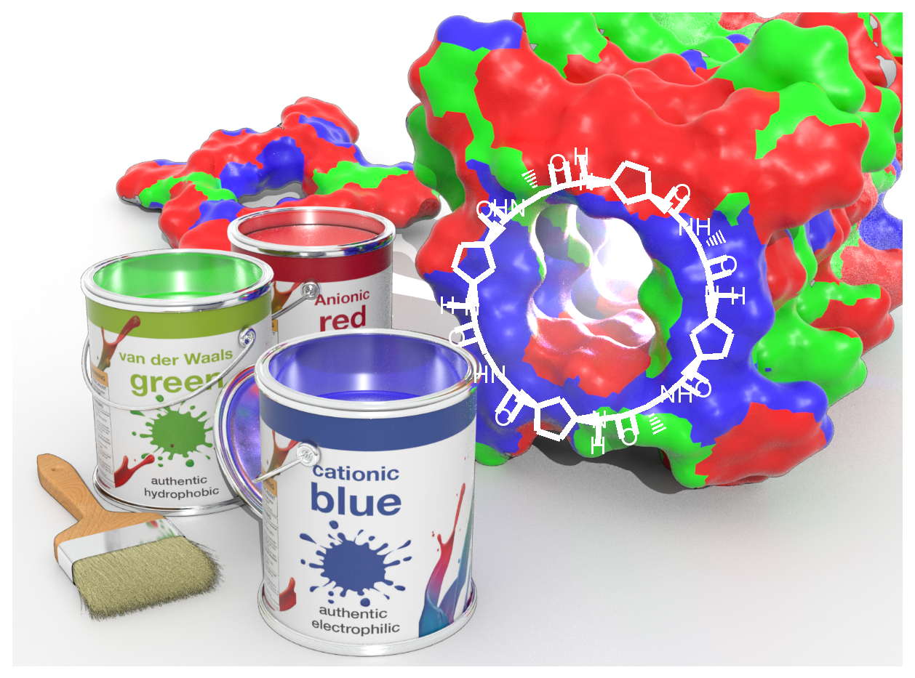
Recent Publications (minimum 5)
- Cuerva M, García-Fandiño R, Vázquez-Vázquez C, López-Quintela MA, Montenegro J, Granja JR (2015) Self-assembly of Ag₃ atomic quantum metal clusters on cyclic peptide nanotubes. ACS Nano. 9:10834-10843.
- Rodríguez-Váquez N, Amorín M, Alfonso I, Granja JR (2016) Anion recognition and induced self-assembly of an α,γ-cyclic peptide to form spherical clusters. Angew. Chem. Int. Ed. 55:4504-4508.
- Fuertes A, Ozores HL, Amorín M, Granja JR (2017) Self-assembling Venturi-like peptide nanotubes. Nanoscale 9:748-753.
- Ozores HL, Amorín M, Granja JR (2017) One step construction of taxane-like skeleton by diendiyne metathesis cyclization. J. Am. Chem. Soc. 139:776-784.
- Rodríguez-Vázquez N, Garcia-Fandiño R, Aldegunde MJ, Brea J, Loza M, Amorín M, Granja JR (2017) Cis-platinum complex encapsulated in self-assembling cyclic peptide dimers. Org. Lett. 19: 2560-2563.

 Biography (150 word limit)
Juan R. Granja received his PhD in chemistry from the University of Santiago de Compostela under the supervision of Professors Antonio Mouriño and Luis Castedo. After his postdoctoral work with Prof. Barry M. Trost at Stanford University, he returned to the University of Santiago as assistant professor. He was appointed as Associate Professor at the USC in 1996 and promoted to Full Professor in 2006. He is at the Center for Research in Biological Chemistry and Molecular Materials (CiQUS), where he leads a research group focused on the design and synthesis of tubular-shaped nanomaterials for biological applications. In 2014 he was awarded with the Ignacio Ribas medal by the Organic Chemistry Group of the Spanish Royal Society of Chemistry (RSEQ).
Email: juanr.granja@usc. es

Notes/Comments:

