Polysaccharide from Tamarindus indica as a promising green inhibitor for low carbon steel corrosion in 1 M HCl.

Prof. Mohammad Mobin, PhD, Corrosion Research Laboratory, Department of Applied Chemistry, Faculty of Engineering & Technology, A.M.U. Aligarh, India.

Marziya Rizvi, M Sc, Corrosion Research Laboratory, Department of Applied Chemistry, Faculty of Engineering & Technology, A.M.U. Aligarh, India.

Abstract

A natural polysaccharide was isolated from Tamarindus indica seeds, the tamarind seed polysaccharide (TSP). The performance of TSP as corrosion inhibitor for low carbon steel in 1 M HCl has been evaluated through various experimental methods. The initial screening by gravimetric analysis revealed the good inhibition efficiency by the inhibitor reaching a maximum of 90.10% at 60⁰C. Thermodynamic and kinetic parameters were instrumental in understanding the process of adsorption. The adsorption of TSP obeys Lagmuir adsorption isotherm exhibiting a comprehensive adsorption on low carbon steel surface. Electrochemical impedance measurements suggest the protection of low carbon steel surface by the adsorbed TSP film. Polarization studies inform us that the inhibition of low carbon steel by TSP is of mixed type. The improvement in surface morphology was assured by Scanning electron microscopy (SEM) and Atomic force microscopy (AFM). UV-Vis spectroscopy assured the formation of TSP-Fe²⁺ complex. The adsorbed TSP film on the low carbon steel surface is characterized using FTIR spectroscopy. To derive a better perception of the corrosion process at molecular level, the important factors relative to the adsorption behavior of the TSP are addressed using theoretical calculations. Application of TSP as a green polymer in corrosion inhibition is of utmost interest, as, not only it is biodegradable, nontoxic and biocompatible in nature, but, being a green polymer also aids in recycling of global carbon.

Image

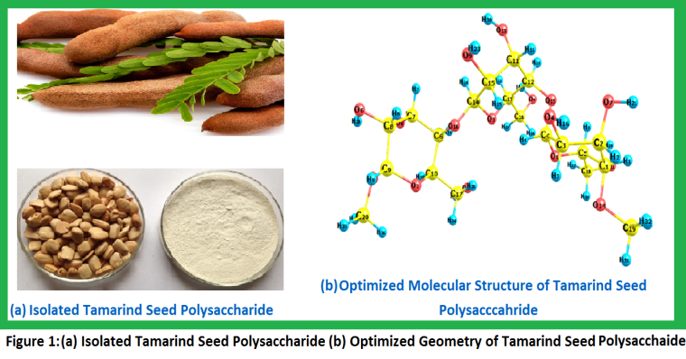

Recent Publications
- S. Banerjee, V. Srivastava, M.M. Singh (2014) Chemically modified natural polysaccharide as green corrosion inhibitor for mild steel in acidic medium. Corrosion Science 59:35–41.
- K. Khounvilay, W. Sittikijyothin (2012) Rheological behaviour of tamarind seed gum in aqueous solutions. Food Hydrocolloids 26:334–338.
- Mohammad M. Fares, A.K. Maayta, Jamil A. Al-Mustafa (2012) Corrosion inhibition of iota-carrageenan natural polymer on aluminum in presence of zwitterion mediator in HCl media. Corrosion Science 65: 223-230.
- C. Cote, O. Rosas, R. Basseguy (2015) Geobacter sulfurreducens: An iron reducing bacterium that can protect carbon steel against corrosion? Corrosion Science 94:104–113
- S. K. Saha, P. Banerjee (2015) A theoretical approach to understand the inhibition mechanism of steel corrosion with two aminobenzonitrile inhibitors. RSC Adv 5:71120.
- F. Neese (2012)An Ab ini tio, DFT and Semiempirical SCF-MO Package, Version 2.9, Max Planck Institute for Bioinorganic Chemistry, Mulheim an der Ruhr, Germany, Jan 2012.

 Dr. Mohammad Mobin
Currently working as a professor at the Department of Applied Chemistry, Aligarh Muslim University. Dr Mohammad Mobin is involved in the teaching and research in the field of materials and corrosion. He has 29 years of extremely active and productive career working at the Aligarh Muslim University and multinational Seawater Desalination Research Institute, Saline Water Conversion Corporation (SWCC), KSA. Dr. Mobin has completed 28 root cause failure investigations, 8 major and 3 minor research projects on materials and corrosion including two projects under international collaboration. Dr. Mobin has a Ph.D. on corrosion and authored 101 research papers. He has also attended 30 national/international conferences/workshops. Dr. Mobin was awarded the NIIS (NACE International India Section) corrosion awareness award in the year 2007.
Email: drmmobin@hotmail.com
Marziya Rizvi
Marziya Rizvi is a research scholar at the Department of Applied Chemistry, Aligarh Muslim University. Currently she is pursuing her Ph.D. on the topic “Studies on corrosion inhibition behavior of some natural polymers” guided by Prof. Mohammad Mobin. Some of her research works have been published in reputed journals.
Email: marziyarizvi@gmail.com

