Zeolites: Fundamental Features and Environmental Implications.
Christopher J. Rhodes, Fresh-lands Environmental Actions, UK.

Abstract (300 word limit)

A critical overview is presented of zeolites and their use in practical applications. Specifically considered are their role as media for selective light-induced oxidations of organic molecules using molecular O₂, and the relationship between this phenomenon and the surface electric fields that exist in zeolites. Methods for determining the strength of the zeolite surface fields are discussed, using sorbed molecules such as CO with IR detection, and the spin-probes, di-tert-butyl nitroxide and NO, as detected using EPR spectroscopy. The relationship between these surface fields and molecular reorientation energetics for organic free radicals sorbed in zeolites, obtained using muonium as a spin-label, is explored. Finally, results obtained from exposing the naturally occurring zeolite, clinoptilolite, to high energy electrons as a means for activating the material toward the selective removal of radioactive caesium and strontium cations from the wastewaters of nuclear power plants are presented.

Image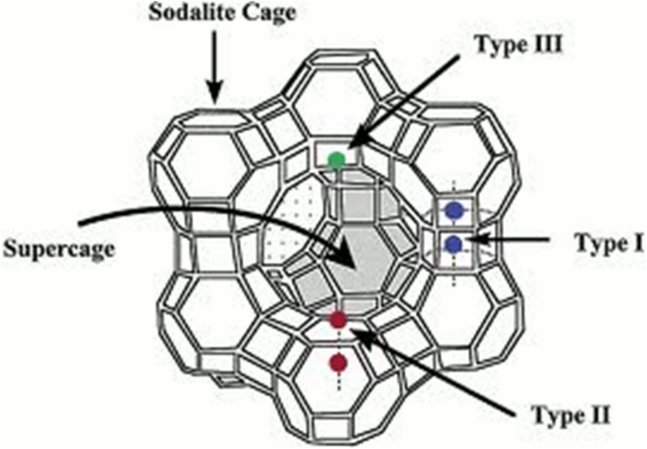

Structure of faujasite with central supercage surrounded by sodalite cages, along with cation sites.

Recent Publications (minimum 5)
- Rhodes C (2017) Magnetic Resonance Spectroscopy. Science Progress 100:241-292.
- Rhodes C (2017) The Imperative for Regenerative Agriculture. Science Progress 100:80-129.
- Propac P, Jomova, K, Simunvova M, Kollar V, Rhodes, C, Valko, M (2017) Targeting free radicals in oxidative stress-related human diseases. Trends in Pharmacol. Sci. 38:592-607.
- Mazur M, Valko M, Rhodes C (2017) A systematic study of the hydration and drying process of xerogel gels using Cu(II) EPR spectroscopy. J. Sol-Gel Sci. Technol. 82:855-861.
5. Rhodes C (2016) Electric fields in zeolites: fundamental features and environmental implications. Chemical Papers 70:4-21.

 Biography (150 word limit)
Professor Chris Rhodes is Director of Fresh-lands Environmental Actions. He has catholic scientific interests which cover radiation chemistry, catalysis, zeolites, radioisotopes, free radicals in biology and medicine, and electron paramagnetic resonance spectroscopy, and more recently have developed into aspects of environmental decontamination and low-carbon energy production. Chris has given numerous radio and televised interviews concerning environmental issues, both in Europe and in the United States, including on BBC Radio 4’s Material World. He has published more than 230 peer-reviewed scientific articles, and six books. He is also a published novelist, journalist and poet. His novel “University Shambles” is available in both print and e-book versions, and was nominated for a Brit Writers Award: Published Writer of the Year.
Email: cjrhodes@fresh-lands.com

Notes/Comments:

