(E)- and (Z)-Stereodefined parallel syntheses of multi-substituted α,β-unsaturated esters: Application to short step syntheses of both (E)- and (Z)- Zimelidines and Tamoxifens
Hidefumi Nakatsuji, Assistant Professor, Kwansei Gakuen Univ., JAPAN
Yoo Tanabe, Professor, Kwansei Gakuen Univ., JAPAN

Abstract (300 word limit)
The stereocontrolled preparation of ubiquitous (E)- and (Z)-α,β-unsaturated esters 1 is pivotal in organic syntheses, because of their wide distribution in natural products, pharmaceuticals, and supramolecules as key structural building blocks. Consistent with our continued interest in finding a methodology directed towards natural product synthesis and process chemistry, we have developed parallel and practical methods for the stereocomplementary preparation of both of “multi”-substituted (E)- and (Z)-1 from readily available β-oxoesters 2 and 2’. The present protocol is composed of sequential (E)- and (Z)-stereocomplementary enol tosylations and stereoretentive cross-coupling reactions (Types I and II).
The salient advantageous features are as follows. (i) Various β-keto or α-formyl esters 2 and 2’ are practically available using bases-promoted and Ti-Claisen condensations. (ii) Both (E)- and (Z)-enol tosylates 3 and 3’ derived from respective 2 and 2’ are prepared in (E)- and (Z)-stereocomplementary manner by using accessible, robust, and bench-top handling TsCl‒N-methylimidazole (NMI) or TsCl‒Me₂(CH₂)nNMe₂ (n = 2, 6) reagents. NMI or Me₂(CH₂)nNMe₂ is a key potential activator for the sulfonylation. A careful ¹H NMR monitoring experiment (−40 °C in CD₃CN) revealed that TsCl coupled with NMI or TMEDA formed active N-sulfonylammonium intermediates. (iii) High and consistent substrate-generality (>100 examples: Suzuki-Miyaura, Negishi, Sonogashira, Kochi-Fürstner) is demonstrated. (iv) The parallel syntheses of (E)- and (Z)-1 and 1’ are performed by using a pair of 2 and 2’. (v) The obtained (E)- and (Z)-α,β-unsaturated ester scaffolds can be transformed into various (E)- and (Z)-stereodefined known and novel olefins.
To demonstrate the utility of the present method, expeditious the first “parallel” syntheses of all four (E)- and (Z)-Zimelidines 4 (5 steps, 33% and 45% overall yield, 80% and 82% average yield) and Tamoxifens 5 (8 steps, 58% and 57% overall yield, 93% and 84% average yield), which are highly representative olefin motifs of pharmaceuticals, was accomplished. (298 words)

Image
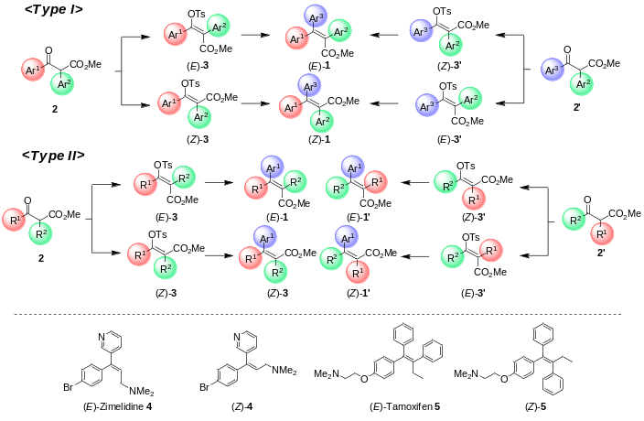
Recent Publications (minimum 5)
- Nakatsuji, H.; Ueno, K.; Misaki, T.; Tanabe, Y. Org. Lett. 2008, 10, 2131.
- Nakatsuji, H.; Nishikado, H.; Ueno, K.; Tanabe, Y. Org. Lett. 2009, 11, 4258.
- Sawamura, Y.; Nakatsuji, H.; Sakakura, A.; Ishihara, K. Chem. Sci. 2013, 4, 4181.
- Nakatsuji, H.; Sawamura, Y.; Sakakura, A.; Ishihara, K. Angew. Chem., Int. Ed. 2014, 53, 6974.
- Ashida, Y.; Sato, Y.; Suzuki, T.; Ueno, K.; Kai, K.; Nakatsuji, H.; Tanabe, Y. Chem. Eur. J. 2015, 21, 5934.
- Nakatsuji, H.; Ashida, Y.; Hori, H.; Sato, Y.; Honda, A.; Taira, M.; Tanabe, Y. Org. Biomol. Chem. 2015, 13, 8205.
- Ashida, Y.; Nakatsuji, H.; Tanabe, Y. Org. Synth. under checker’s review.
- Ashida, Y.; Sato, Y.; Honda, A.; Nakatsuji, H.; Tanabe, Y. Synthesis 2016, 48, 4072.
- Ashida, Y.; Honda, A.; Sato, Y.; Nakatsuji, H.; Tanabe, Y. ChemistryOpen in press.
- Ashida, Y.; Sato, Y.; Honda, A.; Nakatsuji, H.; Tanabe, Y. Synform in press (invited).

Biography (150 word limit)
Hidefumi Nakatsuji received his B. S. degree (2005) and his Ph. D. degree (2010) from Kwansei Gakuin University under the direction of Professor Yoo Tanabe. Immediately, Dr. Nakatsuji moved to Nagoya University (Professor Kazuaki Ishihara’s group) and studied as JSPS Postdoctoral Fellowship and CREST project researcher until 2014. Next, he was promoted to Assistant Professor of the Tanabe’s group. His research interests are developments of chiral phosphine and phosphine oxide organocatalysts for a MCR type cyclization and of condensation reactions for cost-effective reactions directed for process chemistry.
Email: nakatsuji@kwansei.ac.jp

Notes/Comment

