Allylic substitutions of secondary allylic esters: Allylic picolinates with organocopper reagents and allylic phosphates with Ar₂CH anions
Yuichi Kobayashi
Department of Biotechnology, Tokyo Institute of Technology, Yokohama, Japan

We have developed several substitution reactions at a secondary carbon for synthesis of natural products possessing chiral C–C bond(s). Among the reactions, we present herein allylic substitution of the following two types (eqs 1 and 2). The former (eq 1) features the picolinoxy leaving group, which is activated by chelation to MgBr₂ generated in situ [1,2]. This leaving group allows the use of aryl, hetero-aryl, alkenyl, and alkynyl reagents, which are generally less reactive than well-studied alkyl species [3,4]. The substitution with these reagents proceeds with high anti S_{N}2' selectivity. Furthermore, this substitution works well on ß,ß-substituted allylic picolinates, furnishing quaternary carbons [5,6]. This reaction has been utilized as a key step for synthesis of several biologically active compounds such as the active form of loxoprofen, cyclobakuchiol A, mesembrine, anastrephin, axenol, etc. (Figure 1). The second substitution to be presented herein is the allylic substitution of secondary allylic phosphates with Ar₂CH anions (eq 2), which proceeds with high efficiency to afford S_{N}2 products regio- and stereoselectively [7].
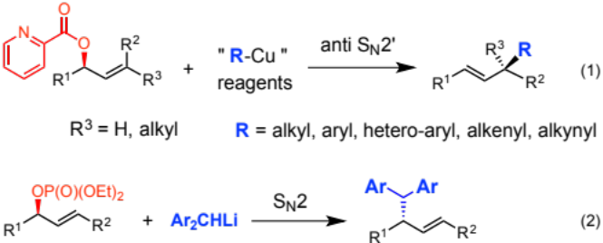

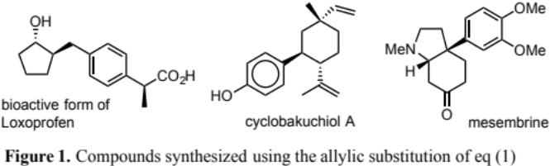
Publications
- Y. Kiyotsuka, H. P. Acharya, Y. Katayama, T. Hyodo, Y. Kobayashi, Org. Lett., 2008, 10, 1719–1722.
- Y. Kiyotsuka, Y. Katayama, H. P. Acharya, T. Hyodo, Y. Kobayashi, J. Org. Chem., 2009, 74, 1939–1951.
- T. Hyodo, Y. Kiyotsuka, Y. Kobayashi, Org. Lett., 2009, 11, 1103–1106.
- Q. Wang, Y. Kobayashi, Org. Lett., 2011, 13, 6252–6255.
5. Y. Kaneko, Y. Kiyotsuka, H. P. Acharya, Y. Kobayashi, Chem. Commun., 2010, 46, 5482–5484.
6. C. Feng, Y. Kobayashi, J. Org. Chem., 2013, 78, 3755–3766.
7. H. Kawashima, N. Ogawa, R. Saeki, Y. Kobayashi, Chem. Commun., 2016, 52, 4918–4921.

Biography (150 word limit)
Yuichi KOBAYASHI: obtained PhD at Tokyo Institute of Technology in 1981 under the supervision by Prof. J. Tsuji; a post doctor of Prof. G. Stork at Columbia University, New York (1981-1982); an assistant Prof. of the Fumie Sato Lab. at Tokyo Institute of Technology (1982-1988). Presently, a full Prof. at Tokyo Institute of Technology.
Research fields are organic synthesis, synthetic methodology using transition metal catalysts, synthesis of natural products, which include fatty acid metabolites such as resolvins, cinchona alkaloids, isoprostane (a new type of cyclopentanoids), phoslactomycins, etc.
Email: ykobayas@bio.titech.ac.jp

Notes/Comments:

(1) We use "symbol" beta twice on line 9: works well on ß,ß-substituted.
(2) Although an example of "Recent Publications" include the title for each publication. we did not add the titles to save a space. If you ask me to add the titles, I will follow.
(3) Macintosh (OS10.11.6) and MSWord (v 15.28) were used for this abstract.

