Multivalent recognition of GlcNAc derivatives-WGA interaction by SPR & Fluorospectroscopic methods
Amrita Kumari, Tetsuo Koyama, Ken Hatano and Koji Matsuoka, Saitama University, Saitama, Japan.

Abstract
N-acetyl-D-glucosamine (GlcNAc) derivative was synthesized by the glycosylation followed by biotin coupling using DMT-MM coupling reagent to form biotin-GlcNAc conjugate as an attractive bio-probe. Finally, biotin-avidin interaction system leads to the formation of tetrameric glycocluster of avidin-biotin-GlcNAc (ABG) complex. The purpose of this research is to describe the interaction between synthetic GlcNAc derivatives with a lectin named wheat germ agglutinin (WGA) on the basis of fluorometric assay and surface plasmon resonance (SPR) assaying. The specific binding of WGA to the GlcNAc residues in the avidin-biotin conjugated GlcNAc could be easily followed from changes in the fluorescence by means of specific excitation of tryptophan present in WGA at the wavelength of λ_{ex} 295 nm and it was found to be very high in case of ABG complex (K_{A} = 1.39 X 10⁷ M⁻¹) as compared to the GlcNAc monomer derivative (K_{A} = 9.62 X 10³ M⁻¹). SPR was performed to reconfirm the binding affinity between ABG complex and other GlcNAc derived polymers. To perform SPR we first immobilize the WGA on sensor surface by amine coupling method. Two polystyrene based GlcNAc polymers (glycopolymer 1 & 2) were used as control to check against tetrameric ABG complex. The efficiency of the method was exhibited in the analysis of the interactions that covered a high affinity range; K_{A} = 6.45 X 10⁷ M⁻¹ for the ABG complex, glycopolymer 1 (K_{A} =3.41 X 10⁵ M⁻¹) and glycopolymer 2 (K_{A} =3.30 X 10⁵ M⁻¹). Both the methods are almost in the same agreement for protein-carbohydrate kinetics/affinity. Little fluctuation in results of two different methods may occurred and it should be emphasized that the fluorometric assay measures the solution-solution interactions, which are different from the solution-solid interactions measured by SPR. The high affinity exhibited by synthetic ABG complex is due to the phenomena of “glycocluster effect”.
Image
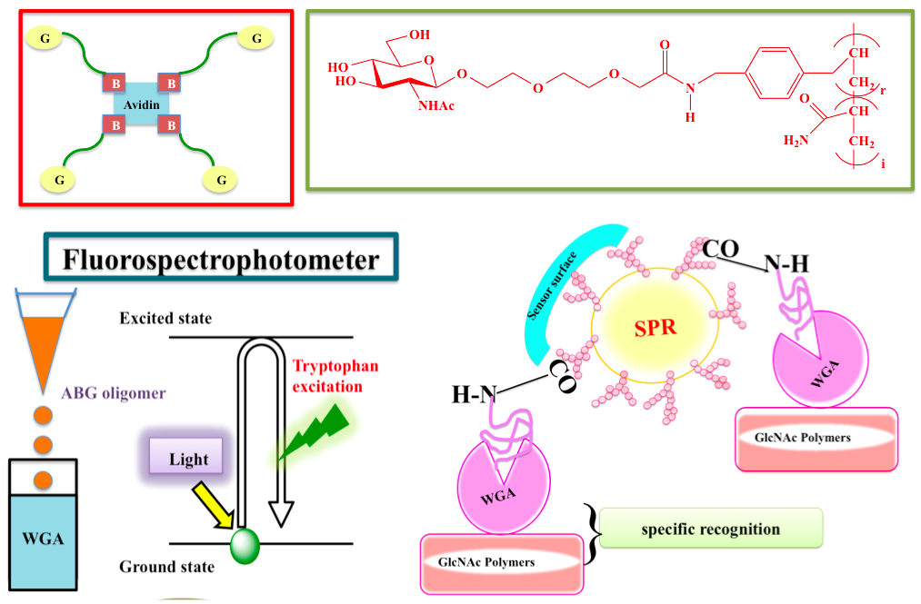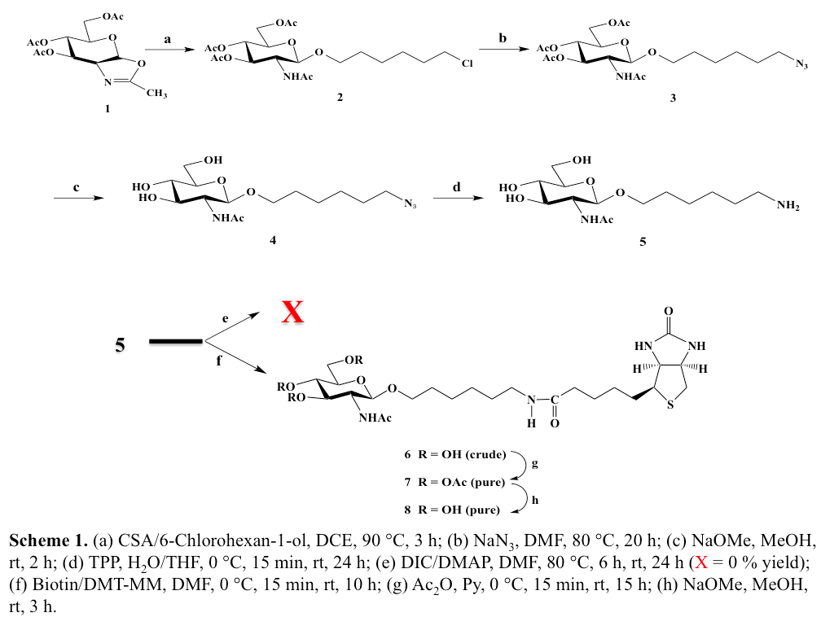

Recent Publications
1. Kumari A, Koyama T, Hatano K, Matsuoka K (2016) Synthetic assembly of novel avidin-biotin-GlcNAc (ABG) complex as an attractive bio-probe and its interaction with wheat germ agglutinin (WGA). Bioorganic Chemistry 68:219-225.

 Biography (150 word limit)
Amrita Kumari is pursuing her Ph.D. from Saitama University, Japan. She graduated from Delhi University, India with B.Sc life sciences in 2011 and received M.Sc degree in Biotechnology with distinction from Rajasthan University, India in 2013. She worked on DST-JSPS ongoing bilateral program in the Tokyo University for 2 months in 2012. During her Ph.D., she provided with a renowned scholarship from Rotary Yoneyama Memorial foundation, Japan. She received best student award from Saitama University in 2015. Awarded with best oral and poster presentations in domestic and international conferences. Her research interests include organic synthesis, synthetic assembly of bioactive glycosides, multivalent carbohydrate recognition, drug synthesis, phytochemical cancer therapeutics and molecular biology.
Email: amrita.juhi211@gmail.com, s13ds052@mail.saitama-u.ac.jp
Mob: +81-80-7959-1410

Notes/Comments

