University of Colorado School of Medicine | Aurora, CO
Mobile: 859-321-0037 ~ Richard.mangan@ucdenver.edu
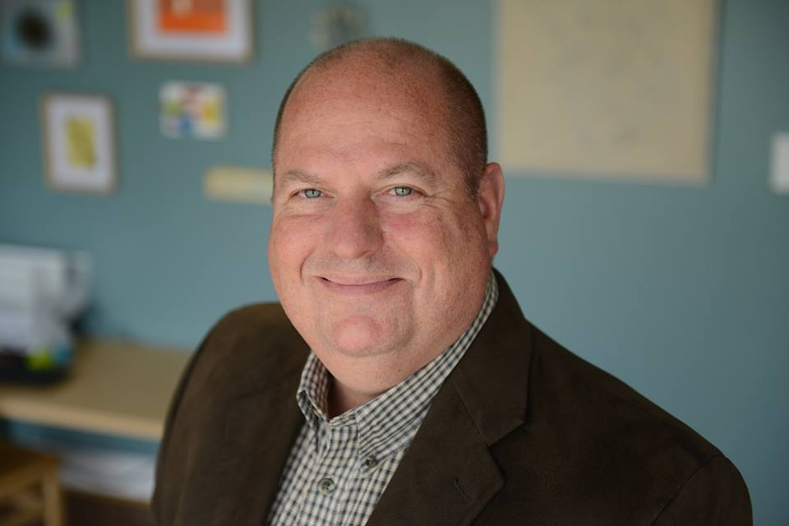

Richard B. Mangan, OD, FAAO
  - Assistant Professor

Introduction
Dear education committee,
As you are aware, Dr. Mangan is a national presenter and educator on a wide array of topics. As a former Center Director for a high volume referral practice for close to 15 years, and now Assistant Professor at the University of Colorado, Department of Ophthalmology, he has developed a number of talks based on his personal experience in the trenches. He is also on the editorial board for three of the major optometric publications (Collaborative Eye, formerly Advanced Ocular Care, Review of Optometry, and Primary Care Optometry News), and has his own bi-monthly column in Review on “Ocular Urgencies”. The link to his column is:
https://www.reviewofoptometry.com/department/urgent-care
Dr. Mangan simply wants to bring to your attention that he currently has over 16 hours of COPE approved courses (see below) for your committee to consider for one of you state, regional, or national CE meetings. For a complete list of courses offered by Dr. Mangan, you may reach him directly at RICHARD.MANGAN@UCDENVER.EDU or myself at HANNA.SOTIROPOULOS@UCDENVER.EDU and/or 720-848-5192.

Course Title | COPE ID Number | CE Hours
The Differential Diagnosis and Management of Headaches | 50246-NO | 2
No Drop Cataract Surgery The Great Debate | 49122-PO | 1
Ocular Urgencies Emergencies Are You Prepared | 48022-GO | 2
MRSA - A Cause for Concern | 59445-SD | 1
Grand Rounds in Ocular Surface Disease | 56524-AS | 2
Anisocoria ~ Now What? | 59444-NO | 1
MIGS: Bridging the Gap Between Drops and Blebs | 59446-GL | 1
Sleep Apnea and the Eye | 59278-SD | 2
The Pursuit of Happiness in the Cataract Patient | 56470-PO | 2
From PK to DMEK: The Keratoplasty Conundrum | 59443-PO | 1
Corneal Collagen Crosslinking Today | 59451-AS | 1

Here are just a few course introductions to consider:

“The Pursuit of Happiness in the Cataract Patient”
This two hour course covers the nuances surrounding the cataract patient with ocular co-morbidities such as glaucoma and ocular surface disease. Topics that will be discussed include surface optimization pearls; premium lens technology as it relates to the glaucoma patient; Effects of multifocal IOLs on contrast sensitivity and ancillary testing such as visual fields and OCT; Minimally Invasive Glaucoma Surgery (MIGS), and more.

“Ocular Urgencies & Emergencies ~ Are You Prepared?”
This two hour course covers 10 of the most significant ocular urgencies or emergencies the private practice optometrist is likely to encounter in clinical practice. Diagnosis and management of these urgent situations will be discussed, including pearls in making sure that the physician and staff are properly equipped to handle these situations should they occur.

“MIGS: Bridging the Gap between Drops and Blebs”
This course compares and contrasts the role of MIGS when managing the cataract patient with concomitant glaucoma. The latest FDA approved procedures are reviewed and cases with video are presented.

“No Drop Cataract Surgery ~ The Great Debate”
This 1 hour course will discuss a novel drug delivery technique allowing patients to have cataract surgery without the need for drops post-operatively. Having co-managed over 15,000 cases of “Drop-less Cataract Surgery”, Dr. Mangan shares his insight into this revolutionary approach to infection and inflammation prophylaxis. The risks, benefits, and alternatives will be reviewed.

And many more…
Dr. Mangan has additional lectures on topics such as lumps and bumps, pharmaceutical compounding, ocular allergy, infectious disease and more!!!

Read just a few of the many positive reviews from recent presentations:
…I think your topic was incredibly dull so thanks for trying to keep it fun with video and good organization.
…Very helpful lecture
…Thorough presentation by a knowledgeable clinician who made a potentially dry topic interesting!
…Great presentation!
…Best lecture in my 20 years!

Thank You for Your Consideration!
Dr. Mangan understands that you may have established your line up of speakers for an upcoming meeting. He hopes you will keep him in mind for any openings in subsequent events. Additionally, if you need any assistance in securing other speakers for an upcoming event, he is happy to help.
Lastly, if any of your local societies would like to have Dr. Mangan speak at a dinner meeting, we can assist in finding willing sponsors for the program.

