Investigating Versatile Computer-Aided Design of Microwave-Bandwidth Photonic Devices

Mikhail E. Belkin, Prof., Dr. of Sciences, MIREA – Russian Technological University, Moscow, Russia

Abstract
Introduction: Microwave photonics (MWP) is an interdisciplinary scientific and technological field that combines the microwave electronics and photonics worlds [1-3]. Emerging applications for information and communication networks (ICN) of fiber-wireless architecture, sub-terahertz wireless systems, radars, and electronic warfare systems indicate that MWP is set to be a subject of increasing importance. In a typical arrangement of MWP-based radio-frequency receiver, a photonic circuit is inserted between two microwave electronic chains (Fig. 1). For direct and inverse transfers of microwave and optical signals there are two interfacing units at their bounds: electrical-to-optical (E/O) and optical-to-electrical (O/E) converters. Between the interfaces there are various photonics units for processing microwave signals in optical domain.
Statement of the Problem: The developer of new MWP devices and systems is facing a problem of choosing an appropriate computer tool for their modeling and design, but is forced to use means of several computer-aided design (CAD) tools because the existing optical and optoelectronic CAD tools (OE-CAD) are not as developed as compared with the CAD tools intended for modeling of microwave devices (E-CAD) For example, well-known OE-CAD allows executing in precision manner the modeling of a fiber-optic link with detailed study of optical units’ characteristics, but RF and especially microwave and millimeter-wave functional units are represented without paying attention to specialties of microwave band. On the other hand, operating at symbolic level modern high-power microwave E-CAD tool simply and with high precision solves this problem but there are completely no models of active optoelectronic components in the libraries [4, 5].
In the paper, a number of the E-CAD models for active and passive MWP elements, such as semiconductor laser, photodetector, optical modulator, multichannel reflecting Bragg grating, and for some MWP devices are presented and experimentally validated.

Image
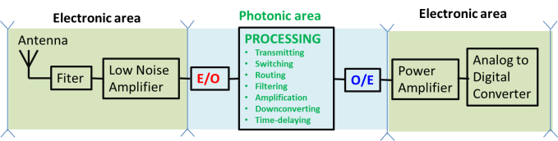

Figure 1. A typical arrangement of MWP-based microwave electronics receiver.

Recent Publications
1. J. Yao, “Microwave Photonics,” IEEE Journal of Lightwave Technology, 27, 3, 2009, pp. 314-335
2. V. J. Urick Jr., J. D. McKinney, K. J. Williams, Fundamentals of Microwave Photonics, Wiley Series in Microwave and Optical Engineering, Hoboken, New Jersey, 2015, 467 pp., ISBN 978-1-118-29320-1.
3. A.C. Paolella, R. De Salvo, C. Middleton. and C. Logan, “Direction in radio frequency photonic systems,” in WAMICON 2015: Proceedings of the IEEE 16th Wireless and Microwave Technology Conference, Cocoa Beach, Fl., USA, 2015, pp. 1-6,
4. M. E. Belkin, L. Belkin, A. S. Sigov, V. Iakovlev, G. Suruceanu, E. Kapon. “Performances of Microwave-Band Analog Signal Transmission using Wafer-Fused Long Wavelength VCSELs,” IEEE Phot. Technol. Lett., 23, 20, 2011, pp. 1463-1465, doi: 10.1109/LPT.2011.2162230
5. M.E. Belkin, V. Golovin, Y. Tyschuk, M. Vasil’ev, and A.S. Sigov, “Computer-Aided Design of Microwave-Photonics-based RF Circuits and Systems,” Chapter in Intech Open book “RF Systems, Circuits and Components”. 2018, Chapter 4, pp. 61-81, doi: 10.5772/intechopen.78945

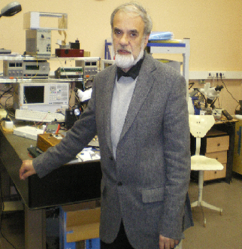 Biography
ogo here
Prof. Dr. Mikhail E. Belkin received an engineering degree in radio and television from Moscow Institute of Telecommunications, in 1971, Ph. D. degree in telecommunication and electronic engineering from Moscow Technical University of Telecommunications and Informatics, in 1996, and Sc. D. degree in photonics and optical communications from Moscow State Technical University of Radio-Engineering, Electronics and Automation, in 2007. He has written more than 250 scientific works in English and Russian. The major current R&D fields are fiber-optic devices and systems, microwave photonics, photonic ICs, incoming cellular communication networks, computer-aided design.
At present, M. E. Belkin is the Director of the Scientific and Technological Center “Integrated Microwave Photonics”, Professor of the department “Optical and Optoelectronic Devices and Systems”, Institute of Physics and Technology, MIREA - Russian Technological University, and he is a member of IEEE’s MTTS, LEOS (now PhS), and COMSOC from 2006, and a member of OSA from 2018.
.
Email: belkin@mirea.ru
Presenting author details
Full name: Mikhail E. Belkin
Contact number: belkin@mirea.ru
Twitter account:
Linked In account:
Session name/ number: Photonics and its Devices
Category: Poster presentation

