Novel transmission properties of planar optical waveguide cladded in prism pair
Jianhua Liu^{1,2,3}, Xiaoyao Pan^{1,2,3}, and Li Tao⁴
¹Department of Optical Science and Engineering, Fudan University;
²Key Lab for Micro and Nanophotonic Structures (Ministry of Education), Fudan University;
³Shanghai Ultra-Precision Optical Manufacturing Engineering Center, Fudan University, Shanghai 200438, China
⁴Department of Electrical Engineering, Stanford University, Stanford, CA 94305, USA

Abstract (300 word limit)
Optical bandpass (OBP) filter is a kind of important device that has been widely used in many optical fields. OBP filters, with bandwidth in nanometer scale and sideband well depressed, usually are made of tens or even hundreds of this thin film pairs piling together. The transmission efficiency typically gets in a range of 50 - 90%, due mainly to the material imperfection and errors in the film deposition processing. In the past two decades, waveguide grating (WG) provided a new way of making narrow bandwidth optical bandpass filters due to the novel property of “optical anomaly”, i.e. 100% transmission efficiency and extremely narrow bandwidth in nano/picometer scale [1-2]. However practically precise control of the profile in the constituent materials of the WG structure is not an easy task.
Recently, we have proposed a new type of narrow bandwidth optical bandpass filter which is composed of only a few (minimally 3) layers of films that form a planar optical waveguide, and two coupling prisms cladding on both side of the POW [3-6]. Light transmits from one prism to the other through the sandwiched POW under the condition of a two-step guided mode resonances (GMR), which makes the transmittance extremely sensitive to the structural configuration, wavelength, and the angle of incidence. We have obtained simulation results of single and/or multiple pass-bands in the visible spectrum with transmission efficiencies about 99% with practical material parameters. The most prominent feature of this kind of OBP filter is that bandwidths for most of the pass-bands are in picometer scale. Meanwhile sensing applicability has also been explored. Because of the simple structure and less number of layers, it could be easily implemented in terms of device fabrication.

Image
POW
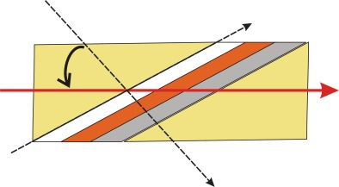
X
g
c
s
θ
LB
Fig. 1 Schematic illustration of the filter structure of a prism pair coupled planar optical waveguide in view of its longitudinal cross section.

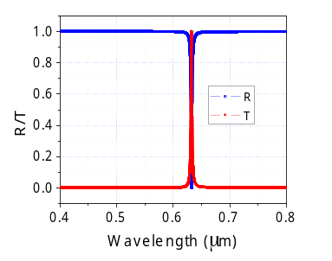
Fig.2 (a) GMR spectral responses for reflectance and transmittance in full visible band. The FWHM bandwidth is 2.2nm.

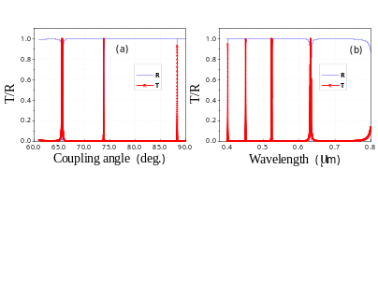
Fig.3 Guided mode resonances for the transmittance and reflectance in the filter as functions of the wavelength at the fixed incident angle of 65.554°, i.e. the 2nd order GM.
Recent Publications (minimum 5)
- X. Fu, K. Yi, J. Shao, Z. Fan, (2009) “Nonpolarizing guided-mode resonance filter”, Optics Letters 34(2) , 124-126.
- W. Liu, Z. Lai, H. Guo, Y. Liu, (2010) “Guided-mode resonance filters with shallow grating”, Opt. Lett. 35(6), 865-867.
- Jianhua Liua*, Li Tao (2017) “Multi-band optical bandpass filter with picometer bandwidth in visible spectrum formed by prism pair coupled planar optical waveguide”, Opt. Express 25(11), 12121-12130
- Jianhua Liua*, Li Tao (2017) “Influence of Parametric Uncertainties on Narrow Width Bandpass Optical Filter of Prism Pair Coupled Planar Optical Waveguide”, IEEE Journal of Quantum Electronics，53(3), 6200105, 2017
- Jianhua Liua*, Li Tao (2017) “Linearly decayed evanescent optical field in planar refractive index well”, Optics Communications 389 54–57
- Jianhua Liu and Li Tao (2016) “Nano/Sub-Nanometer Bandpass Optical Filtering in Prism Pair Loaded Planar Optical Waveguide”, IEEE Photonics Technology Letters, 28(23),2705-7, 2016

Biography (150 word limit)
Dr. Jianhua Liu got his master and bachelor’s degree from Shanghai University of Science and Technology in 1992 and 1989, respectively. In 1995, he got his Ph.D from Shanghai Institute of Optics and Fine Mechanics, Chinese Academy of Science. His interested fields of research include laser spectroscopy of laser crystals, experimental studies on the interaction of short laser pulses with thin film materials, liquid crystal optics, and optical properties of optical planar waveguides.

Li Tao is a PhD candidate at the Electrical Engineering Department of Stanford University. She received her BS degree in Optical Science and Engineering from Fudan University in China in 2012. Her current research interests focus on photonics device analysis and fabrication, as well as developing new detectors for ToF-PET system.

Email: jhliu@fudan.edu.cn

Notes/Comments:

