Optical fibers for solar radiation transmission as an alternative scheme for solid-state laser pumping
Hacene Manaa
Physics Department, University of Bahrain, P.O. Box 32038, Skhir, Kingdom of Bahrain
Keywords: fiber optics, solar-pumped lasers, solar energy, YAG:Nd,
Abstract:
To improve pumping schemes of solar-pumped solid-state lasers, optical fiber bundles for solar radiation transmission are proposed. The conventional laser radiation collectors consist generally on a heliostat and a paraboloidal mirror where the heliostat tracks the sun and reflects the sun radiation on the fixed parabolic mirror and the mirror concentrates the sun light on the laser rod in a few square centimeters area. The inconvenient of this architecture are the security issue, because tens of kilowatts of laser radiation are manipulated, the heaviness of the instruments and their impracticability. In this paper, we propose another alternative for sun light transportation that is based on the use of optical fiber bundles to transmit sun light. The sun light is collected with small parabolic mirrors they will track the sun and concentrate the radiation on the ends of several optical fiber bundles that are placed at the mirrors focus. The fibers transmit the sun light into the laser cavity from outdoors to indoors. This design is expected to overcome the disadvantages of the conventional methods.
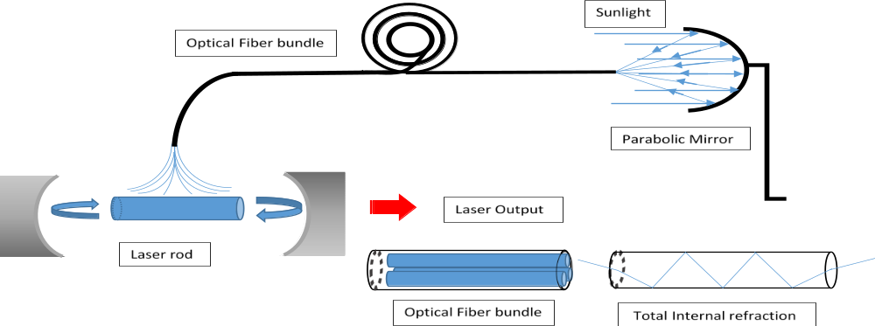
Optical arrangements to pump solar-pumped solid-state lasers
References:
- C. G. Young, Appl. Opt., 5, 6, 993 (1966)
- M. Weksler, J. Shwartz, IEEE J. Quantum Electron. 24(6) (1988).
- T.H.Dinh, T. Ohkubo, T. Yabe, H. Kuboyama , Opt.Lett. 37(2012)2670–2672.

