Unilateral Eales Disease with Presumed Tubercular Etiology, Three Case Reports

Omer Abdullah, MD,M.Sc,ICO,FICO,MRCSEd, Erbil-Iraq

Abstract

To report three cases of unilateral Eales disease with presumed tubercular etiology and management, including a combination of oral steroids plus antituberculosis (anti-TB) therapy. Methods: The clinical, serological, tuberculin skin test, and angiographic evaluations for each patient were carried out. Result: The first case received only oral steroids for the first four months, but the disease progressed, therefore, shifted to the full anti-TB combined with oral steroids. The latter two cases received the same combination with no progression. The third case had stopped oral steroids abruptly caused reactivation of the disease. Conclusion: The diagnosis of Eales disease is an exclusion diagnosis. The natural course, clinical picture, and the FFA findings of the illness make the diagnosis possible. Patients at risk to predispose to tuberculosis needs particular concern when presented with vitreous hemorrhage. Steroid monotherapy causes progression of the disease, and sudden steroid withdrawal results in reactivation.

Image
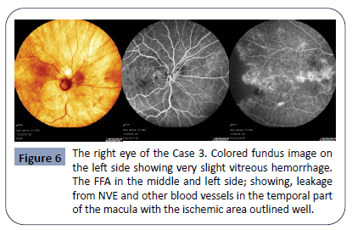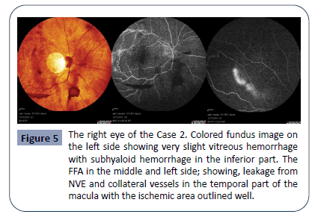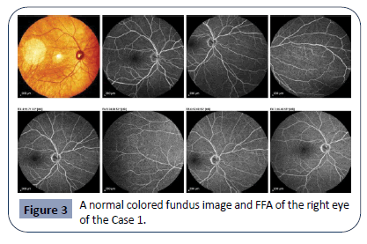
Recent Publications
- Abdullah OO (2020) Unilateral Eales Disease with Presumed Tubercular Etiology, Three Case Reports. Health Sci J. 14 No. 4: 731.
- Abdullah OO (2020) Bilateral Wyburn-Mason Syndrome Presenting with Macular Edema. Health Sci J. 14 No. 4: 733.
3- Abdullah OO (2020) Presumed Idiopathic Central Serous Chorioretinopathy in 9 years old boy. Health Sci J. 14 No. 4: 732.
4- Abdullah OO (2020) A Novel Approach to Prevent Endothelial Tear/Detachment in Combined Advanced Pseudoexfoliation Syndrome and Diabetes Mellitus. Health Sci J. 14 No. 5: 747.
5. Abdullah OO (2020) A Novel Approach to Prevent Intraocular Pressure Spikes and Reflux during Intravitreal Injections. Health Sci J. 14 No. 5: 748.

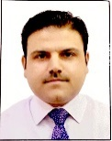 Biography
Paste your Logo here
Omer O. Abdullah completed his M.B.Ch.B at Hawler Medical University, School of Medicine. He completed MD and studied Clinical Master Degree in Ophthalmology at University of Sulaimani, School of Medicine. He joined ICO Vitreoretinal Fellowship Subspeciality at Ankara Hospital University, Faculty of Medicine, Ankara-Turkey and completed with distinction. Dr. Abdullah granted IOFF vitreoretinal Fellowship subspeciality and he is working as both phaco and vitreoretinal trainer at both Rizgary Teaching Hospital and Ibinsina modern eye and retina center. Also he is an associate editor at Health Journal Science.
Currently, he is working on two patents, a mater IOL and a retinal forceps.
Email: omer@ibinsina.org

Notes/Comments:
Presenting author details
Full name: Omer Othman Abdullah
Contact number: +9647501206673 and (Whatsapp +9647804969327)
Mail id: omer@ibinsina.org, majidy6@yahoo.com
Category: Oral presentation

