Presumed Idiopathic Central Serous Chorioretinopathy in 9 years old boy

Omer Abdullah, MD,M.Sc,ICO,FICO,MRCSEd, Erbil-Iraq

Abstract

A 9-year-old male attended our clinic with the blurred vision in his right eye, for one day duration. No past history of systemic or ocular illnesses except for recurrent tonsillitis. On ocular examination; his left eye (OS) visual acuity (VA) was 6/6, and the right eye (OD) VA was 6/9.5 which corrected to 6/9 with +0.75 diopter sphere. Fundus examination revealed normal optic nerve and a serous detachment in the posterior pole, nearly about the disc size. The optical coherence tomography angiography (OCTA) showed neurosensory retinal detachment with subretinal fluid. The family was not able to perform the fundus fluorescein angiography (FFA) due to the financial crisis in the region. Given this background, the diagnosis of idiopathic central chorioretinopathy had given. The clinical course was monitored without any treatments and spontaneous remission achieved within two months and the last OCTA taken after six months.
Image
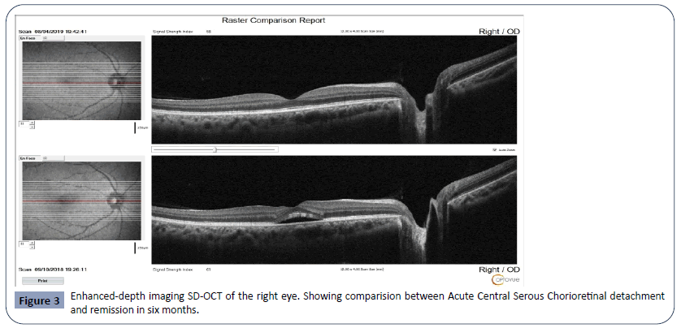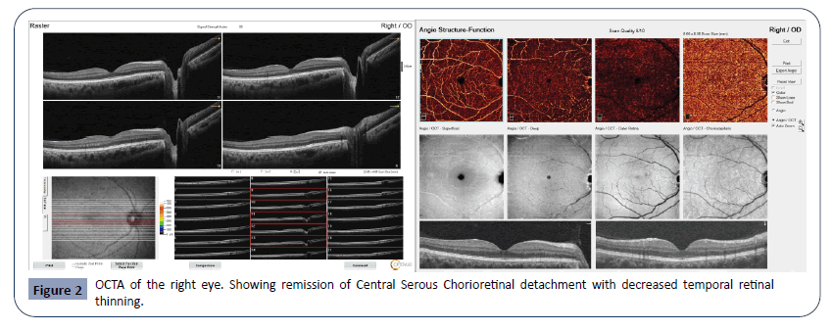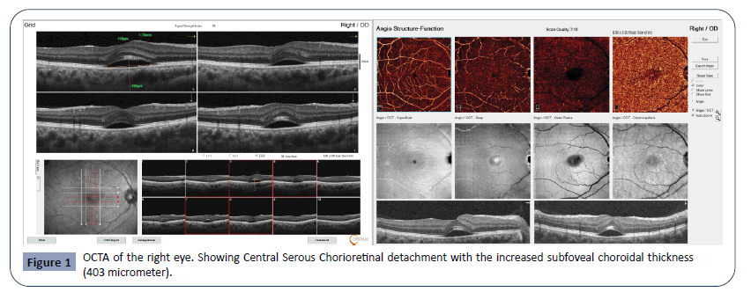
Recent Publications
- Abdullah OO (2020) Unilateral Eales Disease with Presumed Tubercular Etiology, Three Case Reports. Health Sci J. 14 No. 4: 731.
- Abdullah OO (2020) Bilateral Wyburn-Mason Syndrome Presenting with Macular Edema. Health Sci J. 14 No. 4: 733.
3- Abdullah OO (2020) Presumed Idiopathic Central Serous Chorioretinopathy in 9 years old boy. Health Sci J. 14 No. 4: 732.
4- Abdullah OO (2020) A Novel Approach to Prevent Endothelial Tear/Detachment in Combined Advanced Pseudoexfoliation Syndrome and Diabetes Mellitus. Health Sci J. 14 No. 5: 747.
5. Abdullah OO (2020) A Novel Approach to Prevent Intraocular Pressure Spikes and Reflux during Intravitreal Injections. Health Sci J. 14 No. 5: 748.

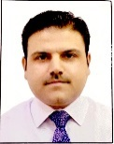Biography
Paste your Logo here
Omer O. Abdullah completed his M.B.Ch.B at Hawler Medical University, School of Medicine. He completed MD and studied Clinical Master Degree in Ophthalmology at University of Sulaimani, School of Medicine. He joined ICO Vitreoretinal Fellowship Subspeciality at Ankara Hospital University, Faculty of Medicine, Ankara-Turkey and completed with distinction. Dr. Abdullah granted IOFF vitreoretinal Fellowship subspeciality and he is working as both phaco and vitreoretinal trainer at both Rizgary Teaching Hospital and Ibinsina modern eye and retina center. Also he is an associate editor at Health Journal Science.
Currently, he is working on two patents, a mater IOL and a retinal forceps.
Email: omer@ibinsina.org

Notes/Comments:

Presenting author details
Full name: Omer Othman Abdullah
Contact number: +9647501206673 and (Whatsapp +9647804969327)
Mail id: omer@ibinsina.org, majidy6@yahoo.com
Category: Oral presentation

