Bilateral Wyburn–Mason Syndrome Presenting with Macular Edema

Omer Abdullah, MD,M.Sc,ICO,FICO,MRCSEd, Erbil-Iraq

Abstract

The Wyburn-Mason or Bonnet-Dechaume-Blanc syndrome is a sporadic illness which is a type of phakomatosis, usually present as unilateral arteriovenous malformations(AVM), for the first defined by Magnus in 1874 as retinal AVM later in 1932 another description gave by Yates and Payne; as an AVMs of the retina and cerebral vasculature, while in 1937 Bonnet, Dechaume and Blanc defined as AVM involving facial, retinal and brain blood vessels, then in 1943 all literature revised by Wyburn-Mason to put together to his case reports, therefore, the name of Bonnet-Dechaume-Blanc syndrome given in France, but in English articles entitled as Wyburn-Mason syndrome. At that time, due to a deficiency in diagnostic imaging techniques, all the diagnosis were performed by clinical findings, operation, or autopsy. Usually, it is a unilateral disorder comprising of three distinct components: orbit, brain (ipsilateral to the retina) and face, in the face; the sensory region of the trigeminal nerve distribution involved, that takes the shape of naevi which might be wholly formed and illness, is complete, or the naevi might be faint or absent, the latter regarded as an incomplete disease but rarely a bilateral involvement encountered with an asymmetrical grade of malformation. The pathology starts in the early embryonic period, and if vascular dysgenesis encountered can lead to a wide range of neurocutaneous vascular defects in the cerebrum or ocular or both. When the disorder reaches the last stage, the AVM can compress the optic nerve causing impaired perfusion, ischemia eventually optic atrophy. Another explanation for visual loss is glaucoma as a result of elevated vascular pressure, neovascularization resulting from ischemia, which might lead to vitreous hemorrhage(5). Archer et al. staged the disease into three groups: Group 1 (AVM cannot be detected clinically). Group 2 (Clinically seen as edema and hemorrhage due to direct AVM, i.e., no capillary network between them). Group 3 (Clinically, it is impossible to distinguish arteries from veins due to severely dilated blood vessels all over retina). We present a 41-year-old male presented with a gradual decrease in his visual acuity in both eyes.
Image
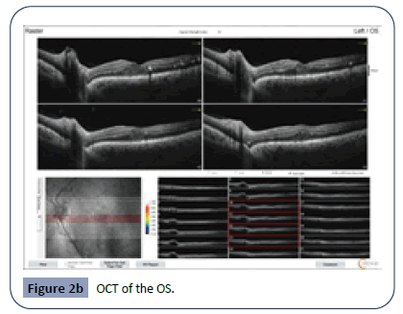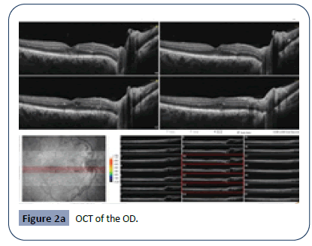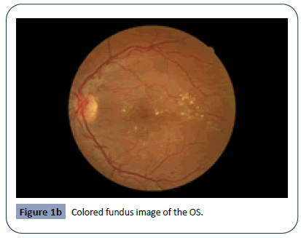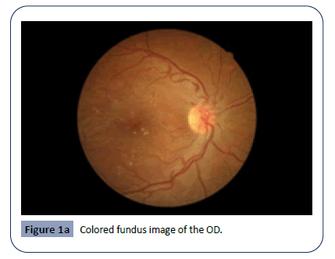
Recent Publications
- Abdullah OO (2020) Unilateral Eales Disease with Presumed Tubercular Etiology, Three Case Reports. Health Sci J. 14 No. 4: 731.
- Abdullah OO (2020) Bilateral Wyburn-Mason Syndrome Presenting with Macular Edema. Health Sci J. 14 No. 4: 733.
3- Abdullah OO (2020) Presumed Idiopathic Central Serous Chorioretinopathy in 9 years old boy. Health Sci J. 14 No. 4: 732.
4- Abdullah OO (2020) A Novel Approach to Prevent Endothelial Tear/Detachment in Combined Advanced Pseudoexfoliation Syndrome and Diabetes Mellitus. Health Sci J. 14 No. 5: 747.
5. Abdullah OO (2020) A Novel Approach to Prevent Intraocular Pressure Spikes and Reflux during Intravitreal Injections. Health Sci J. 14 No. 5: 748.

Biography
Paste your Logo here
Omer O. Abdullah completed his M.B.Ch.B at Hawler Medical University, School of Medicine. He completed MD and studied Clinical Master Degree in Ophthalmology at University of Sulaimani, School of Medicine. He joined ICO Vitreoretinal Fellowship Subspeciality at Ankara Hospital University, Faculty of Medicine, Ankara-Turkey and completed with distinction. Dr. Abdullah granted IOFF vitreoretinal Fellowship subspeciality and he is working as both phaco and vitreoretinal trainer at both Rizgary Teaching Hospital and Ibinsina modern eye and retina center. Also he is an associate editor at Health Journal Science.
Currently, he is working on two patents, a mater IOL and a retinal forceps.
Email: omer@ibinsina.org

Notes/Comments:

Presenting author details
Full name: Omer Othman Abdullah
Contact number: +9647501206673 and (Whatsapp +9647804969327)
Mail id: omer@ibinsina.org, majidy6@yahoo.com
Category: Oral presentation

