Tropical punctate keratopathy in cats
Susyn Kelly, BE(hons), Massey University, NZ

Abstract (300 word limit)
Tropical keratopathy (Florida spots) is a common eye lesion of cats in tropical and subtropical areas which is clinically and epidemiologically similar to human punctate keratopathy (Rice’s keratopathy) reported in the West Indies and the Americas. To determine the pathology of the cat lesions we performed light and electron microscopy on clinically typical lesions which revealed epithelial hyperplasia, thinning of the corneal stroma (by 4 to 18%) and occasional vacuoles in the basement membrane. Small-angle X-ray scattering analysis revealed greater diameters and variation in size of collagen fibrils in the corneal stroma containing the lesions compared to normal corneas (48.8 ± 4.5 nm versus 35.5 ± 2.6 nm; P < 0.05), but no difference in d-spacing in the lesion compared to normal corneal stroma. The average orientation index of the collagen across the corneal stroma containing the lesions was greater than that in normal corneas (0.428 ± 0.08 versus 0.285 ± 0.03, respectively; P < 0.05). A survey revealed “Florida spots” lesions were static over time and only seldom became less obvious when cats were moved to temperate areas. Although tropical keratopathy of cats is macroscopically and epidemiologically similar to Rice’s keratopathy, it is an anterior stromal disorder of unknown etiology, rather than epitheliolysis of the basal cells, epithelial detachment and fatty degeneration in Bowman's membrane, also of unknown aetiology.

Image
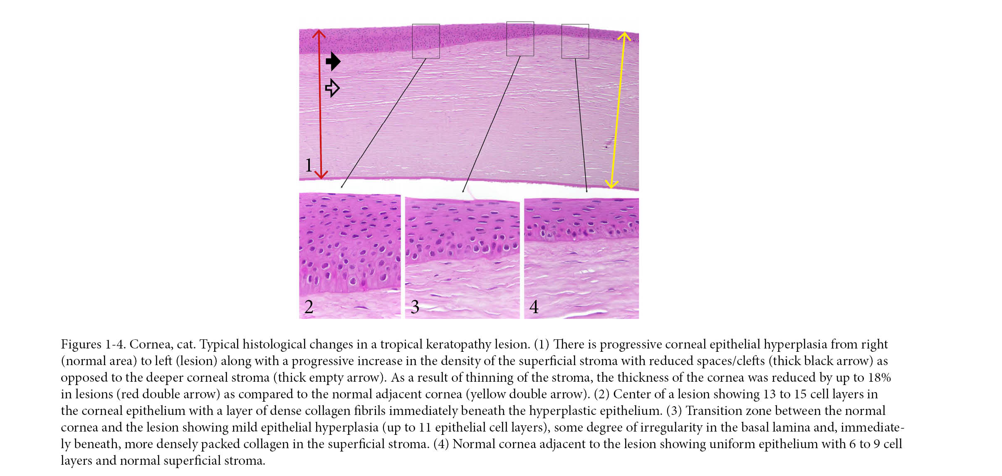
Recent Publications (minimum 5)
- Kelly, S., Edmonds, R., Cooper, S., Sizeland, K., Wells, H., Ryan, T., Kirby, N., Mudie S. and Haverkamp R., Mapping Tear Strength and Collagen Fibril Orientation in Bovine, Ovine and Cervine Hides and Skins. Journal of the American Leather Chemists Association, 2018. 103(1): p. 1-11.
- Kelly, S., P. Kelly, H. Wells, K. Sizeland, R Haverkamp, A. Armien, P. Bolfa, Corneal Epithelial Hyperplasia Combined with a Superficial Corneal Stromal Collagen Disorder as the Main Underlying Changes in Tropical Keratopathy (Florida Spots) in Cats. Journal of Comparative Pathology, 2018. 158: p. 95.
- Wells H., K. Sizeland, S. Kelly, M. Basil-Jones, R. Edmonds, R. Haverkamp, Fibril orientation and strength in collagen materials and adaptation to strain. Advanced Materials Letters, 2018. 9(6): p. 411-418.
- Kelly, S., Wells H., Sizeland K., Kirby N., Edmonds R., Ryan T., Hawley A., Mudie S., Haverkamp R., Artificially modified collagen fibril orientation affects leather tear strength. Journal of the Science of Food and Agriculture. 2017 Dec 30. doi: 10.1002/jsfa.8863.
- Sizeland, K; Wells, H; Kelly, S; Nesdale, K; May, B; Dempsey, S; Miller, C; Kirby, N; Hawley, A; Mudie, S; Ryan, T; Cookson, D; Haverkamp, R. Collagen Fibril Response to Strain in Scaffolds from Ovine Forestomach for Tissue Engineering. ACS Biomaterials Science & Engineering 2017 3 (10), 2524-2532.

Biography (150 word limit)
Susyn is a PhD student at Massey University in Palmerston North, New Zealand. Her thesis looks to investigate the nano-structural motifs of collagen in collagen based materials such as skins and the cornea. Her work builds upon key findings from the Haverkamp research group who has utilized the Australian Synchrotron to characterize collagen structures a range of collagen based materials at the nano-scale and there effect on physical characteristics
Email: S.Kelly2@massey.ac.nz

Notes/Comments:

