Obesity, immunity, physical exercise and COVID-19: Towards breaking the pathological cycle
Jonny St-Amand, Laval University and CHU de Québec-Université Laval Research Center, Canada
Mayumi Yoshioka, CHU de Québec-Université Laval Research Center, Canada
Abdelaziz Ghanemi, Laval University and CHU de Québec-Université Laval Research Center, Canada

Abstract
Obesity, with its diverse pathological consequences, represents a health problem with heavy economic and social impacts. With the current outbreak of coronavirus disease-2019 (COVID-19), debates are taking place around the consequences this pandemic would have on different aspects of the human health including obesity. Indeed, anti-COVID-19 measures such as confinement and economic shutdown impact the lifestyle and health (activity, diet, sleeping, toxicology, mental health, etc.) as well as their incomes. All are direct and indirect factors leading to the increase of obesity incidence within the society.
In addition, this ongoing coronavirus disease-2019 crisis also led to a new socioeconomic reality with the acquisition of novel habits. The measures imposed by the governments and health authorities (confinement, lockdown, etc.) had important consequences (mental health problems, economic crisis, social isolation, etc.). Combined with the newly acquired habits (including hand washing, sanitization, and face masks); all these would lead directly and indirectly to a reduced immunity. Such effects of the immune system would impact not only the epidemiological profile in respect to COVID-19 and other infectious diseases but also limit the efficacy of the ongoing anti-COVID-19 vaccination campaign. Therefore, there is a need to review the approaches and optimize the measures towards a better population immunity that is much required during such an epidemic period.
It is worth noting that both obesity development and immunity reduction resulting from the COVID-19 crisis would increase the vulnerability to COVID-19. Therefore, the establishment of a vicious cycle that needs to be broken. Within this context, exercise would be an excellent option since it allows to both prevent and treat/reverse those health problems and risk factors. It will also improve diverse other factors (regeneration, ageing, metabolism, detoxification, etc.) toward a healthier status. This will allow to break this “COVID-19- Obesity/immunity” cycle.

Images

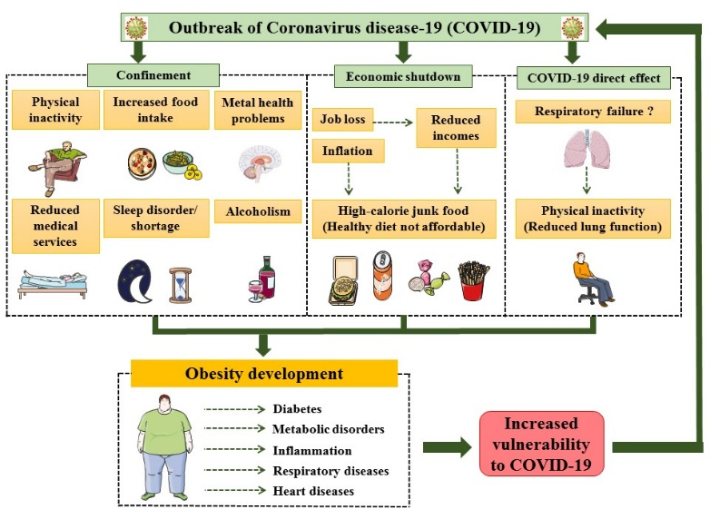

Figure 1: COVID-19 pandemic would lead to develop/worsen obesity pandemic.

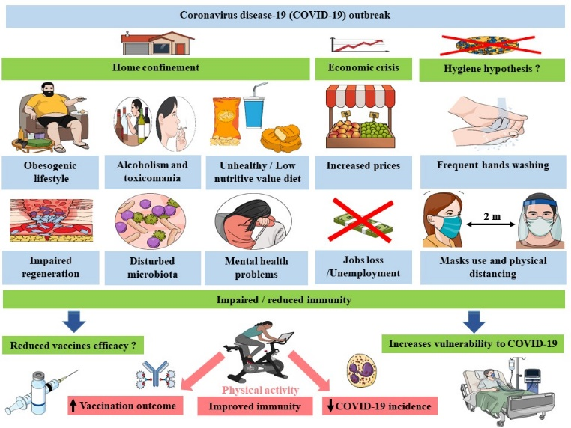

Figure 2 : Potential impacts of COVID-19 crisis on immunity that could be reversed/treated via physical exercise.

Recent Publications
- Ghanemi A, St-Amand J (2018) Redefining obesity toward classifying as a disease. European Journal of Internal Medicine. 55: 20-22.
- Ghanemi A, Yoshioka M, St-Amand J (2018) Broken energy homeostasis and obesity pathogenesis: The surrounding concepts. Journal of Clinical Medicine. 7(11): 453.
- Ghanemi A, Yoshioka M and St-Amand J (2021) Obesity as a neuroendocrine reprogramming. Medicina. 57(1):66
- Ghanemi A, Yoshioka M and St-Amand J (2020). Regeneration during obesity: An impaired homeostasis. Animals. 10 (12): 2344.
- Ghanemi A, Yoshioka M, St-Amand J (2020) Will an obesity pandemic replace the coronavirus disease-2019 (COVID-19) pandemic ? Medical Hypotheses.144 C: 110042.
- Ghanemi A, Yoshioka M, St-Amand J (2021) Coronavirus disease-2019 (COVID-19) crisis: Losing our immunity when we need it the most. Biology (Revision under review).
- Ghanemi A, Melouane A, Yoshioka M, St-Amand J (2020). Exercise training of secreted protein acidic and rich in cysteine (Sparc) KO mice suggests that exercise-induced muscle phenotype changes are SPARC dependent. Applied Sciences. 10 (24): 9108.
- Ghanemi A, Melouane A, Yoshioka M, St-Amand J (2020). Exercise and high-fat diet in obesity: Functional genomics perspectives of two energy homeostasis pillars. Genes. 11 (8): 875.

 Biography
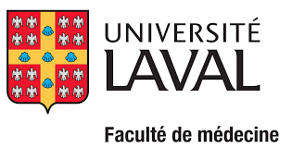

Dr. St-Amand is a full professor at the Department of Molecular Medicine Faculty of Medicine of Laval University and director of the Functional Genomics Laboratory, Endocrinology and Nephrology Axis, CHU de Quebec-Universite Laval Research Center, Canada. He has acquired valuable knowledge in physiology of obesity, coronary artery diseases, exercise physiology, genetic engineering and functional genomic studies. His current research program is aimed to the development of an “exercise pill” or surrogate that will optimize or act similarly to exercise to prevent obesity, metabolic disorders, cardiovascular disease and COVID-19. Dr St-Amand has received more than 34 M$ of research grants and 91 M$ of instruments and infrastructure grants.
Email: jonny.st-amand@crchudequebec.ulaval.ca

Notes/Comments:
Currently, our research team is writing other papers relevant to this talk.
Presenting author details
Full name: Jonny St-Amand
Contact number: +1-418-654-2296; Fax: +1-418-654-2761
Mail id: jonny.st-amand@crchudequebec.ulaval.ca
Category: Oral presentation.

