
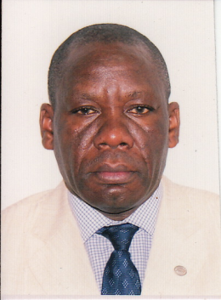
Mulago Hospital Uganda
THE UNDER-ESTIMATED PROBLEM OF OBESITY AMONG CHILDREN IN SUB-SAHARAN AFRICA (SSA): A CASE OF UGANDA AND SOUTH AFRICA
Mworozi. Edison Arwanire, Amaniyo Lucy
Mulago National Referral Hospital /College of Health Sciences, Makerere University Kampala Uganda
During the past two decades, the prevalence of overweight and obesity in children globally has increased from 4.8% to 6.1%. & total numbers doubled from 5.4 to 10.3 million. Obesity in childhood and adolescence is associated with ill health during childhood, premature mortality and physical morbidity in adulthood. Once obesity is established in children, it is challenging to reverse. Until recently, overweight and obesity were considered as diseases of the developed world while malnutrition has been considered a problem of the developing World.
Several studies have established that obesity and overweight among Children in SSA and are on the rise. Studies done in South Africa found the prevalence of obesity in children aged 3-16 years to be 3.2% for boys and 4.9% for girls while overweight was 14% for boys and 17.9% for girls. It was further demonstrated that in rural areas, overweight and obesity were more prevalent among girls (15%) than boys (4%). Similarly, studies in Uganda have indicated high prevalence of obesity (32.3%) and overweight (21.7%) among school children.& higher prevalence among those in private schools (16.6%) compared to those in public schools (11.5%).In adults the prevalence of overweight and obesity was higher in peri-urban than rural areas.. Among the factors associated with the high prevalence of obesity and overweight are; low physical activity , sedentary lifestyle, dietary intake, psychosocial factors, female gender, inaccurate perceptions about dieting, weight and health status and potential social isolation. This paper aims at raising awareness about overweight and obesity among children in SSA.
Biography: A Ugandan Pediatrician interested in infectious diseases, childhood immunization and non communicable diseases. A senior consultant Pediatrician at Mulago National Referral Hospital and Honorary lecturer at the College of Health Sciences Makerere University and Prof of Pediatrics, St Augustine International University. Has published widely and a peer reviewer for several journals. A member of several professional and technical bodies including : the Uganda Medical association, Uganda Pediatric Association, International Society for Infectious diseases, International Pediatric Association, Vienna Vaccine safety Initiative, East African Rotavirus Advisory Collaborative HIV Vaccine Trials; East African Centre for Vaccines and Immunization and member.

