Title: Creating a New Education Paradigm to Prepare Nurses for the 21st Century
Beth Ann Swan, PhD, CRNP, FAAN

Jefferson College of Nursing, Thomas Jefferson University, Philadelphia, PA 19107, USA

Nurse educators are accountable to keep baccalaureate education responsive to the ever changing healthcare delivery environment. The changing context of healthcare delivery requires focusing on population health and social determinants, providing interprofessional, team-based care, advancing innovation, and preparing practice ready baccalaureate nursing graduates. To be practice ready, nursing graduates must be agile and think and reason on their feet due to increasing care complexity beyond the hospital walls, changing care needs of individuals and families, advancing technology, shifting settings of care delivery, and managing multiple transitions. The purpose of this paper is to consider these healthcare changes and share a new, innovative baccalaureate nursing curriculum that radically shifts the paradigm from caring for patients to caring for people, and transforms from a diseased-based, acute care focused curriculum to one promoting a culture of health and multiple new and emerging roles of registered nurses.

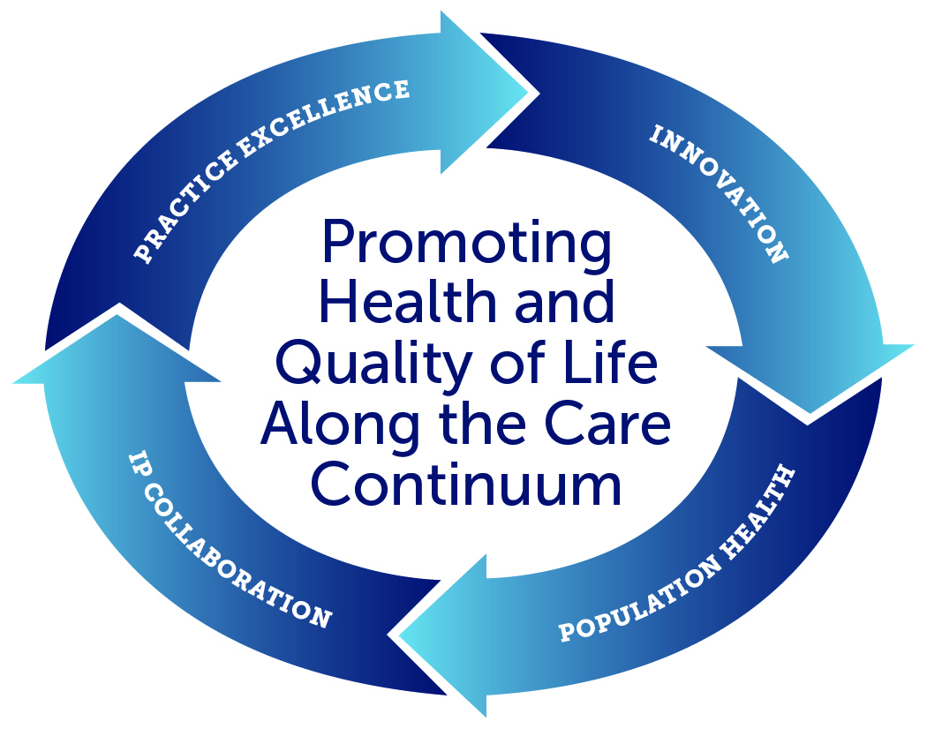

Dr. Beth Ann Swan is Professor and former Dean at the Jefferson College of Nursing. Dr. Swan is a Fellow of the American Academy of Nursing, past president of the American Academy of Ambulatory Care Nursing, and a 2007-2010 Robert Wood Johnson Executive Nurse Fellow. Dr. Swan has a distinguished record of extramural funding, publications, and presentations nationally and internationally on topics related to ambulatory care, care coordination and transition management, and technology applications for education and practice. She is Co-Editor of the text, Care Coordination and Transition Management Core Curriculum. Dr. Swan received her PhD and MSN from the University of Pennsylvania, and BSN from Holy Family University.

Email: bethannswan@gmail.com

