Therapeutic Education: the design of an Educational Program Protocol for primary care diabetic patients
M Rosário Pinto, RN MD, IPSantarém, Higher School of Health, Portugal
Pedro Parreira, Higher School of Nursing of Coimbra, Portugal
Marta Lima Basto, Lisbon University, Higher School of Nursing, Portugal
Lisete Mónico, University of Coimbra, Phycology Faculty, Portugal

Abstract (300 word limit)
Statement of the Problem: Diabetes is considered the XXI century disease due to the increase of patients’ number and to a high prevalence of poor metabolic control. In Portugal, country where this study was conducted, from the diabetic people with records of HbA_{1c} in NHS, 21.8% have values over 8%¹, with the poor metabolic control being a major problem that seems to remain in a significant percentage of Portuguese patients. Therapeutic Education has proven to be structural to diabetic people self-control and Evidence highlights the importance of developing and implementing educational interventions that can reduce this burden, but researchers have reported the shortage of tested educational programs that allow its effectiveness discussion. The purpose of this study is to design a specific protocol of a lifestyle educational program for type 2 diabetic patients. Methodology & Theoretical Orientation: An exploratory and descriptive study using Constant Comparison Methodology² principles, triangulating semi-directive interviews, participant observation and record analysis. Theoretical framework was supported upon Orem’s Self-care Theory. Findings: An educational program with several active components was designed with a 24 weeks’ timeline. The protocol included 3 face-to-face moments with a specific nursing intervention, 2 educational group sessions (focussed on self-motivation, lifestyle generic behaviours and feet self-care) and a telephone monitoring intervention. Conclusion & Significance: The program developed is a Complex Intervention³, with several active components, integrating the intervention usually carried out by the nurses that work in a Community Health Care Centre, in connection to which is added group and telephone intervention. Its significance accrue from the possibility of replication as it follows specific stated sequential phases, making its effectiveness assessment a possibility.
Bibliography:
¹Diabetes Observatory. (2015). Diabetes. Facts and Numbers. Portugal 2014. Annual Report on the National Diabetes Observatory.
²Charmaz, K. (2014). Constructing Grounded Theory. SAGE Publications.
³MRC. (2000). A framework for development and evaluation of RCTs for complex interventions to improve health. Medical Research Council.
³MRC. (2008). Developing and evaluating complex interventions: new guidance (http://www.mrc.ac.uk/complexinterventionsguidance).

Image

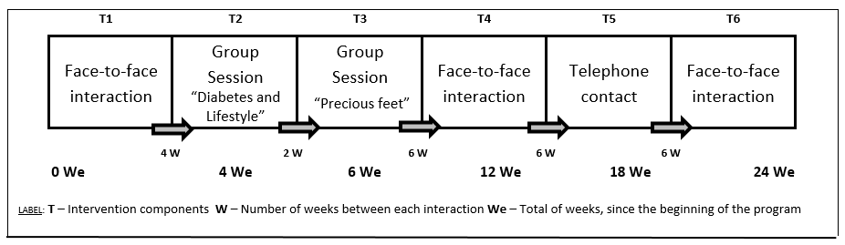
Figure 1 – Educational Protocol
Recent publications (minimum 5)
- Pinto MR, Parreira P, Basto ML, Neves M & Monico L (2016). Assessing the effectiveness of a Complex Nursing Intervention, BMC Health Services Research, 16(Suppl 3):O89
- Pinto MR, Parreira P, Basto ML, Rei A & Monico L (2016). Lifestyle Educational Programme for primary care diabetic patients: the design of a complex nursing intervention, BMC Health Services Research 2016, 16(Suppl 3):O16
- Pinto MR, Parreira P & Basto ML, (2016). Health professionals’ skills development to implement Therapeutic Education. A case study with diabetes certificated educators, 5th EARLI SIG 13 Conference. Moral and Democratic Education – Program and Abstracts, July, pp. 17-18
- Pinto MR, Parreira P & Basto ML (2015). Investigar intervenções complexas em enfermagem. Resultados preliminares da fase de modelação de um programa educativo direcionado a pessoas com diabetes mellitus, Revista da Unidade de Investigação do Instituto Politécnico de Santarém (UIIPS), nov, 3 (5), pp. 415-431, ISSN: 218-9608
- Pinto MR, Parreira P & Basto ML (2014). Resultados da intervenção de enfermagem na adequação do estilo de vida das pessoas com Diabetes Mellitus tipo 2. Uma Revisão Sistemática da literatura. Revista da Unidade de Investigação do Instituto Politécnico de Santarém (UIIPS), nov, 5 (2), pp. 259-278 ISSN: 218-96


Biography (150 word limit)
Maria do Rosário Pinto has her expertise in medical surgical nursing. Her research has been on gender sociology (in MD context), Therapeutic Education (diabetic patients) and Complex Interventions effectiveness assessment. As an Academic, HIV, Cancer and Emergency and Critical Care in Nursing are her major interests, lecturing in these areas in Bachelor and Master Degrees. She is the coordinator for Internationalization of her Health School, participating in a TEMPUS project in which is doing research on VaKE strategy applied to Nursing fields, participating in the conduction of several workshops on the theme (Portugal, Salzburg, Israel).
Email: mrosariopinto.essaude@gmail.com

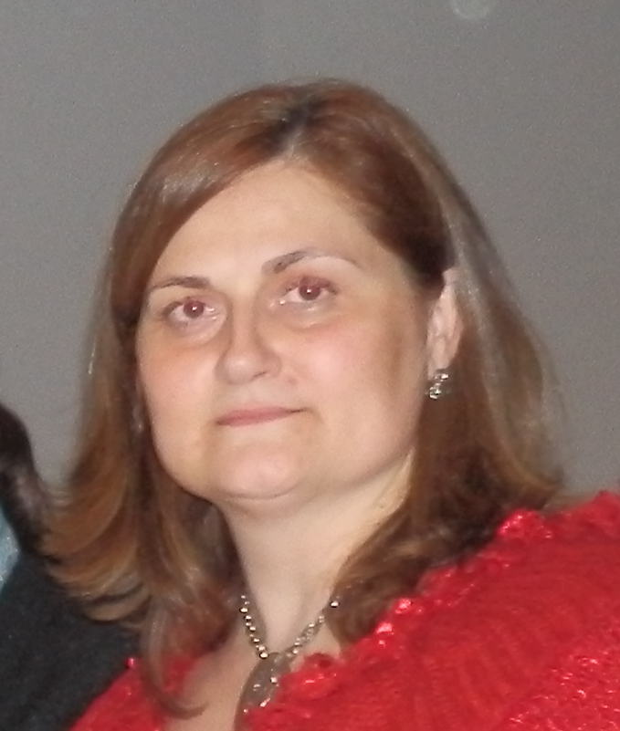 Notes/Comments:

