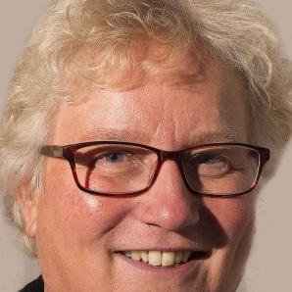
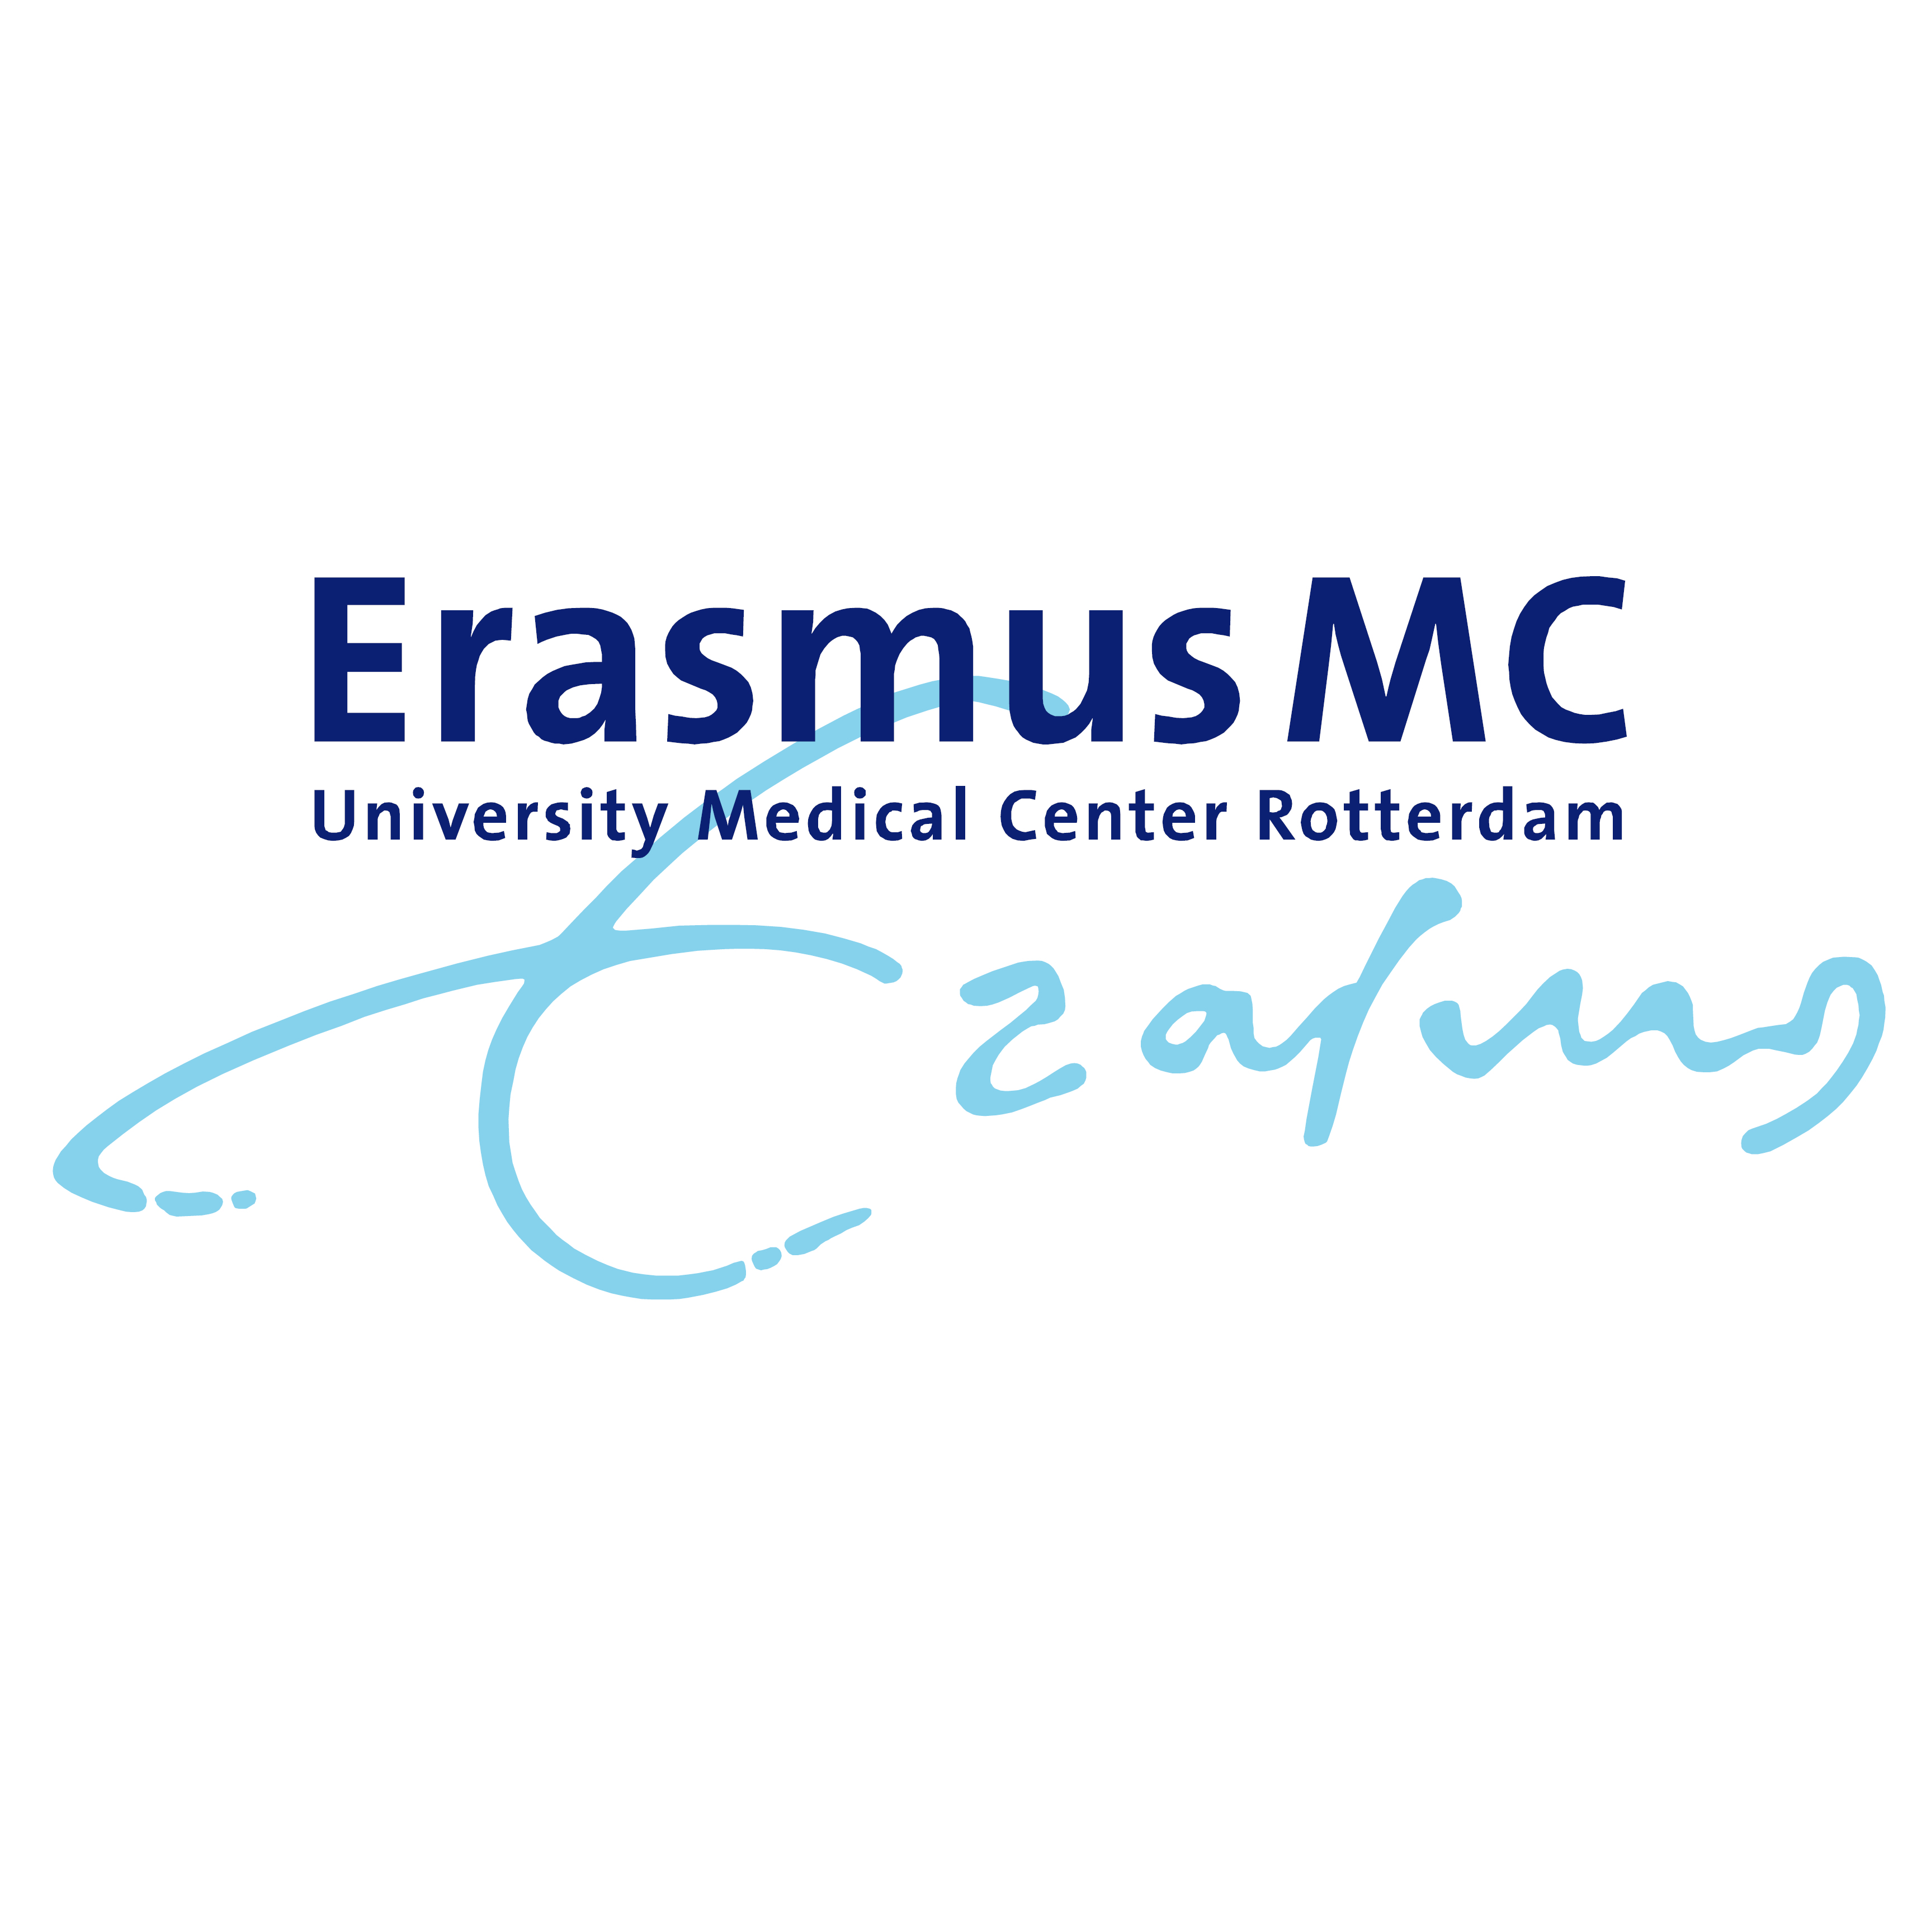

Title: Preconception care for women suffering from chronic diseases in the Netherlands: patients’ view on the role of the general practitioner
Name: dr. A. N. (Ageeth) Rosman

Erasmus MC, University of Rotterdam, 3015 CE, the Netherlands

Preferably, all women suffering from chronic diseases receive specialized individual preconception care (PCC) by an obstetrician if they want to become pregnant but the uptake is low. Specific case finding followed by a referral to an obstetrician for specialized individual PCC by a general practitioner could be a solution to improve the uptake of PCC but this is a new concept for patients. Therefore, the aim of this study is to explore facilitators and barriers of PCC organized by the GP for women suffering from a chronic disease from a patients’ view.
We used semi-structured interviews which were audio-taped and transcribed verbatim. The transcripts were coded and analysed on facilitators and barriers using NVivo 10.
A heterogeneous study population (n=23) indicated a range of facilitators and barriers for the implementation of PCC. The general practitioner (GP) is viewed to be trustworthy , to have knowledge about their medical history and to have a coordinating role but limited knowledge about pregnancy. Patients prefer a referral of the GP to an obstetrician in combination with their medical specialist for a face-to-face preconception consultation.
PCC is ideally organized by GPs, before ceasing anticonception, according to women suffering from a chronic medical condition. The results can be used to implement PCC through GPs in a future pilot study. (Up to 250-350 words)

Biography

Dr. Ageeth Rosman has completed her PhD at the age of 50 years from the University of Amsterdam, the Netherlands. Her thesis was titled: Improving management of breech presentation at term. She has been a midwife for over 30 years. She passed her midwifery education cum laude. She worked in primary, secondary and tertiary midwifery care. She accomplished the birth of more than 3000 children in the Netherlands of which a large number born at home. Nowadays she spent her time as a senior researcher on preconception care, public health affairs, health literacy and breech presentations. She has publications in Midwifery, Journal of Maternal and Child health, BJOG, BMC pregnancy and childbirth and ACTA. Next to this, she is a teacher at the Master Physician Midwifery. (Up to 150-200 words)

