Title: Classification of biosynthesis pathways of alkaloids using graph convolutional neural networks

Name: Ryohei Eguchi
Nara Institute of Science and Technology, JAPAN

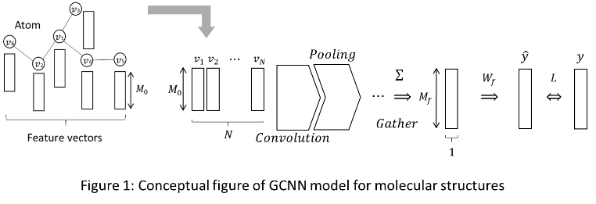
Abstract (300 word limit)

Secondary metabolites are defined as a group of natural compounds that are not directly involved in growth, development or reproduction of organisms. The term ’secondary’ in the context of metabolic pathways, was introduced in 1891. The functions of secondary metabolites are related to their prevalent potent biomolecular activity acquired in evolution process involving pest and pathogen defense, UV-B-sunscreens etc. The classification of secondary metabolites taking chemical structure and metabolic pathway into consideration could provide important clues to activities of metabolites which lead to interpretation of function acquisition mechanisms of secondary metabolites in evolutional process.

And, various chemical descriptors such like molecular fingerprints have been long discussed to represent biochemical features, in order to embed molecular structures into a numerical space and quantify their activities. However, it is still difficult to predict bioactivities from molecular structures since it depends on the choices of those chemical descriptors.

Recently, machine learning methods based on Graph Convolutional Neural Networks (GCNN) have been proposed that can automatically optimize a model for molecular feature extraction from the given training sets.

In this study, we introduce an application of GCNN to predict metabolic pathways of alkaloids, namely, one of the largest family of secondary metabolites in plants. I trained and tested GCNN model on 578 alkaloid compounds and the mean accuracy of 20 runs with random sampling is about 94% (Number of epoch: 200). The results showed that it is greatly expected that it will lead to an understanding of the evolution of metabolic system unique to organisms.
Image

Recent Publications
- Ryohei Eguchi, Naoaki Ono, Hisayuki Horai, Md.Altuf-Ul Amin, Aki Morita Hirai, Jun Kawahara, Shoji Kasahara, Tomoaki Endo, Shigehiko Kanaya, Classification of Alkaloid Compounds Based on Subring Skeleton (SRS) Profiling: On Finding Relationship of Compounds with Metabolic Pathways, Journal of Computer Aided Chemistry, Volume18, p58-75, 2017.
- Satoshi WATANABE, Hoko KYO, KANG Liu, Ryohei EGUCHI, Md. Altaf-Ul-Amin, Aki MORITA(Hirai), Minako OHASHI, Naoaki ONO, Alex Ming HUANG, Yanbo ZHU, Qi WANG, Zhaoyu DAI, Yukiko NAKAMURA, Klaus W. LANGE, Kazuo UEBABA, Shintaro HASHIMOTO, Shigehiko KANAYA, Nobutaka SUZUKI, Data Intensive Study of Accessibility of Edible Species and Healthcare Across the Globe, Japanese Journal of Complementary and Alternative Medicine, April 18, 2018.
- Ryohei Eguchi, Mohammand Bozlul Karim, Pingzhao Hu, Tetsuo Sato, Naoaki Ono, Kanaya Shigehiko and Md. Altaf-Ul-Amin, An integrative network-based approach to identify novel disease genes and pathways: A case study in the context of inflammatory bowel disease, BMC Bioinformatics(Accepted for publication).



Paste your Photograph Here
Biography (150 word limit)
In 2018, after obtaining doctor’s degree in engineering at the Graduate School of Information Science, Nara Institute of Science and Technology, and in the same year he joined the Nara Institute of Science and Technology as a doctoral researcher at the Data Driven Science Creation Center, and has reached the present. I’m involved in the research on gene expression analysis and metabolic pathway prediction of secondary metabolites by applying multivariate analysis and machine learning techniques, mainly in the field of bioinformatics and chemoinformatics.
Email: eguchi.ryohei.eg6@is.naist.jp

Notes/Comments:

