Metabolic syndrome, obesity, and renal progression in chronic kidney disease
Po-Ya Chang¹, Yu-Wei Chang², Kai-Hsiang Ho³, Hung-Yi Chiou^{1*}
¹School of Public Health, Taipei Medical University, Taipei, Taiwan;
² Department of Information Management, China Jiliang University, Hangzhou, China;
³ Department of nursing, Tzu Chi University of Science and Technology, Hualien, Taiwan
Abstract  Metabolic syndrome and obesity are found to cause adverse outcomes in health. However, a subset of healthy obese individuals might not be at an increased risk for metabolic complications; they are referred to as metabolically healthy obese (MHO). People with MHO or metabolically unhealthy non-obese (MUNO) have different risks in cardiovascular diseases, and mortality. There is no study to discuss the interaction of metabolic syndrome and obesity on renal progression. We aimed to investigate this issue among chronic kidney disease (CKD) patients. This prospective cohort study enrolled 4525 CKD patients. The renal progression was defined as a decline in the eGFR by more than 25% according to the baseline eGFR. Metabolic syndrome was defined as subjects who have more than three metabolic disease components: (i) blood pressure ≥130/85 mm Hg or regular use antihypertensive agent (ii) fasting blood glucose ≥100 mg/dl or regular use antihyperglycemic agent (iii) triglyceride levels ≥150 mg/dl or total cholesterol ≥200 mg/dl or regular use antihyperlipidemic agent (iv) Waist circumference ≥90 cm for men and ≥80 cm for women. Obesity was defined as body mass index (BMI) ≥25 kg/m². The investigated subjects are divided into metabolically healthy non-obese (MHNO) (without metabolic syndrome and obese), MHO (without metabolic syndrome and with obese), MUNO (with metabolic syndrome and without obese), and metabolically unhealthy obese (MUO) (with metabolic syndrome and obese). The mean age of the cohort was 62.9 ±13.7 years. Compared with MHNO, the risk for renal progression hazard ratio were 1.132 for MHO, 1.265 for MUNO, and 1.266 for MUO after adjustment for confounders. We further used subgroups analysis by age. When patients aged <65 years, MUNO and MUO have higher risk of renal progression than MHNO. When patients aged ≥65 years, there are no significant differences for the four groups. In conclusion, metabolic syndrome has larger effects on the increased risk of renal progression than obesity. MHO was unrelated to the increased risk of renal progression among CKD patients. | 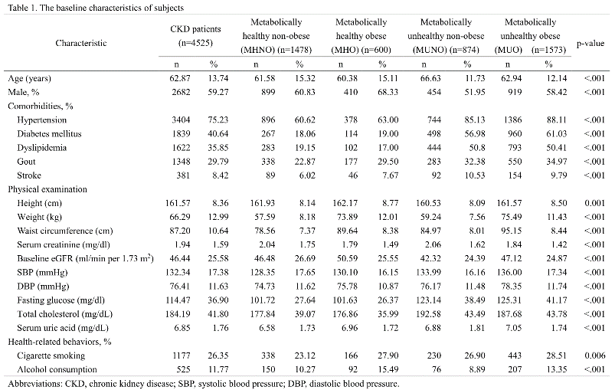  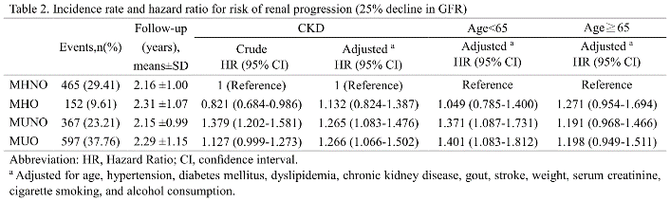  Recent Publications  - Po-Ya Chang, Li-Nien Chien, Yuh-Feng Lin, Wen-Ta Chiu, Hung-Yi Chiou. Simultaneous Control of Glycemic, Blood pressure, and Lipid Significantly Reduce the Risk of Renal Progression in Diabetes Patients. European Journal of Internal Medicine. 2016 Oct; 36, 87-92.  - Po-Ya Chang, Li-Nien Chien, Yuh-Feng Lin, Mai-Szu Wu, Wen-Ta Chiu, Hung-Yi Chiou. Risk Factors of Gender for Renal Progression in Patients with Early Chronic Kidney Disease. Medicine (Baltimore). 2016 June 95; 30, 1-7.  - Po-Ya Chang, Li-Nien Chien, Yuh-Feng Lin, Hung-Yi Chiou, Wen-Ta Chiu. Nonadherence of Oral Antihyperglycemic Medication Will Increase Risk of End-Stage Renal Disease. Medicine(Baltimore). 2015 Nov 94; 47, 1-8.



Biography
Po-Ya Chang is a postdoctoral at the Taipei Medical University of College of Public Health. She holds a Ph.D. degree in Public Health from the Taipei Medical University. She also a visiting scholar at The University of Tokyo, Japan. She research areas are epidemiology, public health, and secondary data analysis.
Email: rj0729@hotmail.com
Euro Metabolomics 2018
