METHOD OF DETERMINING THE HEAT CONDUCTIVITY OF PACKAGE OF MATERIALS OF SEWING PRODUCTS UNDER THE STATIONARY HEAT MODE
Salih Shukurovich Tashpulatov¹, Irina Viktorovna Cherunova²,
Lyubov Fedorovna Nemirova³, Ziyoda Azimdjanovna Sabirova¹,
Umida Tohtasinovna Muminova¹, Barnohon Abdullaevna Rikhsieva¹,
Nafis Rustamovna Mirzaahmedova¹

¹ Tashkent Institute of Textile and Light Industry, Tashkent, Republic of Uzbekistan,
²Institute of the Service Sector and Entrepreneurship (branch) of the Don State Technical University, Shakhty, Russian Federation,
³LLC "Institute for System Design", Omsk, Russian Federation

Contact person: Nafis Rustamovna Mirzaakhmedova, e-mail:
nafismirzaakhmedova@gmail.com
Abstract. In the exploitation of clothes, the package of materials that make it up can be in a dry, wet or chilled state, as well as move from one state to another. For the study of thermal conductivity of packages of materials (textiles, knitwear and non-woven fabrics, leather, fur) clothing developed a special device that allows you to explore samples that are in different states, characteristic of the operation: deformed, moistened, cooled; carry out measurement of test parameters and fixation of results in an automated mode. The device and software of this method are protected by a patent for a utility model and a certificate of registration of a computer program.
The paper proposes a method and device for studying the thermophysical characteristics of materials and packages of clothing materials in the unsteady thermal conditions. The device was developed by the method of regular heat flow, and is a body made of a material with known thermophysical properties, divided into two compartments of the same volume using a partition (wall) on which the sample under study (material, material package) is fixed. In the method, air acts as a heat carrier, which is supplied to the compartments by means of hair dryers (“cold” and “hot”), allowing for controlled heat supply to a given area, which ensures the unidimensionality of the heat flow. In the device, a specially developed program records the parameters at which the study was carried out, into a computer and used them to calculate the thermophysical characteristics of the studied sample (material, or material package). The test is reduced to fixing the temperature change over time at one point of the sample and calculating the desired thermal values ​​using the general laws of heat transfer. Thus, according to this method, depending on the conditions of research, and the object of study, the following characteristics can be obtained: thermal conductivity λ, thermal diffusivity a, total thermal resistance of a material package R sums, convective heat transfer coefficient α. These characteristics in various forms are included in the calculations of the temperature loss of clothing, the heat loss of clothing, as well as the leakage of a device for measuring the thermophysical properties of a material. Test specimens may be rigid, semi-rigid or soft. The material from which the samples are made may be uniform or non-uniform, isotropic or anisotropic. In some cases, the problem of eliminating direct contacts of the elements of the refrigerator and the heater with the sample can be solved, which leads to the elimination of the deformation of the sample under study.
The basis of the device based on the principle of Le Chatelier - Brown. The thermal conductivity of packages, including such materials as gabardine, cotton wool, synthetic winterizer, leather, fur, and knitwear, was measured using the developed test complex in the “CentexUZ” certification laboratory of the Tashkent Institute of Textile and Light Industry. Taking into account the processing of research results and compliance with their confidence accuracy, the following results were obtained. The proposed device allows you to set modes and measure the parameters characterizing the thermophysical properties of materials used in the manufacture of clothing and their packages. The device provides high reproducibility of results: the coefficient of time variation over which the required temperature in the range from + 50 ° C to -50 ° C is reached is from 7% to 10% depending on the rated performance of the device, which is acceptable for this type of research. The device allows with high accuracy to record the temperature change in the sample, record and save the results. The thermophysical properties of packages of materials including cotton wool are investigated, and the values ​​of the heat transfer coefficient during convective heat transfer are obtained. The developed device allows to carry out studies of the thermophysical properties of materials for clothing and their packages, ensuring that I require accuracy (up to 10%), adopted in studies in light industry. The results obtained allow us to formulate and solve the problem of choosing materials in packages, taking into account changes in the user's comfortable state.
The research results confirmed the possibility of using a new device and computer software during testing of textile materials, and the obtained data on the thermal conductivity of a number of materials in various physical and technical conditions are of great interest for the design of thermal protective clothing, including determining the conditions for drying clothes in the process of leaving.
Keywords − Measuring devices, heat conductivity, textile materials, clothing packages.

SOURCE OF FINANCING. ACKNOWLEDGMENTS
This study was carried out at the Tashkent Institute of Textile and Light Industry within the framework of the State Program of the Agency for Science and Technology under the Cabinet of Ministers of the Republic of Uzbekistan for the project OT-A3-63 (2017-2018). Leader Dr. Sc. Salih S.Tashpulatov.

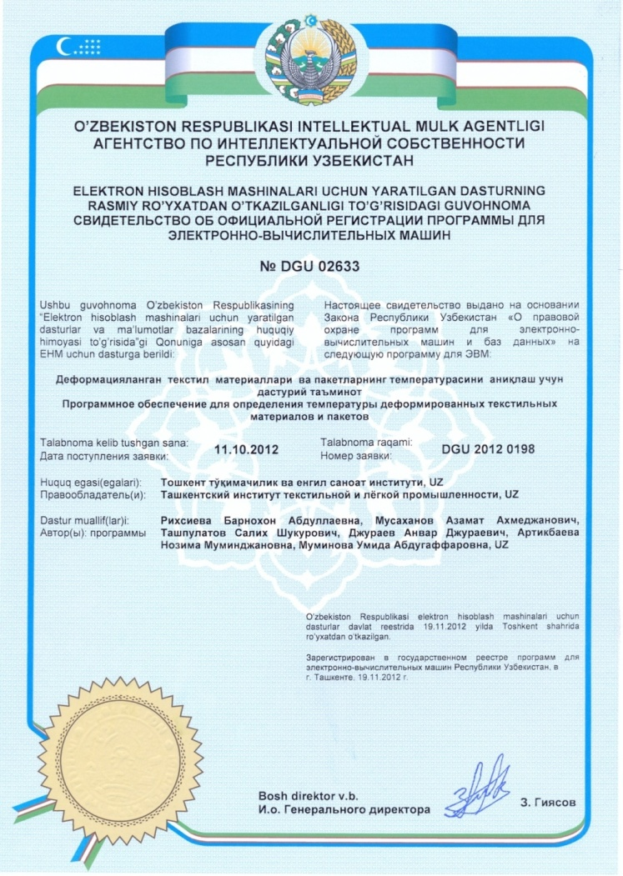 | 