STUDY OF SYNTHESIS AND CHARACTERIZATION OF HIGH TEMPERATURE CUPRATE PEROVSKITES

ª Dr. Sumit Kumar Gupta, ^{b}Harish Jangam, ^{c} Nipun Sharma
Department of Physics
ª Assistant Professor Parishkar College of Global Excellence, Jaipur, India

^{b,c} Research Scholars Sru University, Alwar India

ABSTRACT
YBCO was the first material found to be superconducting above nitrogen temperature. It exhibits a very interesting and complex relationship between its chemistry, crystal structure and physical properties. A very subtle electronic charge balance exists between the one dimensional cooper-oxygen chains, which have variable oxygen content and the two dimensional cooper-oxygen pyramidal planes, where superconductivity originates. In oxygen deficient YBCO, oxygen is removed from the CuO chains. Related to this, 90 K superconductor is obtained for 0< x < x < x. In this paper pure YBCO is synthesized by solid state reaction method and measurement of resistivity versus temperature are taken by four probe method. YBCO is a high temperature superconducting material having transition above the liquid nitrogen temperature. SnO₂ was added to YBCO to form a composite in order to increase its current density and observe the changes in its properties. Microstructural analysis is performed using SEM, and phase confirmation of YBCO composite is done using X-Ray Diffraction method. DC electrical transport properties provide some understanding of the mechanism of this material. Now a days, research is going on to find mechanism of high temperature superconductivity as BCS theory is silent about this. Since preovskites are ceramics, the procedure for making them is very similar to making other ceramics. So that oxides, carbonates, and nitrates are good sources for the metals needed to make YBCO. All over the world, several researches that included effects of substitutions and different preparation conditions have been investigated. It was accepted that the most widely used procedure is conventional solid-state reaction technique.
INTRODUCTION
The most unusual and interesting properties of solid is superconductivity in which the electrical resistivity falls suddenly to zero when the solid is cooled to a suitably low temperature and the specimen behave as perfect diamagnetic. The materials which obey both electrical (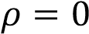) and magnetic properties (-ve susceptibility) are called superconductors.Above the critical temperature a given specimen is in normal state and below the critical temperature it is in superconducting state. The two main characteristics of a superconductor are
- Zero resistivity below critical temperature
- Negative susceptibility i.e.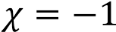 . It behaves as a perfect diamagnet.

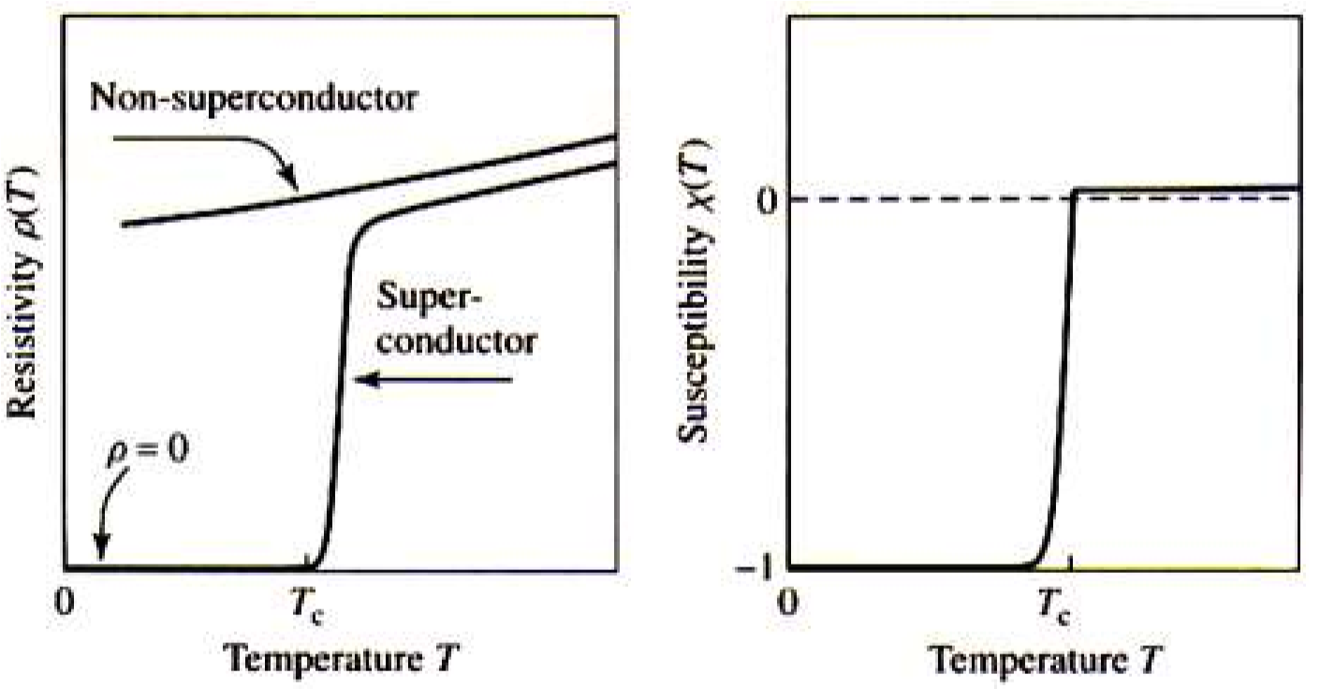
Figure.1. Superconducting phase transition

(a) zero resistivity at critical temperature (b) negative susceptibility below critical temperature

HIGH TEMPERATURE SUPERCONDUCTOR (HTSC)
HTSC have a superconducting transition temperature above 30K or 77 K i.e above the boiling point of liquid nitrogen. Much higher magnetic field is needed to suppress superconductivity in these superconductors as they allow magnetic field to penetrate their interior in quantized units of flux. Critical temp as high as 135K have been achieved in HBCCO system. Examples of HTSC are LBCO, YBCO, LSCO, BSSCO, TBCCO, and HBCCO.
Table 1 Critical temperatures of various HTSCs
HTSC | T_{C}
YBCO  LSCO  BSCCO  TBCCO  HBCCO | 92K  108K  110K  127K  135K
There is always a demand for materials having superconducting properties as superconductivity has applications in many fields such as electrical power transmission, high speed trains, large physics machines, optoelectronics magnetic levitation, magnetic shielding etc. They are also less expensive and better than the former one. The major challenge now-adays is to synthesize a superconducting material whose critical temperature is close to room temperature. Heading towards this path the current focus of much of the research, development and commercialization of superconductors is on YBa₂Cu₃O_{7-δ}.
STRUCTURE OF HTSC:
High temperature superconductors (HTSCs) are structurally members of a crystallographic family known as perovskites.

PEROVSKITE STRUCTURE
Perovskites are ceramics which is a combination of metallic elements and non-metals, usually oxygen that have a particular atomic arrangement. They have their generalised formula as ABX₃. The A and B atoms are metallic cations and X atoms are non-metallic anions.
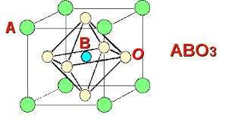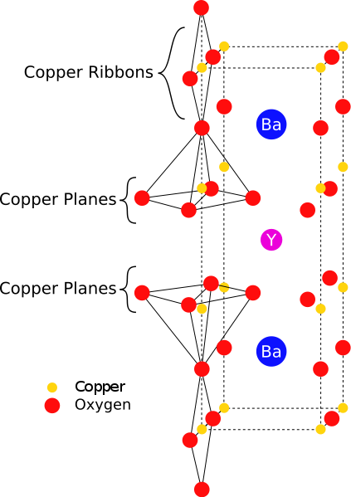

Fig.
3
23
Perovskite

structure

Structure of

YBCO:

Fig 8
:
4 S
Structure of YBCO

The compound YBa₂Cu₃O₇ has orthorhombic symmetry. The structure can be described as a perovskite with an shortage of oxygen. By eliminating oxygen atoms from the ideal perovskite lattice, we can obtain YBa₂Cu₃O₇.
Its unit cell contains.
- A layer of Cu–O having copper is surrounded by four oxygen ions
- A layer of BaO
- A layer of Cu–O, where Cu is surrounded by five oxygen ions forming a polyhedron
- A layer of yttrium shortage of four oxygen.
Thus, the stacking sequence of the (ab) planes is Y–CuO–BaO–CuO2–BaO–CuO2–Y. It is to be noted that there are Cu–O chains along the b-axis. The presences of oxygen atoms in these chains are essential for superconductivity. The general formula of the compound is YBa₂Cu₃O_{7−x}where 0≤ x ≤ 1.The lattice parameters vary with the oxygen content (x-value) and for x ≥ 0.6the structure is tetragonal. In YBa₂Cu₃O₆(x = 1), there are no chain (O4sites) oxygen and Cu in b-axis is in the 1⁺state. (Non-superconducting state).Thus, the unit cell parameters vary with the value of x in YBa₂Cu₃O_{7−x} (i.e. a, b and c parameters vary with the oxygen-stoichiometry). The structure is orthorhombic for x = 0.
SnO₂:
Tin oxide, also known as stannic oxide is an inorganic compound with molecular formula SnO2. It is a colourless, white to off white coloured powder. Its mineral form is a main ore of tin. It is diamagnetic and amphoteric in nature. It is a crystalline solid having rutile structure.
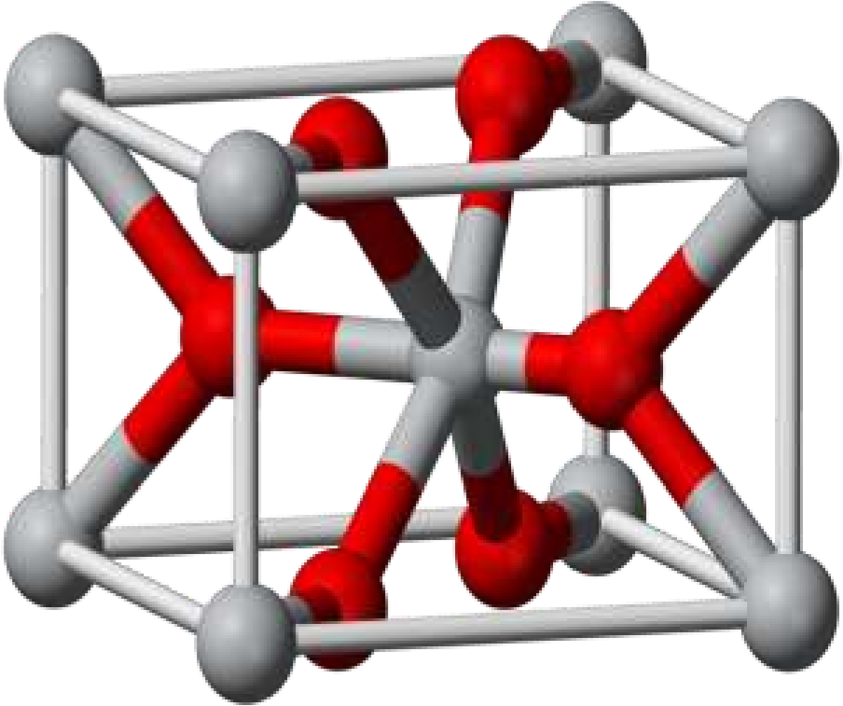
Figure 4: Structure of Tin oxide
SAMPLE PREPARATION
Heating profile:
(a) Heating profile for calcinations:

High temperature superconductors are prepared using the Solid state reaction method. The steps involved are:
- Assimilation the powders
- Calcinations with intermediary grinding
- Annealing in the presence of oxygen at 500 ⁰C for 8 hours.
This reaction takes place at high temperature. After the reaction has taken place, theYBCO should be reground to a powder and then pressed into a pellet.
YBCO was prepared by mixing the chemicals as per the balanced chemical equation.
Steps involved in the preparation of YBCO are as follows:
  - Yttrium oxides (Y₂O₃), Barium Carbonate (BaCo₃), Copper Oxide (CuO) were taken in stoichiometric ratio (1:2:3) to prepare YBa₂Cu₃O_{7-δ}.
  - The precursor powders are mixed together in an agate mortar for 2-3 hours to get the gray powder of YBCO.
  - The grounded sample was taken in an alumina crucible and subjected to calcinations (which promotes the decomposition of carbonates, nitrates or any other impurity phase leading to the formation of desired phase of the superconducting YBCO) at
900 for 12 hours for 5 times followed by intermediate grinding.
- The mixture was taken out after the desired temperature was reached.
- The calcined powder so obtained was ground well and pressed in the form of pellets using a pelletizer giving a pressure of 100kg/m².
- The YBCO pellets were sintered in an indigenous programmable conventional furnace at 920 for 12 hours annealed at 500 for 8 hours in oxygen atmosphere.
Preparation of composite of YBCO with SnO₂:
SnO₂ powder was added to pristine superconducting YBCO powder in various wt.%. The different composites were ground individually for one hour. Each composition was pressed into pellets and was sintered at920 for 12 hours and anneled at 500 for 8 hours in oxygen atmosphere and allowed to cool slowly within the furnace to room temperature.
The different wt. % of SnO₂ added to YBCO are x= 0.0, 0.01, 0.05, 0.1wt. %.
(a) Heating profile for sintering:
CHARACTERIZATION TECHNIQUES

X-RAY DIFFRACTION (XRD)
X-rays are produced generally by either x-ray tubes or synchrotron radiation. Waves are diffracted from different atoms. If the atoms are arranged in a periodic way the diffracted waves consist of sharp interference maxima (peaks) with the same symmetry as in the distribution of atoms. Measuring the diffraction pattern allow us to figure out the distribution of atoms in a material. This is governed by Bragg’s Law given by,
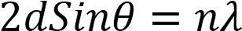
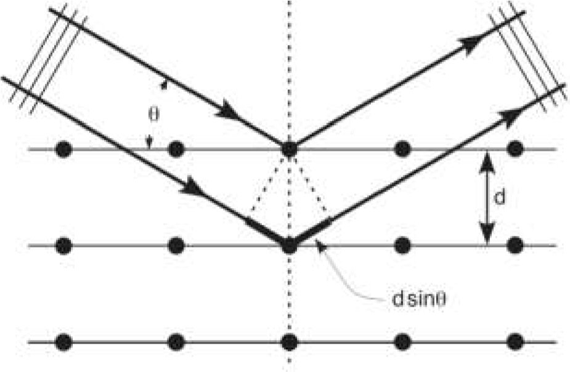

Figure 5: Diffraction through crystal planes

SCANNING ELECTRON MICROSCOPE (SEM)
SEM is used to know the external morphology and chemical composition of the sample. It uses electrons instead of light to scan an image. It can scan an image very fast and also over a large area. It is also followed by EDXS which analyzes the elements present in the sample and also quantify their amount.



Figure 6
:

Schematic diagram

of a SEM

LOW TEMPERATURE R-T MEASURMENT BY FOUR PROBE METHOD:
The temperature dependence of resistivity was measured using four probe method. Two probe method is not used due to some of its demerits.
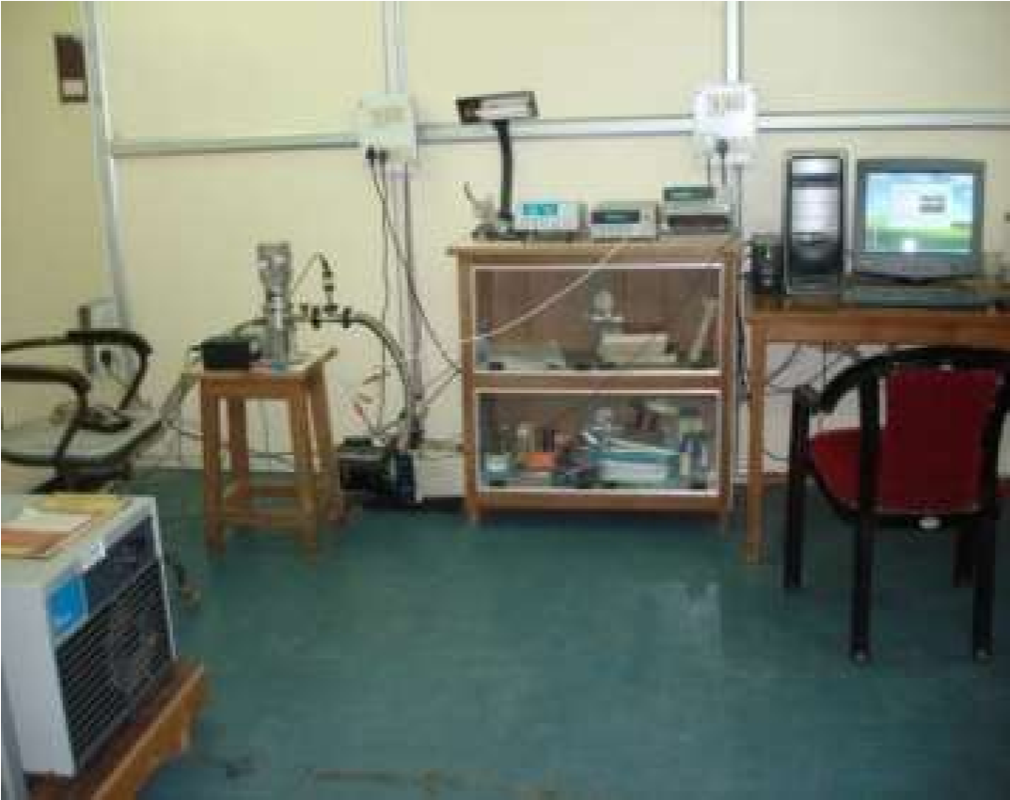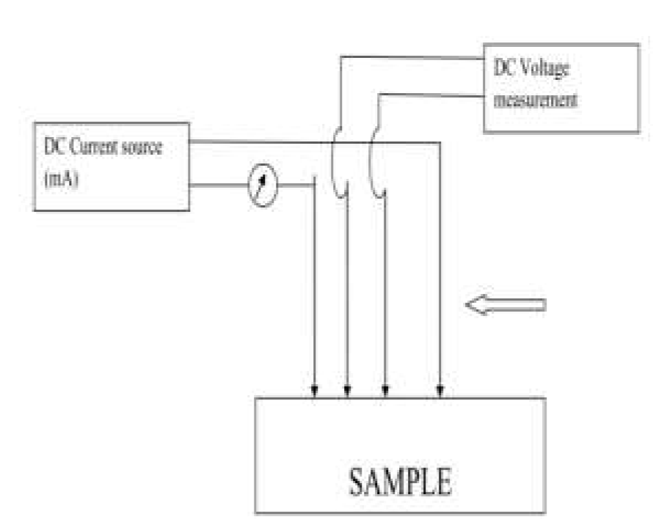
Figure 7:Four probe set up for resistance measurement

RESULT AND DISCUSSION

Structural analysis by XRD:
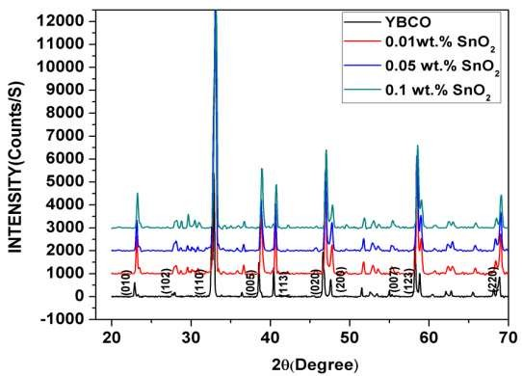

Fig 8: XRD graph of YBCO+xSnO₂ (x= 0.0, 0.01,0.05,0.1 wt. %) composites.

Figure 7 shows the XRD pattern of YBCO+ xSnO₂ (x=0.0, 0.01, 0.05, 0.1 wt. %) composites. Indexing of the pattern shows that all the samples are in orthorhombic structure with space group P_{mmm}. Some SnO₂ peaks are also seen in the pattern. It is also observed that the structure has not changed even after doping SnO₂. The symmetry has also not changed after doping. It concludes that the addition of SnO₂ to pure YBCO has no significant effect on the structure and symmetry of the composites. The lattice parameters and unit cell volumes calculated by check cell software are listed in Table2 below.
Table 2. Lattice parameters calculated from XRD graphs
SnO₂(wt.%) | a (A⁰) | b ( A⁰) | c (A⁰) | V ( A⁰³)
YBCO | 3.818 (1) | 3.884 (1) | 11.681 (2) | 173.218
0.01 | 3.818 (1) | 3.873 (1) | 11.630 (4) | 171.974
0.05 | 3.817 (1) | 3.871 (1) | 11.647 (4) | 172.091
0.1 | 3.795 (1) | 3.898 (1) | 11.711 (5) | 173.239
The lattice parameters changes with the addition of SnO2.Here we see that the volume decreases as we decrease the doping concentration. The highest concentration added has nearly same volume as that of pure YBCO.
Scanning electron microscopy (SEM):
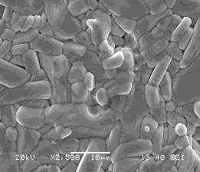
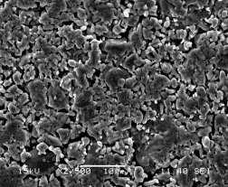
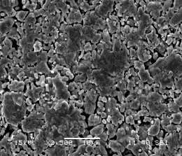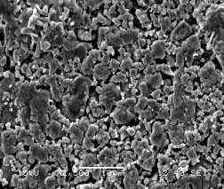

X=0.05

X=0.1

Fig.9. SEM micrographs of YBCO+ x SnO₂(x= 0.0,0.01,0.05,0.1 wt.%) samples.
It shows that pure YBCO has long and extended grains randomly oriented in all direction with size varying from 1 to 10μm. Grains are very closely packed to each other. With the addition of SnO₂ the grain size decreases to a large extent with the increase of pores and voids in the sample. The grains become rounder in shape.
EDX analysis:
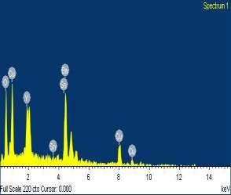
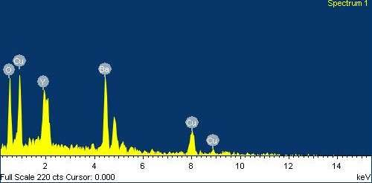
The elemental analysis and their percentage composition was confirmed by EDXA. The presence of the elements Yttrium, Copper, Barium, and Oxygen was observed by the peaks of EDXA. The presence of Tin was also confirmed by EDX image after doping. The weight % and atomic % composition is given in he is below

0.01
%

YBCO

Element | Weight% | Atomic %
O | 12.84 | 46.78
Cu | 28.70 | 26.33
Y | 9.03 | 5.92
Ba | 49.43 | 20.97

Element | Weight % | Atomic %
O | 14.10 | 49.18
Cu | 29.82 | 26.20
Y | 7.89 | 4.95
Sn | 1.14 | 0.54
Ba | 47.05 | 19.13

Fig. 10. EDX picture of YBCO+x SnO₂(x= 0.0, 0.01, 0.1 wt.%) samples.

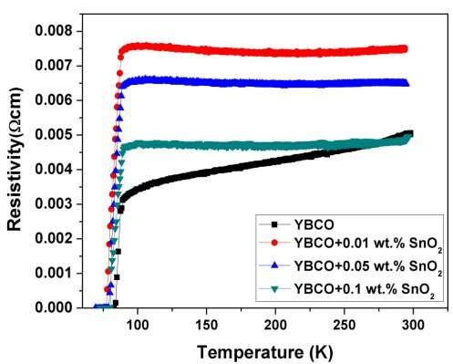

Temperature vs Resistivity Measurement

Fig.11 Temperature vs. Resistivity plots forYBCO+xSnO₂ (x=0.0, 0.01, 0.05, 0.1wt. %) samples.

Measurement of the resistivity dependence of temperature for different samples with various amounts of SnO₂ is shown in Fig.12.Pure YBCO shows metallic behaviour. But with the addition of SnO₂ the metallic behaviour decreases with the increase in concentration of SnO₂.

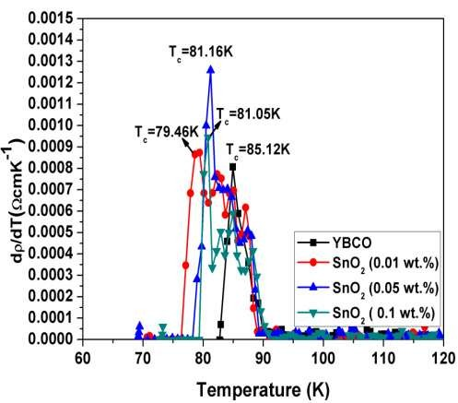

Fig.12. Temperature derivative of Resistivity plots for YBCO+xSnO₂ (x=0.0, 0.01, 0.05, 0.1wt. %) samples.
There are two regions- the normal region and the superconducting region and in this region it follows Anderson and Zou relation given by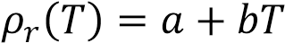where a is the intercept gives the residual resistivity ρ₀ and b is the slope and then extrapolating to T_{c} gives the slope. Different critical temperatures are observed from the different composites. The derivative of the RT graph was done to get the critical temperatures. The temperature derivative of resistivity curves are shown in fig.18. T_{c} is defined as the peak position of the derivative and is observed to decrease with the addition of SnO₂.The peak broadening is occurring due to addition of SnO₂composite which is affecting the inter granular weak link between grains.
Table 3 Critical temperatures from R~T graph for YBCO+xSnO₂(x=0.0, 0.01, 0.05, 0.1 wt. %) samples

SnO2 (wt.%) | T_{c0}(K) | T_{c}(K)
0.0 | 82.91 | 85.12
0.01 | 76.38 | 79.46
0.05 | 78.27 | 81.16
0.1 | 79.77 | 81.05

CONCLUSION
High temperature superconductor YBCO was synthesized using solid state reaction method. The effect of addition of tin oxide (SnO₂) to YBCO was studied by various characterization techniques. The phase of YBCO was confirmed by XRD analysis and the critical temperature was found out to be 85.12K by RT measurements. Various critical temperatures are found for different compositions of SnO₂ in YBCO. The morphological analysis was done by Scanning electron microscope and the presence of SnO₂ was confirmed by EDX analysis. The grain boundaries decrease with the increase in concentration of SnO₂. Addition of the material to YBCO matrix decreases the transition temperature as resistance of the weak link Josephson junction increases.

REFERENCE
- “Solid state physics” – S.O.Pillai
- “Solid state physics”- Kittle
- Crystal Structure of Superconductors By Ajay Saxena
[3]R Teranishi, Y Miyanaga, K Yamada, N Mori, M Mukaida, M Inoue,
T Kiss, M Miura, M Yoshizumi, T Izumi , M Namba, S Awaji, K Watanabe Journal of Physics: Conference Series 234 (2016) 022039
- Akio Suzumura,Dai Zhigang,Hirotaka Ogawa Material Transactions, JIM,VOL 37 NO 5 (1996)
- S. Marinel , G. Desgardin, Journal of the European Ceramic Society 21 (2010) 1919–
1923.
- Wikipedia-the free encylopedia

